Name: __________________________________________________________________________________ Per: ______
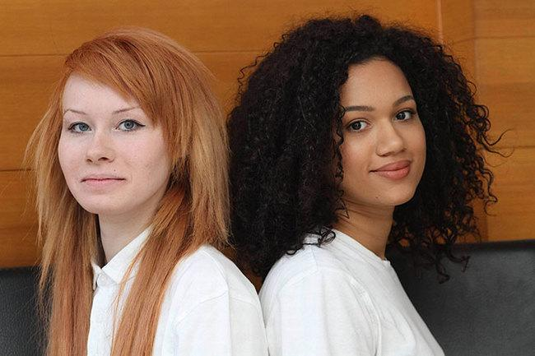
Twin Model

Question: How could these two girls, born at the same time from the same parents, look so different?

Our big question for this unit: Why are we so different from each other?
We have learned about several sources of variation throughout this unit. Explain what they are (causes), when they happen, and how they create variation (effects).

Source of Variation (cause) | What is it? Explain the process. | When does it happen? | How does it create variation (effect)?
Independent Assortment

Crossing-over

Random Fertilization

Mutation

Background information
Although there are more than 10 genes that control skin color, and all those genes have many different alleles, our model will only show 2 of those genes.
- The first gene is MC1R. This gene codes for proteins that control what kind of melanin the skin cells make.
  - One version of the protein tells cells to produce eumelanin, a dark brown melanin. Use (E) to represent the allele that codes for this protein.
  - One version of the protein tells cells to produce pheomelanin, a pink/pale melanin. Use (P) to represent the allele that codes for this protein.
- The second gene is KITLG. This gene codes for proteins that control how much melanin the skin cells make.
  - One version of the protein tells cells to produce high levels of melanin. Use (H) to represent the allele that codes for this protein.
  - One version of the protein tells the cells to produce low levels of melanin. Use (h) to represent the allele that codes for this protein.

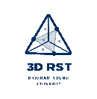

3D-RST is supported by the NSF under grant number #DRL-2101383
Part 1: How did the twins inherit their traits from their parents?

- Fill out the table below based on the information you have just read.
Name of Gene | Possible Alleles | What does the protein do? | How do the alleles interact?
MC1R | E |  | - Complete dominance  - Incomplete dominance
MC1R | P |  | - Complete dominance  - Incomplete dominance
KITLG | H |  | - Complete dominance  - Incomplete dominance
KITLG | h |  | - Complete dominance  - Incomplete dominance

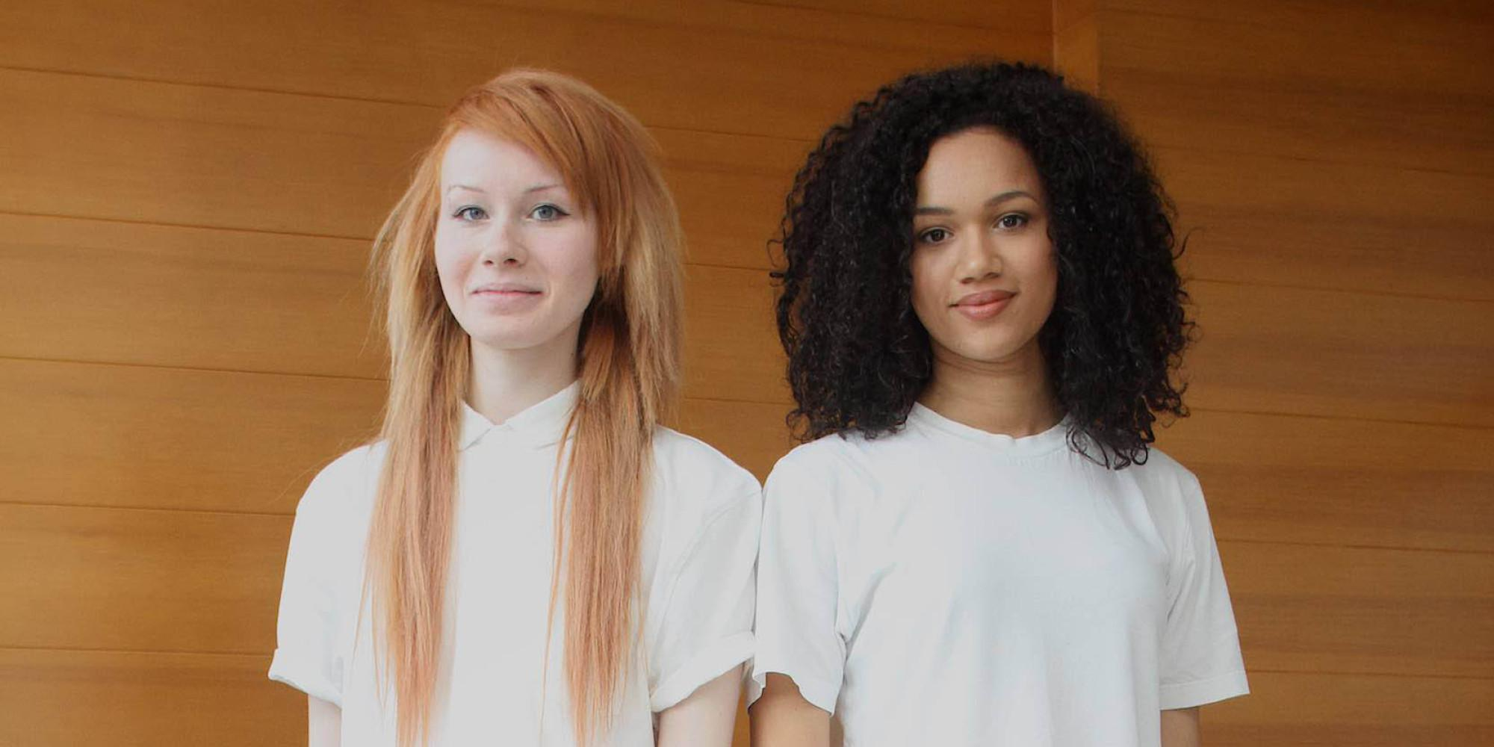
Lucy has a genotype of PPhh. Maria has a genotype of EEHH.
What is her phenotype? What is her phenotype?

- What are Lucy and Maria’s parents’ genotypes? _______________ X _____________

- Fill in the diagram below for Lucy and Maria’s parents. CIRCLE Lucy and Maria’s genotypes on the Punnett Square.
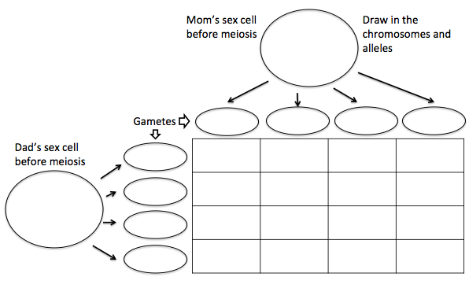

What process (source of variation) caused these gametes to have different allele combinations?
What process (source of variation) caused these offspring to have different allele combinations?

What was the probability percentage that Lucy and Maria’s parents would have twins like them? Calculate this as: (Lucy’s genotypic ratio) x (Maria’s genotypic ratio)

Part 2: How did the twins’ different DNA result in their different physical traits?

Lucy and Maria have an older brother, George, who is heterozygous for the MC1R gene. Use the DNA Protein Trait Model to show how differences in George, Maria, and Lucy’s DNA would result in differences in their appearance. For this part, we will only show the MC1R gene.

- In the nucleus of each cell, draw chromosomes with the MC1R gene labeled (remember to use E or P as your labels). Keep in mind the type and number of alleles that Lucy and Maria should have.

- Use the space in the model to show the following things:
- Draw the proteins being produced in the cytoplasm. Make sure you show these proteins as clearly different from each other.
- Show the type of melanin being produced in the cell as a result of these proteins. Make sure there is a clear difference between eumelanin and pheomelanin.
- If all humans started only having the E allele (producing eumelanin), what process (source of variation) caused the P allele to appear? Name the source of variation.

- How is this an example of Cause and Effect? Explain using evidence.

- What are the three sources of variation represented in this activity? Explain how each contributed to the variation in the twins.

DNA  What are the different variations in the genes? | The Cell  What happens in the cell? | Job of Protein/Job Location  What does protein do in the body? | Trait  What is the physical trait?
Maria |  | Maria’s Proteins | Maria’s Trait
George |  | George’s Proteins | George’s Trait
Lucy |  | Lucy’s Proteins | Lucy’s Trait
DNA Protein Trait Model: MC1R

