Chromosome Crossover Name ________________________________ Per ____
Make an initial argument explaining how the twins, Lucy and Maria Aylmer, inherited such different traits from their parents. Use scientific terms, evidence, and reasoning to support your argument.

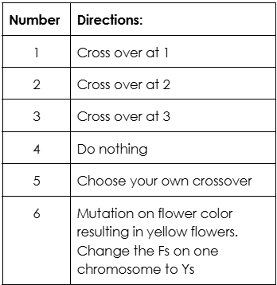
Chromosome Crossover Simulation: Pea Plant Traits
Roll the dice, cut, and swap according to the table. Each student will roll the die 3 times.
After you’ve performed the crossovers, you will now cut apart your chromosomes so that you have four separate chromatids. Glue or tape them into the spaces below. Then fill out the table, using the information about plant height, flower color, and seed covering.

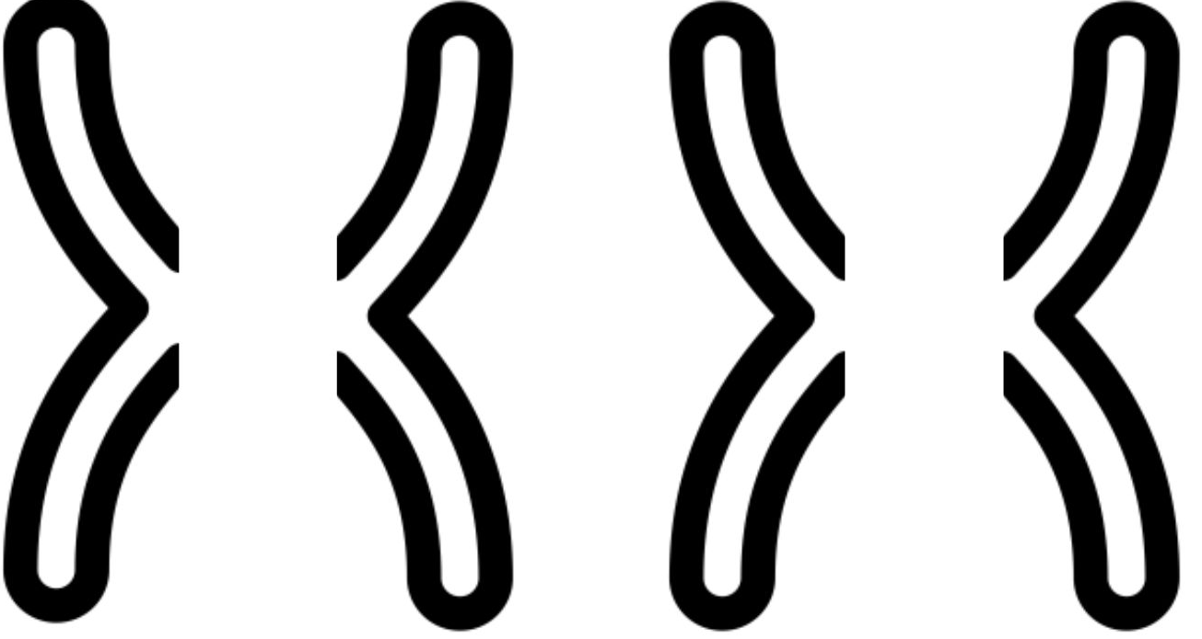
Chromatid #1 Chromatid # 2 Chromatid #3 Chromatid #4
1. Based on the letters in each chromatid, use the trait key below to determine the traits for each.
 | Chromatid #1 | Chromatid #2 | Chromatid #3 | Chromatid #4
Plant height
Flower color
Round/Wrinkled

Trait Key | Plant height | T: tall plant | t: short plant
Trait Key | Flower Color | F: purple flowers | f: white flowers
Trait Key | Seed Covering | R: round seeds | r: wrinkled seeds
2. Compare your 4 chromatids with at least three other students. What do you notice?

3. How is rolling dice to determine crossover locations related to actual determination of crossover location during prophase I of meiosis? Hint: Consider what role the dice played in the simulation

4. What is the result of crossover locations being random?

In animals, gametes are sperm and egg cells. In pollinating plants, gametes are pollen and ovum cells. Each pollen and ovum cell contains chromatids that have undergone crossover during prophase I and are therefore unique. Every time meiosis occurs, 4 haploid gametes are formed from one original diploid cell. Pea plants have a haploid number of 7 and a diploid number of 14.
5. How many chromatids will be in each pea pollen cell?
6. How many chromatids will be in each pea ovum cell?
7. After pollination, how many chromatids will be in each pea seed or resulting pea plant?
8. You and your partner will each choose one chromatid to simulate pollination. Write down the traits (3 letters) carried in each gamete, and determine what traits (6 letters) the resulting offspring will carry.
Pollen (3 letters) | Ovum (3 letters) | Offspring (6 letters)

Peas demonstrate simple patterns of inheritance with the traits above. Skin color in humans is not nearly as simple. Melanin is a pigment responsible for skin, hair, and eye color. The following tables simplify this and show different possible gamete combinations with 3 genes, all involved in melanin production.
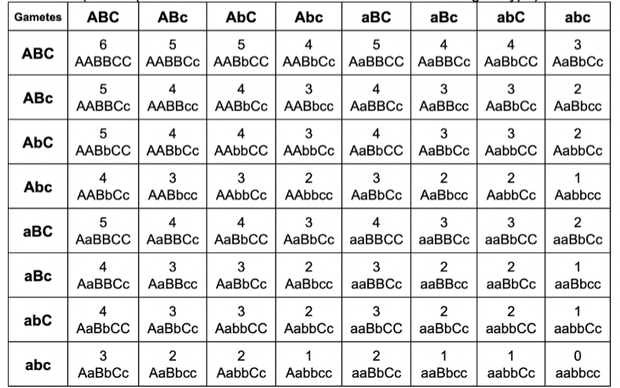
# of capital letters | 1 | 2 | 3 | 4 | 5 | 6
Skin color

The chart on the right is called a Punnett Square. Along the top and left are possible genes carried by the parents (in sperm and egg cells. The other boxes show the outcome of different gamete fertilization, based on which sperm and egg come together to form the zygote.
9. From the chart above, what traits were passed on to the Aylmer sisters from their parents? Consider which traits could be passed on (in gametes) to give us such different outcomes. From the chart above, what 6 letters (this is called genotype) do you think each of the twins has?

Sperm (3 letters) | Egg (3 letters) |  | Sperm (3 letter) | Egg (3 letters)
Lighter twin - Lucy (6 letters) |  |  | Darker twin – Maria (6 letters)

10. Go back to your initial argument from the first question. Now that you’ve done the chromosome crossover activity and know a little more about independent assortment and melanin, revise your argument, using skin color as an example of variation between siblings. Consider the ideas addressed in the gummy bear lesson, meiosis stations, pipe cleaners, and this crossover activity.

Write a paragraph - Make an argument explaining how the twins, Lucy and Maria Aylmer, inherited such different traits from their parents. Use scientific terms, evidence, and reasoning to support your argument.

Be sure to address the following points in your argument.
- How can the twins get such different genes related to melanin from the same mom and dad?
- Overall conclusion for how variation occurs between siblings, with all genetic traits.

