Links for Pictures

Stomach

Mouth

Esophagus

Small Intestine

Large Intestine

Rectum

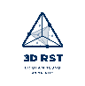

3D-RST is supported by the NSF under grant number #DRL-2101383

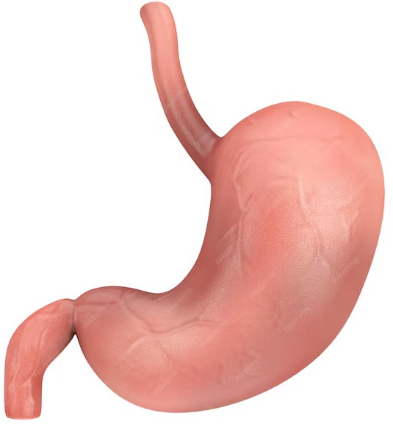

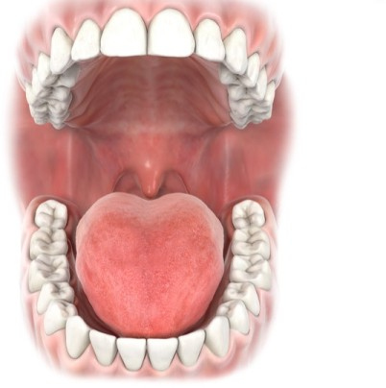

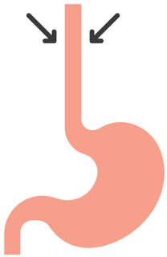

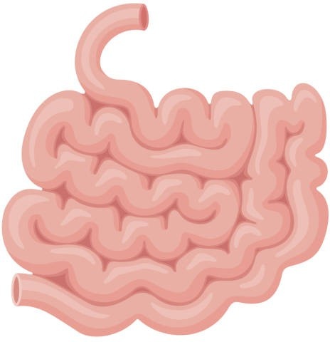

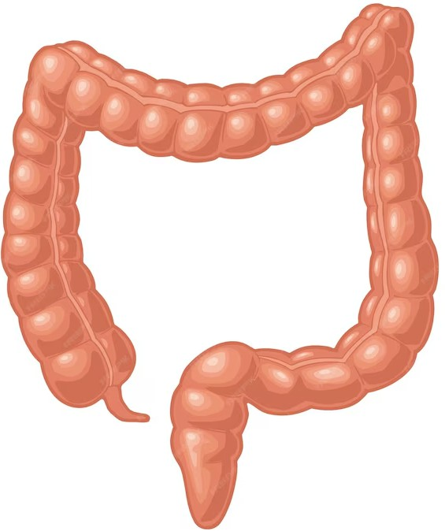

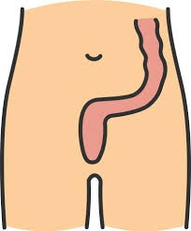

A.
The chyme enters this organ, which is a 7-meter-long tube. This organ has villi and microvilli, which create a very large surface area for digestion. In fact, 90% of all nutrient absorption occurs here. Once the food molecules are broken down even further by various chemicals, they move into the bloodstream. The molecules that came from the cracker are absorbed as energy.

B
This organ (also called the colon) is a 1.5-meter-long tube. Its main function is to absorb water and any remaining nutrients from the food before sending the undigested food to the rectum. The body absorbs the last remaining energy-rich molecules.

C.
The large intestine ends with this organ. The excess waste is tightly packed and stored. When full, a muscle called the anal sphincter loosens and the waste (feces) passes out of the body through the anus. Any cracker molecules that were unusable by the body are now expelled from the body’s systems.

D.
This organ is a 20 cm long tube that connects your mouth to your stomach. When you swallow food, a small flap called the epiglottis closes, preventing food from entering your trachea (windpipe) and lungs. It has muscles that move in a wave and push the food down into the stomach. The liquified and partially digested cracker pieces are moved along in the digestive system.

E.
This is a J-shaped sac that stores and helps further break down food. It will physically churn the food, which helps break it into smaller pieces. It also releases acids and enzymes that break down food into a partially digested mixture called chyme. Acids finish breaking the molecules down and rearrange into nutrients, ATP energy, and waste.

F.
Your teeth help grind up food into smaller pieces. Saliva contains an enzyme called amylase, which breaks down starches into sugar. Your tongue is a muscle that pushes food into your throat, where it travels to the esophagus. In this step of its journey, the cracker becomes more liquid and begins to taste sweet.
GROWTH
Living things grow, and to grow, organisms must get energy and matter. Plants make their own food using the sun’s energy, as well as build their bodies from the sugar/glucose they produce during photosynthesis.
Consumers are organisms that must eat to obtain energy and mass. Animals are consumers. The food consumers eat is used both as energy for the body to move and function, as well as to grow and build their bodies.

DIGESTIVE SYSTEM
When you eat, the molecules in your food are not in a form that your body can use. They are too big to be absorbed by the blood. The main purpose of the digestive system is to break down food into simple molecules so that the body can absorb them.
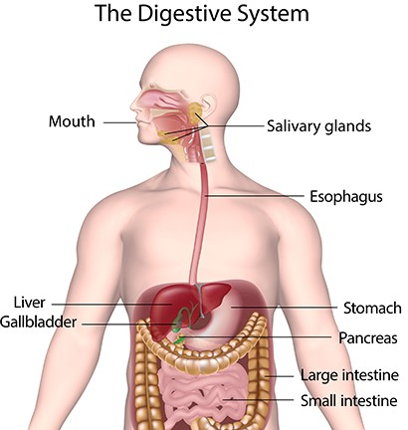

For this process to occur, food enters through the mouth, is stored in the stomach, and then moves on to the small intestine.
These three organs, the mouth, stomach, and small intestine, break down the food both by physically smashing it and, through chemical reactions, breaking down the molecules.
The small intestine also absorbs the nutrients from the food, and it is absorbed into the bloodstream. The food then travels into the large intestine, where it takes out water, which is then absorbed into the bloodstream.

