Mouth

Your teeth help grind up food into smaller pieces. Saliva contains an enzyme called amylase, which breaks down starches into sugar. Your tongue is a muscle that pushes food into your throat, where it travels to the esophagus. In this step of its journey, the cracker becomes more liquid and begins to taste sweet.

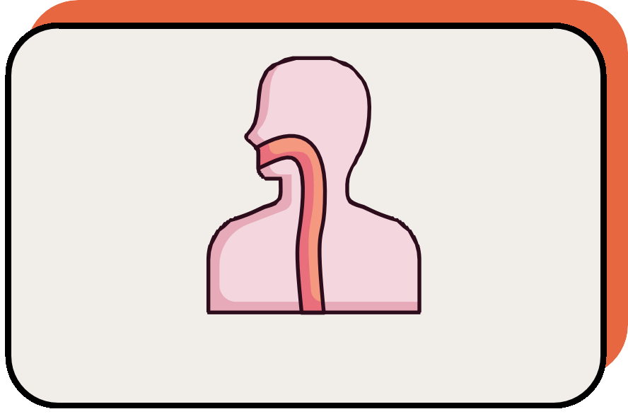
This organ is a 20 cm long tube that connects your mouth to your stomach. When you swallow food, a small flap called the epiglottis closes, preventing food from entering your trachea (windpipe) and lungs. It has muscles that move in a wave and push the food down into the stomach. The liquified and partially digested cracker pieces are moved along in the digestive system.

Esophagus

Stomach

This is a J-shaped sac that stores and helps further break down food. It will physically churn the food, which helps break it into smaller pieces. It also releases acids and enzymes that break down food into a partially digested mixture called chyme. Acids finish breaking the molecules down and rearrange into nutrients, ATP energy, and waste.

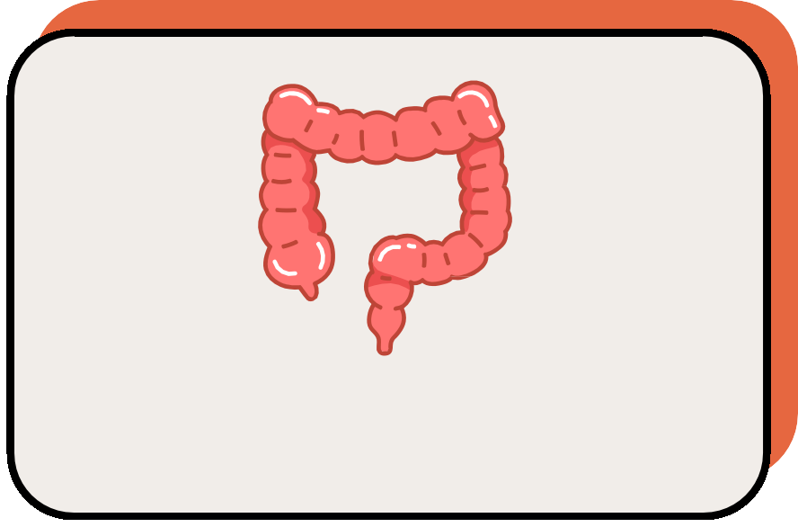
This organ (also called the colon) is a 1.5-meter-long tube. Its main function is to absorb water and any remaining nutrients from the food before sending the undigested food to the rectum. The body absorbs the last remaining energy-rich molecules.

Large Intestine

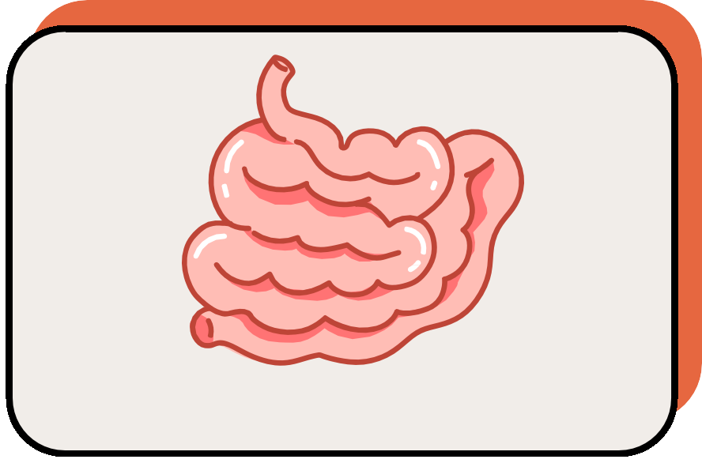

Small Intestine

The chyme enters this organ, which is a 7-meter-long tube. This organ has villi and microvilli, which create a very large surface area for digestion. In fact, 90% of all nutrient absorption occurs here. Once the food molecules are broken down even further by various chemicals, they move into the bloodstream. The molecules that came from the cracker are absorbed as energy.

Rectum
The large intestine ends with this organ. The excess waste is tightly packed and stored. When full, a muscle called the anal sphincter loosens and the waste (feces) passes out of the body through the anus. Any cracker molecules that were unusable by the body are now expelled from the body’s systems.

