Name: Period

8.3.2 The Journey of Energy through the Digestive System

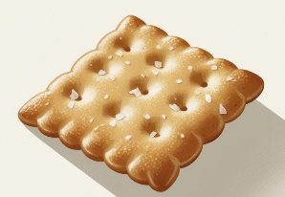 After the Bite
How is the energy from food changed through a chemical reaction so the body can use it?

Questions for discussion before eating the cracker:
- What is the first step to eating food?

Procedure:
- Take one Saltine each and begin to chew it.
- Try to chew it for as long as you can. Pay attention to the taste.
- Don’t swallow the cracker until you are instructed to do so.

Questions to consider while chewing the cracker:

- What type of energy are you using while chewing this cracker?

- Does the taste of the cracker change at all as you are eating it?

- What do you think is happening inside your mouth to make it so that the cracker flavor changes?

- An average American eats 2,000 pounds of food every year. Consider this: why don’t you gain 2,000 pounds every year?

GROWTH  Living things grow, and to grow, organisms must get energy and matter. Plants make their own food using the sun’s energy, as well as build their bodies from the sugar/glucose they produce during photosynthesis.  Consumers are organisms that must eat to obtain energy and mass. Animals are consumers. The food consumers eat is used both as energy for the body to move and function, as well as to grow and build their bodies. | How do consumers get their energy?  __________________________________________  How do consumers get the matter they need to grow?  __________________________________________  What are the two ways your body uses the food you eat?  1,  2.
DIGESTIVE SYSTEM  When you eat, the molecules in your food are not in a form that your body can use. They are too big to be absorbed by the blood. The main purpose of the digestive system is to break down food into simple molecules so that the body can absorb them.  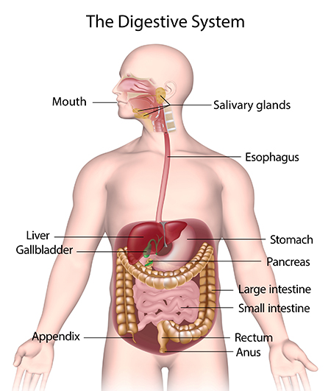  For this process to occur, food enters through the mouth, is stored in the stomach, and then moves on to the small intestine.  These three organs, the mouth, stomach, and small intestine, break down the food both by physically smashing it and, through chemical reactions, breaking down the molecules.  The small intestine also absorbs the nutrients from the food, and it is absorbed into the bloodstream. The food then travels into the large intestine, where it takes out water, which is then absorbed into the bloodstream. | What is the main purpose of the digestive system?  Why does your body need to break down the food you eat?  Where does food enter the body?  Which organs help break down food? (There are 3)  1.  2.  3.  Which organ stores the food for a short time?  Which organ absorbs the particles of food into the bloodstream?

The basic function of your digestive system is to break down food into smaller pieces so that your body can absorb the nutrients. The matching activity below will help us know the journey food takes from when it enters your mouth to when it exits your body.

Match the following digestive system organs with their definitions.

- Mouth | A. The chyme enters this organ, which is a 7-meter-long tube. This organ has villi and microvilli, which create a very large surface area for digestion. In fact, 90% of all nutrient absorption occurs here. Once the food molecules are broken down even further by various chemicals, they move into the bloodstream. The molecules that came from the cracker are absorbed as energy.
- Stomach | B. This organ (also called the colon) is a 1.5-meter-long tube. Its main function is to absorb water and any remaining nutrients from the food before sending the undigested food to the rectum. The body absorbs the last remaining energy-rich molecules.
- Small Intestine | C. The large intestine ends with this organ. The excess waste is tightly packed and stored. When full, a muscle called the anal sphincter loosens and the waste (feces) passes out of the body through the anus. Any cracker molecules that were unusable by the body are now expelled from the body’s systems.
- Esophagus | D. This organ is a 20 cm long tube that connects your mouth to your stomach. When you swallow food, a small flap called the epiglottis closes, preventing food from entering your trachea (windpipe) and lungs. It has muscles that move in a wave and push the food down into the stomach. The liquified and partially digested cracker pieces are moved along in the digestive system.
- Large Intestine | E. This is a J-shaped sac that stores and helps further break down food. It will physically churn the food, which helps break it into smaller pieces. It also releases acids and enzymes that break down food into a partially digested mixture called chyme. Acids finish breaking the molecules down and rearrange into nutrients, ATP energy, and waste.
- Rectum | F. Your teeth help grind up food into smaller pieces. Saliva contains an enzyme called amylase, which breaks down starches into sugar. Your tongue is a muscle that pushes food into your throat, where it travels to the esophagus. In this step of its journey, the cracker becomes more liquid and begins to taste sweet.

Name: Period

8.3.2 The Journey of Energy through the Digestive System

Create a Comic Strip
You will be doing the following:
Develop a comic strip model to illustrate how food undergoes chemical reactions to form new molecules that support growth and release energy as matter cycles through an organism, demonstrating how energy flows through the digestive system. Emphasize that during cellular respiration, molecules are broken apart and rearranged into new molecules, which releases energy. Use the sentence stems on the next slide to aid in creating your comic strip.

  - Use the information from the worksheets on Digestion.
  - Your comic should illustrate the path food (energy) takes as it goes through the human digestive system. Each panel should represent one step of the process and should include a caption that tells the reader what step you are on. (For example, your first caption could be “Mouth,” or any fun comic-style title of your choice that fits the description. If your comic panel has more than six panels, the other panels can be used to add to your story.)
  - Your comic must contain illustrated scenes and dialogue, within comic bubbles, that match your storyline.
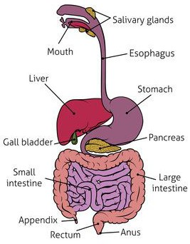
  - Your illustrated scenes should be labeled where appropriate. Proper spelling and grammar should be used, and all wording should be legible (easy to read).
  - Your comic should be creative, neat, colorful, and scientifically appropriate.
  - You will illustrate what happens to your favorite food (energy) as it passes through the various steps of the digestive system. Remember that the format is a comic, so it can be silly, but it also should be informative. Have Fun!

Scoring Rubric
Category | Points Possible | Points Earned
Content  □ The comic accurately explains how food is broken down and absorbed during the process of digestion. Use 5 of the vocabulary words from slide 3 and underline them. | 10
Illustrated Scenes  □ Each comic panel has colored, somewhat detailed illustrations that match the scene. | 10
Scientific names and appropriate pictures  □ Pictures included must be scientific and appropriate. | 5
Dialogue  □ The story includes dialogue, within comic bubbles, that is well matched to the storyline. | 10
Spelling & Grammar  □ No spelling, punctuation, or grammar errors are present. | 5
Clarity & Neatness  □ The comic is legible and easy to understand. Labels are included where appropriate. | 10
Creativity  □ The comic is not purely informational. The story is told in a comic-style format, combining words and illustrations to create a fun and informative narrative. | 10
Score Total: (Out of 60 Points Possible)
Letter Grade:
Name: Period

