Air Mass Movement Shapes Our Weather
Weather is influenced by many factors, and one of the most important is the concept of air pressure. Air pressure is the weight of the air above us, and it can be classified as either high or low. These pressure systems play a crucial role in determining our weather patterns, especially when it comes to weather fronts.
What is High Pressure?
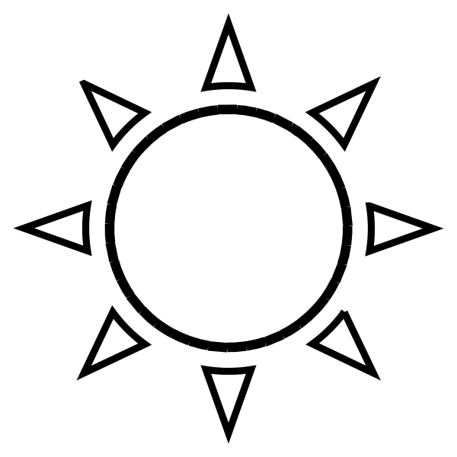
High-pressure systems occur when the air is cooler and denser. In these areas, the air is pushing down toward the Earth's surface. High pressure usually brings clear skies and calm weather. When there is a high-pressure system in place, it means that the weather is generally stable. This is why you often find sunny days in regions experiencing high pressure.
What is Low Pressure?

On the other hand, low-pressure systems occur when the air is warmer and less dense. In these areas, air is rising, which creates a vacuum that pulls in surrounding air. Low pressure is often associated with stormy weather and precipitation. This is because when air rises, it cools and condenses, forming clouds and eventually leading to rain or snow.
Weather Fronts
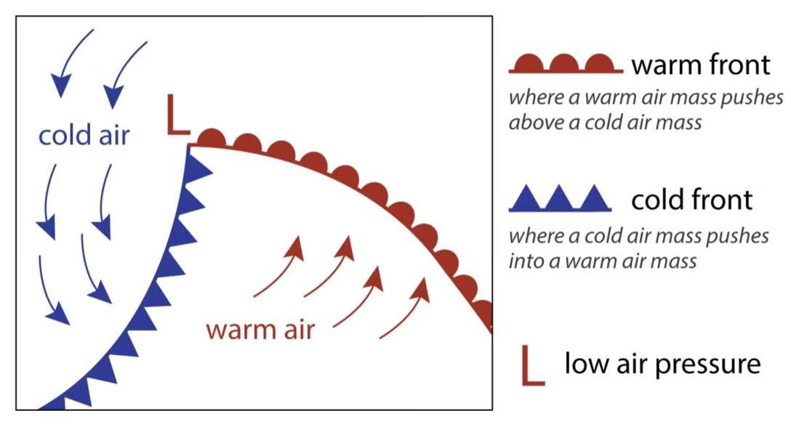
A weather front is a boundary between two different air masses, usually one cold and one warm. When a low-pressure system moves in, it causes the warm, moist air to rise over the cold air. This rising air cools and can create clouds and storms.

How High and Low Pressure causes weather conditions.
High and low pressure systems play a crucial role in the movement and behavior of weather fronts. High pressure systems often push against low pressure systems, creating the conditions for weather. For instance, when a high-pressure area meets a low-pressure area, it can result in significant weather changes, such as storms or clear skies.
Understanding these concepts helps meteorologists predict the weather. By observing the movement of high and low pressure systems, they can forecast whether we will have sunny days or rainstorms.
In conclusion, high and low pressure systems are essential components of our weather. They influence weather fronts, which in turn affect our daily lives. By learning about these systems, we can better understand the weather patterns that shape our environment.
