States of Matter Matters: The Impact of Heat Energy on States of Matter and Density
Objective: Develop a model to predict the effect of heat energy on states of matter and density.
Have you ever noticed how ice melts into water and then evaporates into steam? This transformation is a perfect example of how heat energy affects the states of matter and their density. Understanding these changes is important in science, and we can even create a model to predict what will happen when heat energy is added or removed.
Matter exists in three main states: solid, liquid, and gas. Each state has different properties and densities.
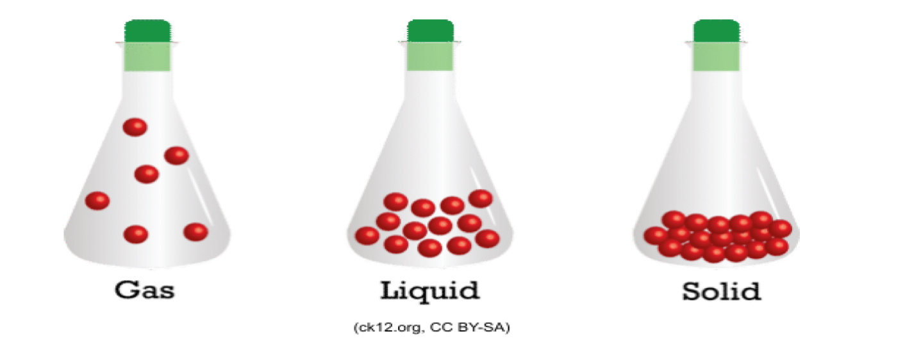

Solids, like ice, have a fixed shape and volume while the particles vibrate in place. The particles in a solid are tightly packed together, which makes the matter denser. When heat energy is added to a solid, it causes the particles to gain energy and start to move more freely. This process is called melting, and it changes the solid into a liquid. Liquids have no definite shape and take the shape of a container, have definite volume, and particles are free to move over each other while being attracted to each other. For instance, when butter melts, it becomes liquid, which is less dense than a cube of butter, allowing it to float.

Next, when more heat energy is added to the liquid, the particles move even faster. Eventually, the liquid reaches its boiling point and transforms into a gas in a process known as evaporation. Gasses have no shape or volume and take the shape of their container, and particles move randomly with little to no attraction to each other. In this state, the particles are spread out and move quickly, resulting in a gas that is much less dense than the liquid. For example, steam is the gaseous state of water, which takes up more space than the same amount of water in liquid form.


Now, let's think about what happens when heat energy is removed. When a gas cools down, it causes the particles to lose energy and begin to slow down. This process can cause the gas to condense back into a liquid. For instance, when steam cools, it turns back into water. Removing even more heat energy from the liquid causes it to freeze into a solid.
To visualize this process, we can create a simple model. Imagine a container filled with ice cubes, water, and steam. When we apply heat to the container, we can observe the changes in the states of matter. First, the ice cubes will melt into water. If we continue to apply heat, the water will begin to boil and produce steam. Conversely, if we remove heat, we can see the steam condense back into water and freeze into ice. This model shows how heat energy influences the state of matter and density.
In conclusion, heat energy is crucial in determining the state of matter and its density. By adding or removing heat, we can predict whether a substance will be a solid, liquid, or gas. Creating models to demonstrate these changes helps us understand the fascinating relationships between heat energy, states of matter, and density, which are fundamental concepts in science.

