Name: Period:

Does Mass Matter? Mass vs. Kinetic Energy
Standard 8.2.1
Use computational thinking to analyze data about the relationship between the mass and speed of objects to the relative amount of kinetic energy of the objects

DCI: Energy & Matter | SEP: Analyze & Interpret Data | CCC: Cause & Effect

Important Prior Knowledge
Mass: | The amount of matter in an object
Kinetic Energy: | The energy an object (mass) has because it is in motion (speed)

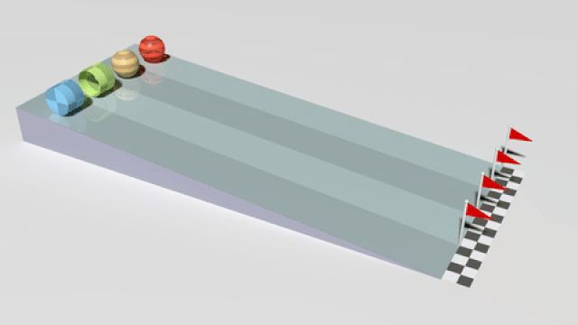
3 Observations:
3 Questions:
As you watch the video, please pay close attention to how the mass effects the race and the vehicle. What do you notice?

Which carts move the farthest? Do lighter or heavier carts go farther? (Hint: what does the number of people in the cart have to do with distance?)

How might weight play a factor in who wins the race?

Research Question | How does the amount of mass affect the amount of kinetic energy observed?
Hypothesis
Experiment
Independent Variable | Amount of mass of the different spheres
Dependent Variable | The amount of kinetic energy in the sphere is measured by how much the energy moved the container at the end of the ramp.
Control | The container’s movement with 0 grams hitting it (where the container is sitting)
Materials Needed | Container, measuring tape (centimeters) or meter sticks, spheres of different masses, ramp

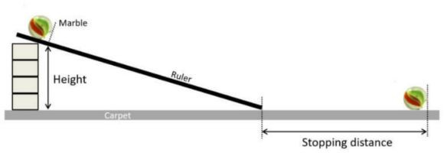
- Set up the ramp using a chair to ensure that you have the same angle each time.
- Place the container at the bottom of the ramp. Place the measuring tape or meter stick at the end of the ramp to mark “0” distance.
- Take one sphere and place it at the top of the ramp and let go.
- Measure from the back edge of the container (end of the ramp) to how far it moved from its original control position in centimeters. Record this in your data table. Test 3 times.
- Repeat steps 2-5 with the other masses of the spheres. Repeat each test 3 times.
- Calculate the average distance that each mass of the spheres traveled. (Remember the farther the container traveled the more kinetic energy it had)
Procedure/ Steps
STOP!!! You cannot fill out the remaining sections until you have run the experiment!

Mass of the sphere | 2g  Styrofoam | 7g Wood | 11g Acrylic (CLEAR) | 20g Glass Marble | 67g Steel
1st Trial
2nd Trial
3rd Trial
The average distance the container traveled.
**THIS IS THE NUMBER YOU WILL GRAPH!!**
(Add all 3 and divide by 3. Round to the nearest whole number)
Analysis: On a scale of 1-5, identify which sphere had the most kinetic energy (5) and which had the least kinetic energy (1)

Line Graph
Instructions:
❏ Create a title for the whole graph that describes the experiment (turn your research question into a title)
❏ Number the y-axis
❏ Label the y-axis with a title (what did you measure?)
❏ Label the units (i.e., grams, cm, mL)
❏ Check for ACCURACY
❏ Draw a line connecting the dots

Title:

Styrofoam Wood Acrylic Glass Steel

Mass:

1. What pattern do you notice if you draw a line to connect the data points?
2. Circle the graph that best represents the graph you created.  Based on this evidence, what is the mathematical relationship between kinetic energy and mass? | 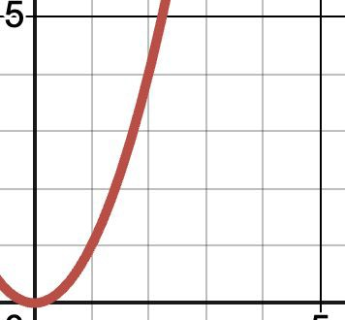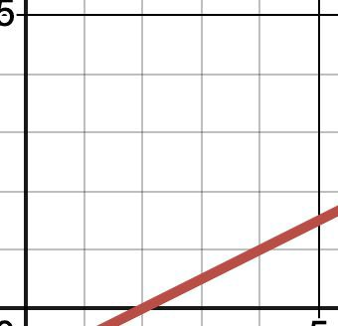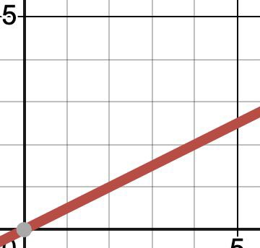  Exponential Linear, not Proportional Proportional
Analysis
In one sentence, explain what the data shows.
What kind of mathematical relationship do you see in the graph & data?

Conclusion Paragraph CER
- Claim: Restate your hypothesis
- Claim: Answer the question: How does mass affect the amount of kinetic energy in a moving object?
- Quantitative Evidence: Give numbers from your experiment data to support your claim.
- Reasoning: Explain the scientific reason behind the results that you got. Talk about kinetic energy and mass and how they are mathematically related (refer to questions 1 and 2 in your analysis for help).
- The paragraph must be at least five sentences.

Circle Back to Phenomenon.
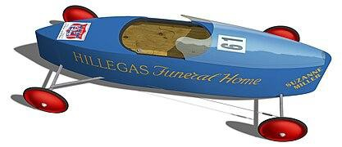
Suzanne Miller of Akron, OH, won the 1976 Junior Rally Championship with the above-pictured racer. Based on the results of your investigation, what did Suzanne’s racer most likely have that helped it to go faster and farther than the other racers?
EXTENSION QUESTION:
Knowing how mass affects kinetic energy and recognizing the equation for kinetic energy is K.E. = 0.5m • v², if we were to double the speed of the racer, how would the kinetic energy of the racer increase?

