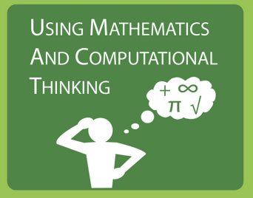
4 | - The student can accurately apply appropriate mathematical concepts and methods or ratios and proportionality to represent and solve scientific questions or engineering problems and explains whether the answer “makes sense”.  - The student can identify and describe the components in a given representation.  - The student can use a computational simulation.
3 | - The student can apply appropriate mathematical concepts and methods (e.g., ratio, rate, percent, basic operations, algebra, and functions) to answer scientific questions or engineering problems.
2 | - The student can apply appropriate mathematical concepts (e.g., ratio, rate, percent, basic operations, algebra, and functions) relevant to scientific questions or engineering problems, but applies them with minor errors or omissions.
1 | - The student can identify mathematical concepts or methods (e.g., ratio, rate, percent, basic operations, algebra, and functions) relevant to scientific questions or engineering problems, but applies them with major errors or omissions.

