Name______________________________________ Per_____
Managing the Waste
Lesson objective: Students will design a solution to address the cause and effect of waste on the environment while considering environmental, economic, geographical, legal, ethical, and aesthetic constraints.
Phenomenon driving questions:
- What is the cause and effect of human garbage disposal on the environment?
- What are potential solutions for negative environmental impacts from human-produced garbage?
- What are the potential limitations of addressing the issue of human-produced garbage?

Personal Garbage Meter: Reflect honestly on the amount of garbage you go through in one day. Circle the size of garbage can you think you would need to contain your garbage from one day.
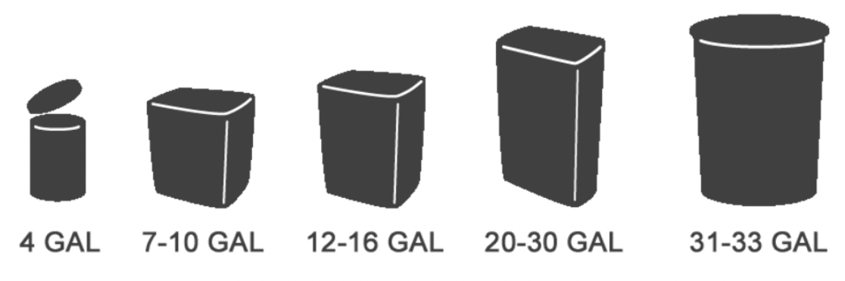
SEE  What do you observe is happening? | THINK  What do you think about what is happening?
FEEL  What are your feelings about what is happening? | WONDER  What do you wonder about what is happening (possible solutions)?

The Problem (effect):
Individual:_____________________________________________________________________________________________________________________________________

Group:________________________________________________________________________________________________________________________________________

Class:_________________________________________________________________________________________________________________________________________
Understanding Constraints:  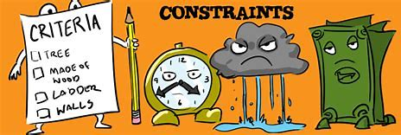 | Definition of a constraint: A limitation or restriction  EXAMPLES: “Time constraints make it impossible to do everything.” “The availability of water is the main constraint on food production.”
Case Study Analysis:
Discuss the teacher’s example solution: Humans can just send all our garbage into space. Discuss as a small group and fill in the boxes of your assigned constraints, then discuss with the class to fill in the remaining boxes.
Constraint | Define the area of constraint. | Provide at least one example of a constraint for each area using the teacher’s solution.
Environmental
Aesthetic
Economic
Ethical
Geographical
Legal

Design a Solution:
- Task: In your assigned group, you will brainstorm and sketch a waste management solution that addresses the cause and effect of waste on the environment.
- Considerations: Your group must consider environmental constraints and constraints from at least one additional area above.
- Questions to Address: Refer to your solution design worksheet.
- Refer to the rubric criteria as you design your solution

