What Factors Affect a Wireless Phone Charger?
Use this model to draw or explain how you think a wireless charging pad works. Use the space to begin thinking about how it works, even if you do not know yet. 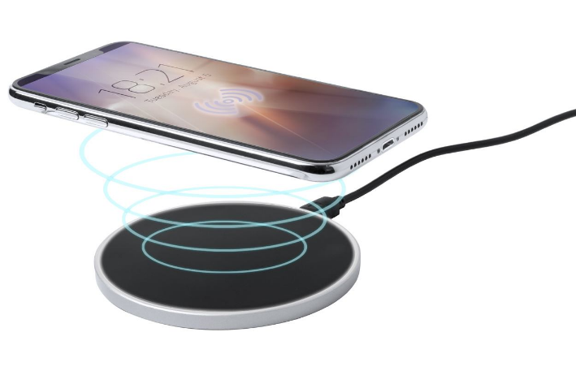

Station 1: Electric Motor
- What component(s) cause the motor to move?

- Which coil appeared to spin the fastest and why?

Station 2: Aluminum Can
- What factor(s) caused the aluminum can to move? What actions did you take to cause the aluminum can to move?

- What force do you think is moving the aluminum can?

Station 3: Iron Shavings
- Draw a model that compares and contrasts the pattern formed by the iron shavings as they interact with different magnets.
Magnet A Pattern | Magnet B Pattern

- What causes the differences in the shape and size of these patterns?

Station 4: Bumper Cars
 | Predicted Distance (cm) | Actual Distance (cm)
Attract
Repel

- What effect did turning Magnet B around have on Magnet A?

Assessment
- Label the diagrams with the following labels 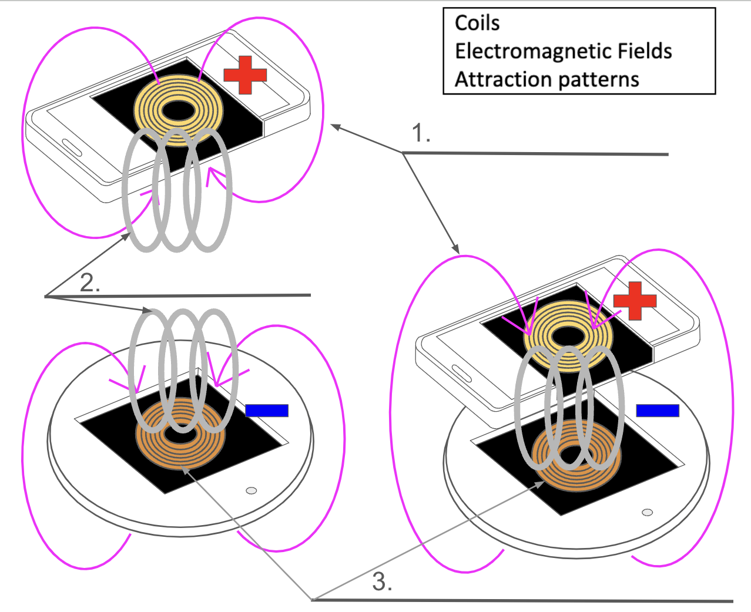

- Give one example of something that would cause the charger not to charge the phone. Support your claim with evidence from today’s observations.

