Station 3: Iron Shavings

The paper plate should have a thin layer of iron shavings spread evenly on the plate.

Take the plate and hold it over one of the magnets.

Draw what you see on your worksheet.
Now, hold the plate over the other magnet.

Draw what you see on your worksheet.

Discuss with your group: What do the iron shavings allow you to see?

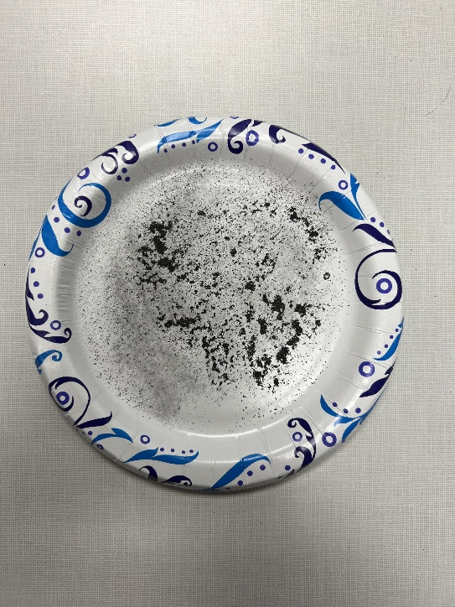
Station 4: Bumper Cars

On your worksheet, make a prediction of what distance you think the magnets will repel/attract each other.

- Place one magnet at the end of the ruler. That magnet will be called magnet A. Make sure the ruler won’t be in the way of the magnet’s motion.

- With the other magnet (magnet B), start at the opposite end of the ruler and slowly move it closer to magnet A.

- Record on your worksheet the distance in (cm) at which magnet A begins to move.

Now return magnet A to the end of the ruler and magnet B to the other end, but turn magnet B around.

Repeat steps 1-3.

Discuss with your group: If both magnets were stronger, how would that affect the distance of attraction/repulsion?

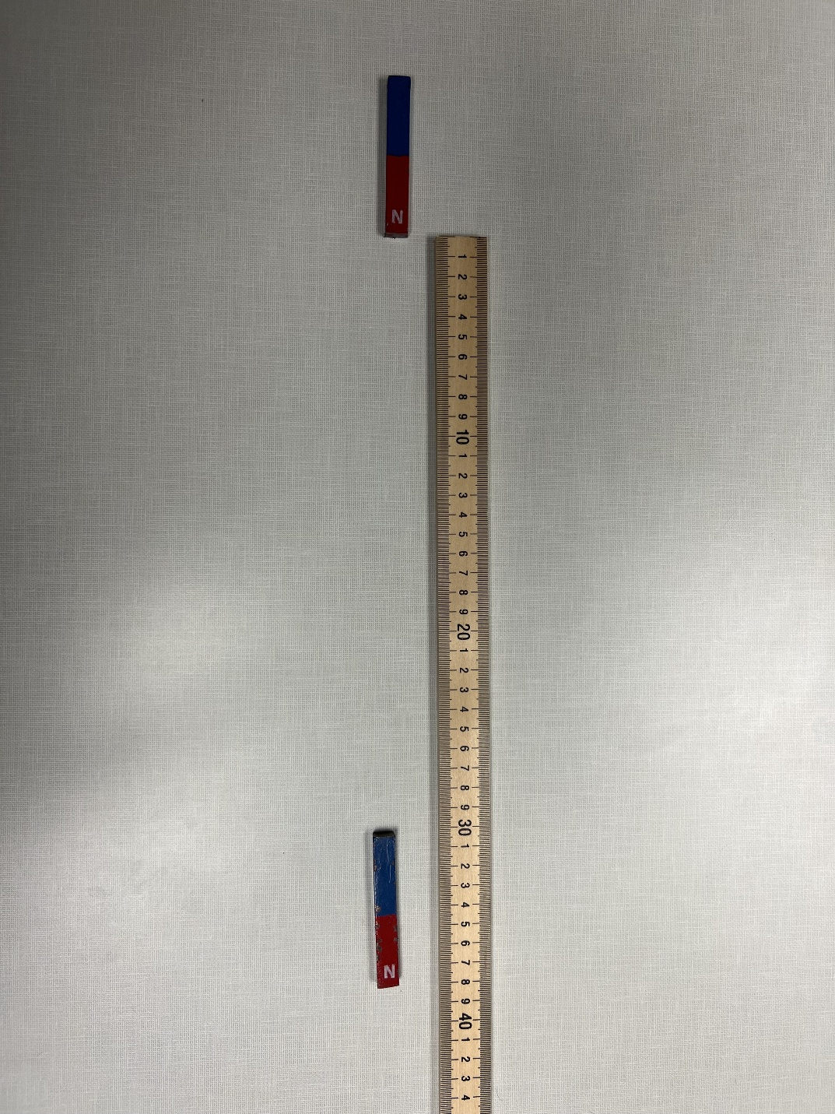

Station 2: Pop Can Magic

Place the empty pop can in the middle of the table. The can should be lying on its side.

Rub the PVC pipe with the cloth for 10 seconds.

Move the pipe around the can and see if you can get the can to move without touching the can itself. Be sure to hold the pipe parallel to the can.

Discuss with your group: What force or forces is/are moving the can?
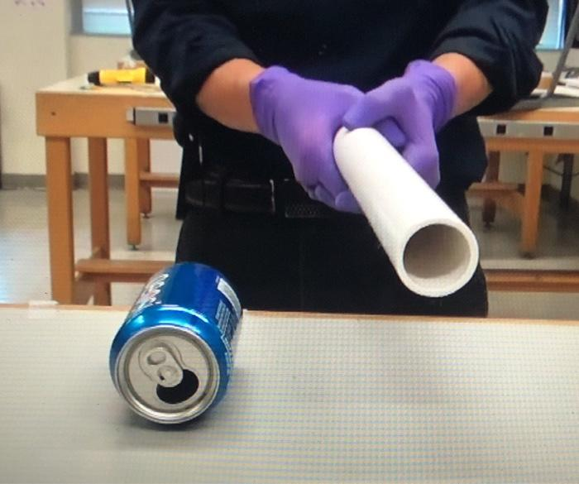

Station 1: Electric Motor

Start with coil A and place it in the motor.

Observe the speed at which the coil spins.

Remove coil A and repeat the process with coils B and C.

Discuss with your group: How does adding more coils affect the system?

(After you have tried adjusting the coil, but it still won’t spin, try replacing the battery.)
