Name: ____________________
Fusion is the BOMB!
Introduction: Experiencing the Phenomenon:
- After you watch the video and make observations, record three scientific observations and questions relating to the energy released during the explosion.
Observations: | Questions:
- As a group, determine the most important question in figuring out what is happening at the nuclear level during the hydrogen bomb. Record this guiding question below:
- Use the space below to construct an explanation using a drawing model of what is happening at the nuclear level during a hydrogen bomb explosion.
  - Include what might contribute to the explosion.
  - Label your drawing with as much detail as you can. You will have a chance to add to or change your explanation later.
- Brainstorm: What do you still need to know to complete your explanation?
Activity #1: Explaining Fusion
The Correlation between Nuclear Binding Energy and Atomic Mass

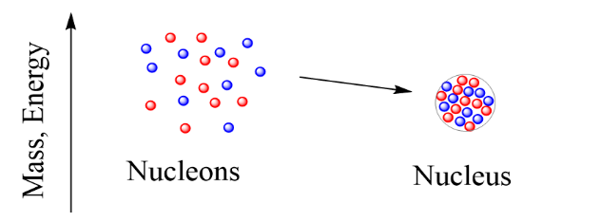
Background: The energy change when a nucleus is formed or broken is known as nuclear binding energy. Nucleus refers to the “bound” protons and neutrons, while nucleons refer to the individual protons and neutrons when they are not “bound together.”
- Use the information below to create a LINE graph of the relationship between the nuclear binding energy and mass.
(Important Note: Nucleons refer to the individual subatomic particles in the nucleus, including protons and neutrons. MeV, mega electron volt, is the unit of measurement used to describe the change in binding energy.)
Nucleon | Mass | Nuclear Binding energy (MeV)
Hydrogen –1 | 1 | 0
Hydrogen-3 | 3 | 2.8
Helium – 4 | 4 | 7.0
Carbon – 12 | 12 | 7.6
Nitrogen –15 | 15 | 7.7
Sulfur –36 | 36 | 8.5
Iron – 56 | 56 | 8.8

In nuclear reactions, the reaction tends to occur in the direction of stability, and that releases energy. The most stable nuclei are nearest the stability peak.

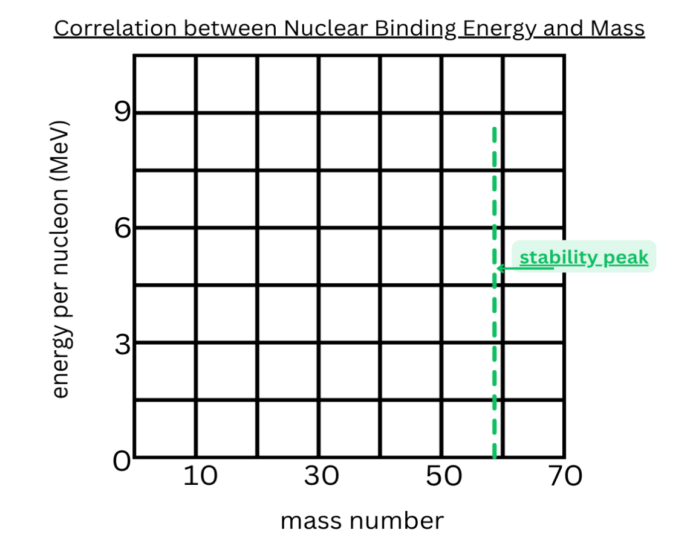
Analyze the information and graph on the previous page you made to answer the following questions:
Nucleons are “unbound” protons and neutrons. Some nucleons are less stable than others. Nucleons will react in the direction of stability.  - How does an increase in mass affect stability and nuclear binding energy, based on comparing the binding energy of Hydrogen-1 and Hydrogen-3 to Helium-4? | Effect on stability:  Effect on nuclear binding energy:
- How might the nuclear binding energy be affected if two lighter nucleons in this system combined to form a heavier nucleon?
- Describe on the right how you can use isotopes in your drawing to explain how nuclear binding energy and mass contribute to your understanding of a hydrogen bomb. Add it to your initial model in #3 in RED color pencil. | LIST:  I added this information to my model in RED: YES or NO  (circle one)

Activity #2: Exploring fusion
Instructions:
- Individually read the article, Understanding Fusion: The Role of Mass Defect and Nuclear Forces
- Answer the questions below from the reading about how fusion relates to your model:
- Explain the role mass defect has in a hydrogen bomb.

- Describe how the nuclear binding energy relates to the flow of energy in a fusion reaction.

- What evidence is there that energy is being conserved in fusion?

- Describe on the right how you can use arrows in your drawing to explain how energy changes contribute to your understanding of a hydrogen bomb. Add it to your initial model in #3 in BLUE color pencil. | LIST:  I added this information to my model in BLUE: YES or NO  (circle one)

Activity #3: Explaining Nuclear Binding Energy
Instructions:
- Follow the link to the Phet simulation (https://tinyurl.com/stablenucleus)
- Click on CHART INTRO
Task A:
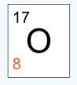
Use the arrows at the bottom of the simulation to create a nucleus of Oxygen-17. Look at the box in the top right. It should look like this:
- Notice the energy line on the left. As you added nucleons to make Oxygen-17, what happened to the energy of the particles in the nucleus?
- What happens to the nucleons in a row when more are added to the next energy level?
Task B:
Build a different nucleus Hydrogen-3.
Hint: Use the start-over button on the bottom right-hand corner.
- Draw the box from the upper right corner with the symbol, the mass, and the proton number. | 
- What effect does the relationship of protons and neutrons have on the energy of the nucleus?
- How does the arrangement of the nucleons in hydrogen-3 relate to nuclear binding energy?

Claim-Evidence-Reasoning Assessment
Explain how nuclear binding energy relates to the change in energy from a fusion reaction.
EVIDENCE
Evidence from Activity 1: Exploring Mass and Binding Energy (graph)  What evidence explains why nuclear binding energy changes during a change in mass? | Evidence:
Evidence from Activity 2: Exploring Fusion (Article)  What evidence explains how the nuclear binding energy of the reactants (input) compares to the nuclear binding energy of the products (output) in a fusion reaction? | Evidence:
Evidence from Activity 3: Explaining Nuclear Binding Energy (Phet)  What evidence explains how nuclear binding energy changes when the number of neutrons changes? | Evidence:
CLAIM
Based on your evidence, CONSTRUCT an EXPLANATION of how nuclear binding energy relates to the change in net energy from the fusion reaction. | Claim:
REASONING
Explain the connections between your evidence and explanations in a final drawing.

Label the following in your model:
- Reactants / Products (input/output)
- Protons (p⁺) & Neutrons (n⁰)
- Stronger / Weaker nuclear binding energy
- Net Energy Change
  - Use arrows to show the direction of the flow of energy change in the reaction.

