Light Lab Make-up
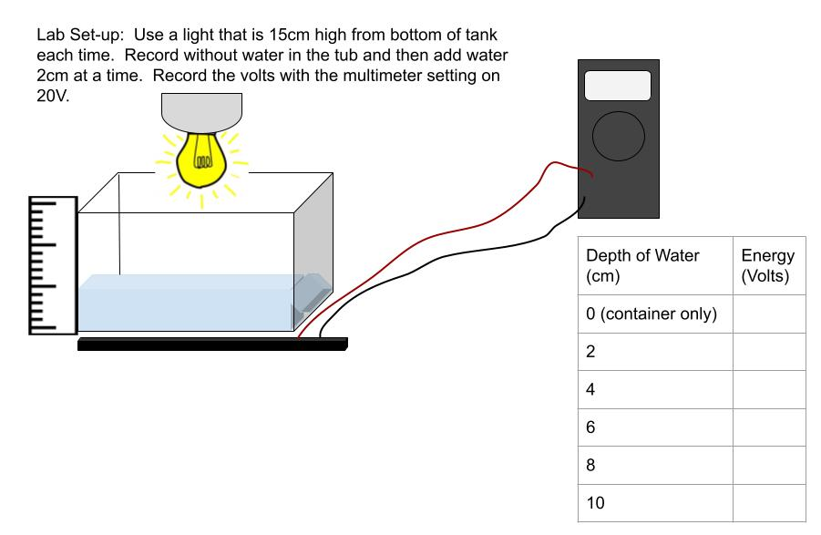
What is the independent variable in this experiment?
What is the dependent variable in this experiment?
What are the controlled variables in this experiment? Must state at least 2

What is the question they are trying to answer?

Graph the data they collected below. Be sure to include a title, x- and y-axis labels, correct scale, and data points.

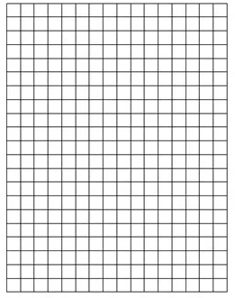

What conclusion can you make based on the data given?

They used a regular lamp to conduct the experiment. What type of electromagnetic radiation were they most likely studying in this investigation? Circle below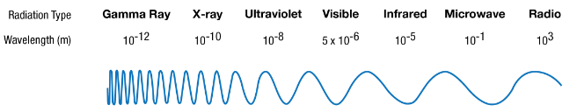

A younger sibling of a friend asks if dangerous radiation is coming from their iPad. How do you respond with what you know about light energy?

What three types of energy from the sun hit your skin every time you go outside into the light?

