Evaluation Questions Name_________________________________

- Identify where the UV, visible and IR wavelengths are located in the electromagnetic (EM) spectrum below. (Circle each and label) *hint: find the wavelengths on your worksheet.
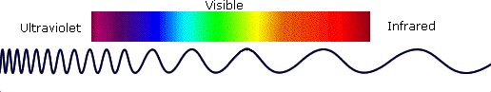

1 500 1000 1500
Wavelength in nanometers (nm)

- Use the following wavelengths, infrared, visible, and microwave, to match the different types of EM radiation emitted from each smartphone aspect below.
Watching a video | Sending or receiving a text message to a friend | Overheating by playing an app too long

- Choose one of the following prompts to complete:
Create a social media post as an expert from the American Cancer Society communicating how light energies, specifically infrared, UV, and visible light from the sun affect matter in your skin.  Below is the image; write the caption. | Create a social media post as an expert from NASA communicating how the lenses in different telescopes filter energies to allow us to observe matter in space.  Below is the image; write the caption.
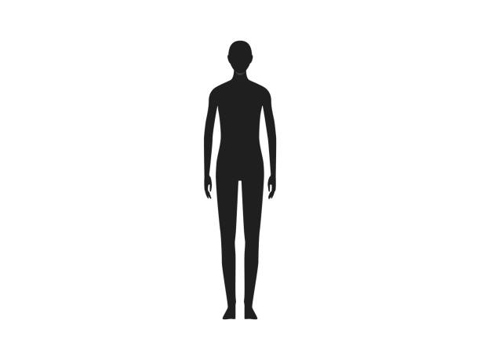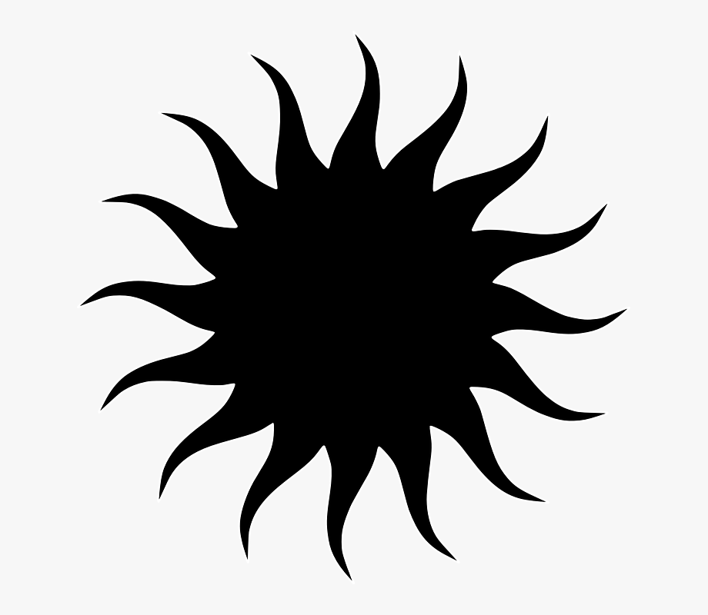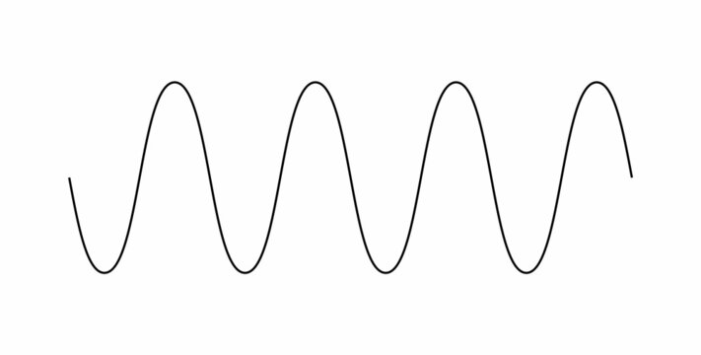  IR  UV  Visible  Direction of radiation | 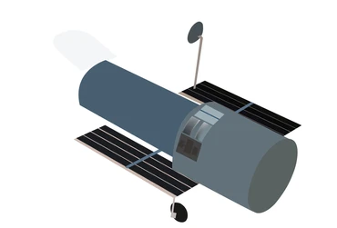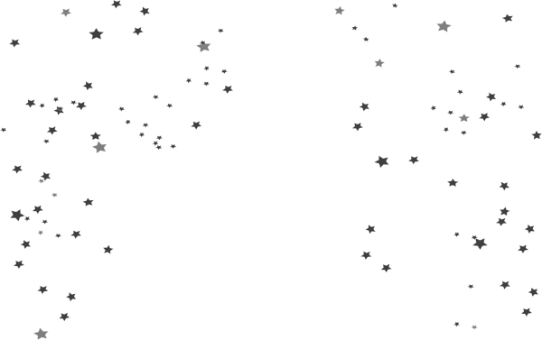  IR  UV  Visible  Direction of radiation
Caption:

Evaluation Questions (Teacher key) Name_________________________________

- Identify where the UV, visible, and IR wavelengths are located in the electromagnetic (EM) spectrum below. (Circle each and label) *hint: find the wavelengths on your worksheet.

1 500 1000 1500
Wavelength in nanometers (nm)

- Use the following wavelengths, infrared, visible and microwave, to match with the different types of EM radiation that is emitted from each aspect of a smartphone below.
Watching a video | Sending or receiving a text message to a friend | Overheating by playing an app too long
Visible | Microwave | Infrared

- Choose one of the following prompts to complete:
Create a social media post as an expert from the American Cancer Society communicating how light energies, specifically infrared, UV, and visible light from the sun affect matter in your skin.  Below is the image; write the caption. | Create a social media post as an expert from NASA communicating how the lenses in different telescopes filter energies to allow us to observe matter in space.  Below is the image; write the caption.
IR  UV  Visible  Direction of radiation | IR  UV  Visible  Direction of radiation
Caption:

