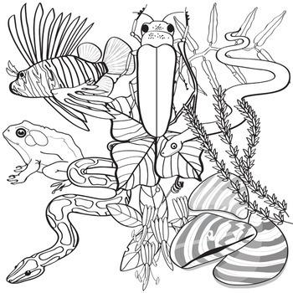
Name: _________________________________________ Period: ________

Evaluating Management Solutions for Invasive Species

- Explain what an invasive species is and how they can affect the process of natural selection.
Word Bank
Competition
Invasive Species
Native

An ________________________ is a non-native (or alien) species to the ecosystem under consideration and a species whose introduction causes or is likely to cause economic harm, environmental harm, or harm to human health.

- An invasive species affects the process of natural selection by causing extinctions of _____________ plants and animals, reducing biodiversity, creating __________________ with native organisms for limited resources, and altering habitats.

Match the following words to the definitions.

Biological Roundup Mechanical Population Chemical Pulling

- Briefly describe each of the three categories of management solutions discussed, and provide an example of each:
  - _______________: This control means physically removing plants from the environment through cutting or pulling.
Example: ______________ or mowing weeds in the backyard.

  - _______________: This control uses herbicides to kill plants and inhibit regrowth.
Example: Using ______________ to spray weeds might slow their growth.

  - _______________: This control method uses plant diseases or insect predators, typically from the targeted species’ home range. Several techniques may be effective in controlling a single species, but there is usually one preferred method—the one that is most resource-efficient with minimal impact on non-target species and the environment.
Example: Using termites to reduce the _______________ of an invasive tree because the termites are a native insect in the area where the invasive trees are growing.

- On your own, read through the Invasive species fact sheet provided to you by your teacher to find the information requested below.

Invasive Species name: _____________________

Explain the cause or reason that your invasive species is affecting the stability of the environment in which they are currently found in Utah by underlining the best possible answer.
The invasive species that I read about is causing _______________native plants to die from lack of water / native plants to grow and spread from getting a lot of water______________ in the state of Utah.
Explain what CHANGES/EFFECTS result from the invasive species in different parts of Utah (and elsewhere).
Native plants are getting _____________all the water and space needed to be healthy and grow / very little water to survive and no place to grow______________ because of invasive species of plants growing in Utah.
Describe proposed solutions:

Some of the solutions that were proposed in the article were Mechanical, Chemical, Biological, or a combination of 2 or more

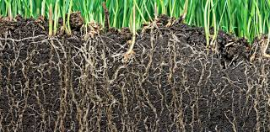

- Using the information from the invasive species fact sheets read in class, complete the following table about the three management types:
Management Solution Type | List and describe the specific techniques used by this type | Criteria  What makes each solution EASY to use or beneficial? | Constraints  What makes each solution hard to use? Limitations
Mechanical
Biological
Chemical

- Using what you know about managing invasive species, evaluate the best method (mechanical, biological, or chemical) or combination of methods to deal with the problem of a specific invasive species. Your response should incorporate examples and evidence from the invasive species fact sheets explored in class. It should be 1-2 solid paragraphs in length.
It must include:
- Name of invasive species
- Identification: What is the best proposed solution(s) to eradicate or control the invasive species?
- Analysis: Why is this solution(s) the best? Which criteria support your decision? Which constraints eliminate the other solutions?
- Explanation: In detail, explain the process behind your thoughts. You are making a claim that is supported by evidence from your research.

Name of Invasive Species: _______________________

The best solution to this problem is: ____________________________________________________________________________________________________________________________________________________________________________________________________________________________________________________________________________________________________________
The reason this is the best solution is because: ____________________________________________________________________________________________________________________________________________________________________________________________________________________________________________________________________________________________________________
Some possible criteria for this solution might be: ____________________________________________________________________________________________________________________________________________________________________________________________________________________________________________________________________________________________________________
Some possible constraints that eliminate other solutions might be: ____________________________________________________________________________________________________________________________________________________________________________________________________________________________________________________________________________________________________________
What evidence do you have that these solutions are the best: ____________________________________________________________________________________________________________________________________________________________________________________________________________________________________________________________________________________________________________

- Using what you know about controlling invasive species, develop a plan to help manage the invasive python problem in the Everglades. Explain whether your solution is mechanical, biological, chemical, or a combination. Your response should incorporate examples and evidence from the case studies explored in class. It should be 1-2 solid paragraphs in length.
_______________________________________________________________________________________________________________________________________________________________________________________________________________________________________________________________________________________________________________________________________________________________________________________________________________________________________________________________________________________________________________________________________________________________________________________________________________________________________________________________________________________________________________________________________________________________________________________________________________________________________________________________________________________

