“Invasive species” –they may not sound very threatening, but these invaders, large and small, have devastating effects on wildlife.
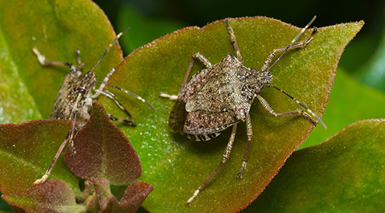
Invasive species are among the leading threats to native wildlife. Approximately 42 percent of threatened or endangered species are at risk due to invasive species.
Human health and economies are also at risk from invasive species. The impacts of invasive species on our natural ecosystems and economy cost billions of dollars each year. Many of our commercial, agricultural, and recreational activities depend on healthy native ecosystems.

What Makes a Species “Invasive”?
An invasive species can be any kind of living organism—an amphibian (like the cane toad), plant, insect, fish, fungus, bacteria, or even an organism’s seeds or eggs—that is not native to an ecosystem and causes harm. They can harm the environment, the economy, or even human health. Species that grow and reproduce quickly, and spread aggressively, with potential to cause harm, are given the label “invasive.”
An invasive species does not have to come from another country. For example, lake trout are native to the Great Lakes, but are considered to be an invasive species in Yellowstone Lake in Wyoming because they compete with native cutthroat trout for habitat.

How Invasive Species Spread
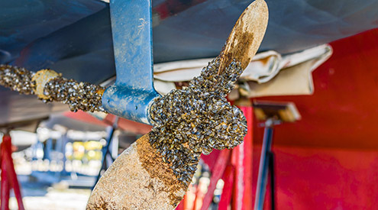Invasive species are primarily spread by human activities, often unintentionally. People, and the goods we use, travel around the world very quickly, and they often carry uninvited species with them. Ships can carry aquatic organisms in their ballast water, while smaller boats may carry them on their propellers. Insects can get into wood, shipping palettes, and crates that are shipped around the world. Some ornamental plants can escape into the wild and become invasive. And some invasive species are intentionally or accidentally released pets. For example, Burmese pythons are becoming a big problem in the Everglades.
In addition, higher average temperatures and changes in rain and snow patterns caused by climate change will enable some invasive plant species—such as garlic mustard, kudzu, and purple loosestrife—to move into new areas. Insect pest infestations will be more severe as pests such as mountain pine beetle are able to take advantage of drought-weakened plants.

Threats to Native Wildlife
Invasive species cause harm to wildlife in many ways. When a new and aggressive species is introduced into an ecosystem, it may not have any natural predators or controls. It can breed and spread quickly, taking over an area. Native wildlife may not have evolved defenses against the invader, or they may not be able to compete with a species that has no predators.
The direct threats of invasive species include preying on native species, outcompeting native species for food or other resources, causing or carrying disease, and preventing native species from reproducing or killing a native species’ young.
There are indirect threats of invasive species as well. Invasive species can change the food web in an ecosystem by destroying or replacing native food sources. The invasive species may provide little to no food value for wildlife. Invasive species can also alter the abundance or diversity of species that are important habitat for native wildlife. Aggressive plant species like kudzu can quickly replace a diverse ecosystem with a monoculture of just kudzu. Additionally, some invasive species are capable of changing the conditions in an ecosystem, such as changing soil chemistry or the intensity of wildfires.

Examples of Invasive Species

INVASIVE CARP

BROWN MARMORATED STINK BUG

ZEBRA MUSSELS

Additional examples:
- Cogongrass is an Asian plant that arrived in the United States as seeds in packing material. It is now spreading through the Southeast, displacing native plants. It provides no food value for native wildlife, and increases the threat of wildfire as it burns hotter and faster than native grasses.
- Feral pigs will eat almost anything, including native birds. They compete with native wildlife for food sources such as acorns. Feral pigs spread diseases, such as brucellosis, to people and livestock. E. coli from their feces was implicated in the E. coli contamination of baby spinach in 2006.
- European green crabs found their way into the San Francisco Bay area in 1989. They outcompete native species for food and habitat and eat huge quantities of native shellfish, threatening commercial fisheries.
- Dutch elm disease (caused by the fungus Ophiostoma ulmi) is transmitted to trees by elm bark beetles. Since 1930, the disease has spread from Ohio through most of the country, killing over half of the elm trees in the northern United States.
- Water hyacinth is a beautiful aquatic plant, introduced to the U.S. from South America as an ornamental. In the wild, it forms dense mats, reducing sunlight for submerged plants and aquatic organisms, crowding out native aquatic plants, and clogging waterways and intake pipes.

Curbing the Spread
One way to curb the spread of invasive species is to plant native plants and remove any invasive plants in your garden. There are many good native plant alternatives to common exotic ornamental plants. In addition, learn to identify invasive species in your area, and report any sightings to your county extension agent or local land manager.
Regularly clean your boots, gear, boat, tires, and any other equipment you use outdoors to remove insects and plant parts that may spread invasive species to new places. When camping, buy firewood near your campsite (within 30 miles) instead of bringing your own from home, and leave any extra for the next campers. Invertebrates and plants can easily hitch a ride on firewood you haul to or from a campsite—you could inadvertently introduce an invasive to a new area.
https://www.nwf.org/Educational-Resources/Wildlife-Guide/Threats-to-Wildlife/Invasive-Species

