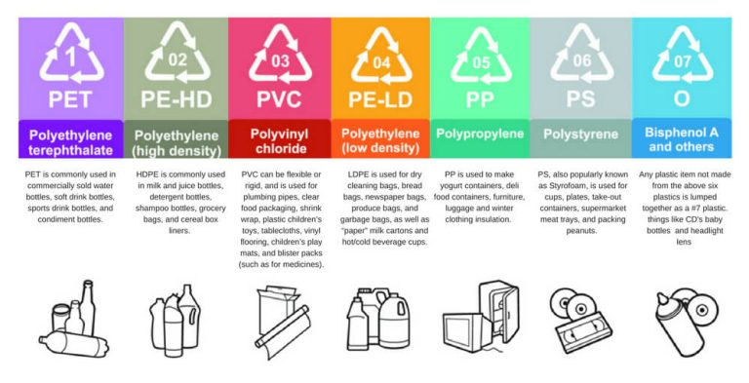Plastic #1: Polyethylene Terephthalate (PET or PETE)
This is the type of plastic most often used for water and soda bottles. It’s also found in some food packaging, like peanut butter jars and cooking oil bottles.
PET plastic is generally considered safe but can leach chemicals into your food if heated too much.

Plastic #2: High-Density Polyethylene (HDPE)
This type of plastic is found in milk jugs, detergent bottles, butter tubs, and some yogurt containers. HDPE plastic is considered safe and is not known to leach chemicals into food.

Plastic #3: Polyvinyl Chloride (PVC)
This type of plastic is often used in food packaging, as well as in pipes and plumbing materials. PVC contains harmful chemicals that can leach into food, so it’s best to avoid using it altogether.

Plastic #4: Low-Density Polyethylene (LDPE)
This type of plastic is found in cling wraps, shopping bags, and food packaging. LDPE is considered safe, but it can release harmful chemicals if it’s heated too much.

Plastic #5: Polypropylene (PP)
This type of plastic is found in some takeout containers, yogurt cups, and microwaveable bowls.
It is generally considered safe and does not leach harmful chemicals into food when used for heating purposes.

Plastic #6: Polystyrene (PS)
This type of plastic is found in Styrofoam, trays, disposable cups, and takeout containers.
Polystyrene is a known carcinogen that can leach toxic chemicals into food, so it’s best to avoid using this type of plastic altogether.

# Plastic Number 7:

Other Plastics or “Mystery” Plastics
There are several other types of plastics that are not assigned a specific number by the FDA. These include plastics labeled with letters like PBA and PC, as well as some bioplastics.
These “mystery” plastics may be safe, but there is not enough information available to say for sure. For this reason, it’s best to avoid using them, if possible.

The Dangers Of Microwaving Food In Unsafe Plastics

There are a few dangers associated with microwaving plastic.
First, plastics can leach harmful chemicals into food when they’re heated. This is especially true of plastics that are not labeled “microwave-safe.”
Second, when heated, plastics can release harmful toxins into the air. These toxins can be breathed in and cause serious health problems.
In some cases, these chemicals can even be carcinogenic, which means that they can increase your risk of developing cancer.
Third, plastics can catch fire if they’re heated to high temperatures.
This is why it’s important to follow the safety guidelines listed above and avoid microwaving plastics that are not labeled “microwave-safe.”
Fourth, unvented plastic containers can explode due to the build-up of pressure. This is why it’s important to make sure that container lids are vented before microwaving them.
In general, it’s best to avoid microwaving plastic altogether. If you must use plastics, choose those labeled “microwave-safe” and follow the safety guidelines listed above.
When it comes to your health and safety, it’s always better to err on the side of caution.
If you’re unsure about what type of plastic an item is made from, it’s always best to play it safe and assume it’s not safe for use in the microwave.
The endocrine-disrupting chemicals released from plastics can also disrupt the body’s natural hormone levels.
This can lead to a variety of problems, such as early puberty, infertility, and thyroid disorders.

