Name ______________________________ Period ___________
Splitting Hairs
Guiding Question: ______________________________________________________________
_____________________________________________________________________________
1. Predict the pattern of light you will see when a laser beam passes around a thin wire or hair.
Laser light without a barrier to go around: | Laser light with a barrier to go around:
$$d=\frac{λL}{∆y}$$
d = width of the object $λ$ = wavelength of light $L$ = distance between the object and the screen
$∆y$= Distance from center of one dark band to the center of the next dark band

2. Data Table: Measure and record the distance between the dark spaces. Complete calculations when directed by the teacher.
Object | Laser | Wavelength of laser light  λ (mm) | Distance from Object to Screen  L (mm) | Distance between dark spaces  ∆y (mm) | Calculate Object width  (mm)
Copper Wire | Red | 0.000650 | 2000
Copper Wire | Green | 0.000532 | 2000
Copper Wire | Blue | 0.000405 | 2000
Human Hair | Red | 0.000650 | 2000
Human Hair | Green | 0.000532 | 2000
Human Hair | Blue | 0.000405 | 2000

3. Describe the pattern of light you observed as you increased the size of the object the light passed around (from hair to wire).

Describe the pattern of light you observed as you decreased the wavelength of light (from red to green, then blue).

Were your predictions accurate? Why or why not?

Water Model
4. Carefully fill your plastic tub with one inch of water. Tap the water lightly with your fingertip repeatedly where the X is located in the diagram below. Draw and describe the pattern of waves.
X | Describe:
5. Now, repeatedly tap again but stand a ruler up in front as a barrier as shown in the diagram. Observe how the pattern of waves is different from before. Draw and describe them.
X | Describe:
6. Look closely at the patterns in the water. What happens when the waves move around the ruler? How do the two waves interfere with each other?

7. Define the following terms describing wave behaviors, and describe how you observed them in the water model.

Diffraction

Constructive Interference

Destructive Interference

Light Model
8. Draw a model of light waves wrapping around small and large objects.
Model Large Obstacle (Copper Wire): Model Small Obstacle (Human Hair):
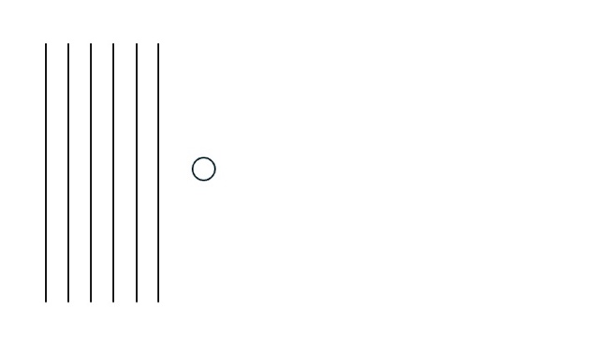
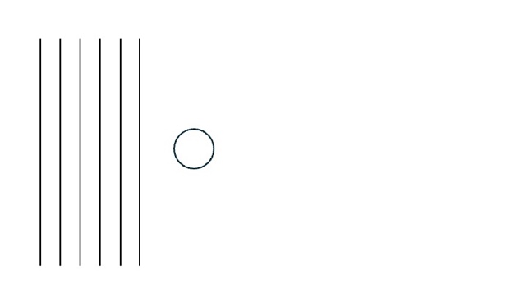

9. Draw a model of light waves of long and short wavelengths wrapping around an object.
Model Long Wavelengths (Red): Model Short Wavelengths (Blue):


10. The diffraction grating used at the beginning of class has 1000 microscopic lines per mm. Explain why you saw the pattern of light and dark when the laser light passed through the diffraction grating. Your explanation should include how waves behave when they encounter obstacles, the terms you learned today, and relate to the pattern of light you saw.

