What Causes a Widow's Peak?
In the same way that a cleft chin or naturally curly hair is a genetic trait, the V-shaped hairline of a widow's peak commonly runs in families. Sometimes, it's a slight V in an otherwise straight hairline, and sometimes the hairline has a distinctive shape.
Scientists have been unable to define the genetic traits of a widow's peak hairline or how someone can inherit the trait. It is believed to be caused by multiple genes, and it can be hard to predict whether someone will or won't develop the hairline. However, the research is minimal and could be caused by one dominant gene.
A widow's peak hairline has been associated with a few genetic conditions, such as:
- Donnai-Barrow syndrome (DBS) — mutations in the LRP2 gene cause this rare genetic condition. It can cause irregular features of the ears, nose and eyes.
- Aarskog syndrome — short stature and other signs of abnormal development characterize this rare genetic condition. It's associated with the FGD1 gene on the X chromosome.
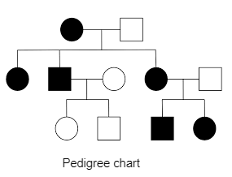
- Frontonasal dysplasia — this very rare condition involves unusual development of the face and head. Several versions of the condition are known to be caused by mutations in the ALX 3, ALX4 and ALX1 genes.
If you have a widow's peak, you might feel different from others, but many people sport the look with pride, and it's pretty common. A study involving 1000 university students found that 36.8% (men and women) presented with a widow's peak.
https://vegamour.com/blogs/blog/widows-peak-hairline

