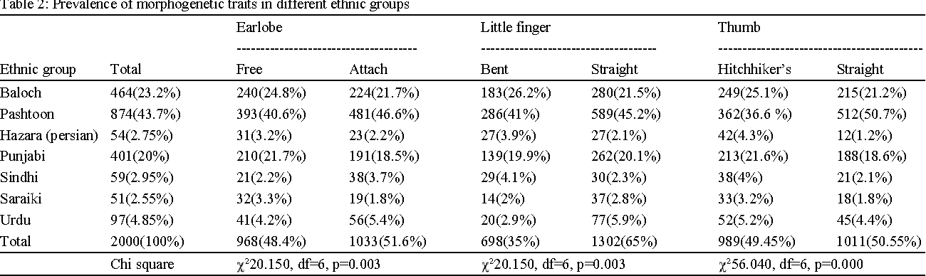

https://www.semanticscholar.org/paper/Assessment-of-Morphogenetic-Inherited-Traits-%3B-%2C-%E2%80%99-Munir-Sadeeqa/a94edd2d8f74e7f8f8c5e2eaee8252ae86ab9592

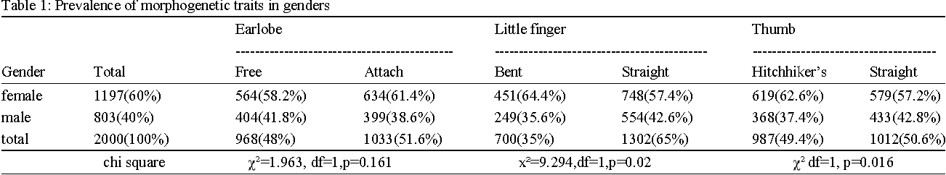

https://www.semanticscholar.org/paper/Assessment-of-Morphogenetic-Inherited-Traits-%3B-%2C-%E2%80%99-Munir-Sadeeqa/a94edd2d8f74e7f8f8c5e2eaee8252ae86ab9592

