Hitchhiker’s Thumb
Glass and Kistler define a Hitchhiker’s Thumb as a thumb that bends more than 50 degrees. In their study, between 24.7% and 35.6% of individuals in the United States have a Hitchhiker’s Thumb.
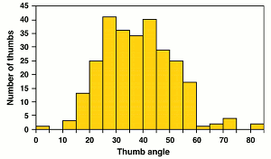
John H. McDonald’s reproduction of the Glass and Kistler study (1953).

https://bioinformatics.csiro.au/blog/do-you-have-the-genetics-for-the-hitchhikers-thumb/#:~:text=Here%2C%20Glass%20and%20Kistler%20define,John%20H.

Prevalence of hitchhiker’s thumb
Hitchhiker’s thumb hasn’t been studied extensively, and there is little to no data on its prevalence in the United States or worldwide.
However, a 2012 study found that 32.3 percent of a random sample of 310 people had hitchhiker’s thumb. Of those subjects, 15.5 percent were male, and 16.8 percent were female.
A 1953 study at Johns Hopkins University was one of the first to analyze hitchhiker’s thumb. In that study, 24.7 percent of white people and 35.6 percent of Black people were found to have this condition in the United States.

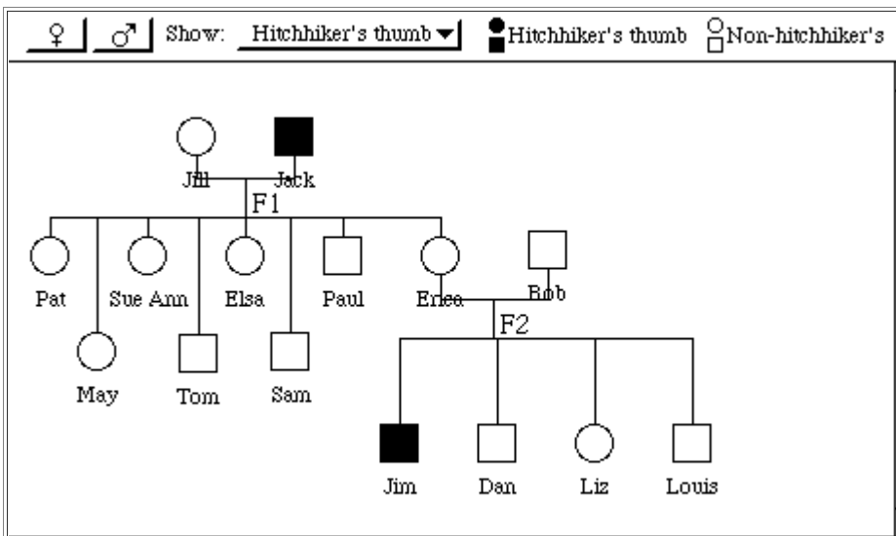
Causes of hitchhiker’s thumb
Hitchhiker’s thumb may be an inherited condition with a genetic link.
Some people with hitchhiker’s thumb may have acquired two recessive copies, or alleles, of the gene that determines thumb straightness, meaning that the trait for hitchhiker’s thumb was present in both parents of the person born with it.
If, instead, one parent had the dominant gene for thumb straightness and the other had the recessive gene for hitchhiker’s thumb, their offspring wouldn’t have the condition. People with the recessive gene for this condition are called carriers.
A person with a recessive gene would have to have a child with another carrier of the gene to inherit the trait.
There’s some debate, however, about thumbs always being one of two kinds: straight or hitchhiker’s. An alternative theory is that thumb bendability involves a spectrum that ranges from no bendability in the joint to extreme bendability.
https://www.healthline.com/health/hitchhikers-thumb#causes

