How can we study inheritance?
When spending time with your family, friends, and neighbors, you may have noticed many traits run in families. For instance, family members may share similar facial features, hair color, or a predisposition to health problems like diabetes. Characteristics that run in families often have a genetic basis, meaning that they depend on genetic information a person inherits from his or her parents.
What if you wanted to determine how genetic information is transmitted between generations? For instance, you might be curious how traits can “skip” a generation or why one child in a family may suffer from a genetic disease while another does not. How could you go about asking these kinds of questions scientifically?
An obvious first idea would be to study human inheritance patterns directly, but that turns out to be a tricky proposition. In this article, we’ll see how a nineteenth-century monk named Gregor Mendel instead uncovered the key principles of inheritance using a simple, familiar system: the pea plant.

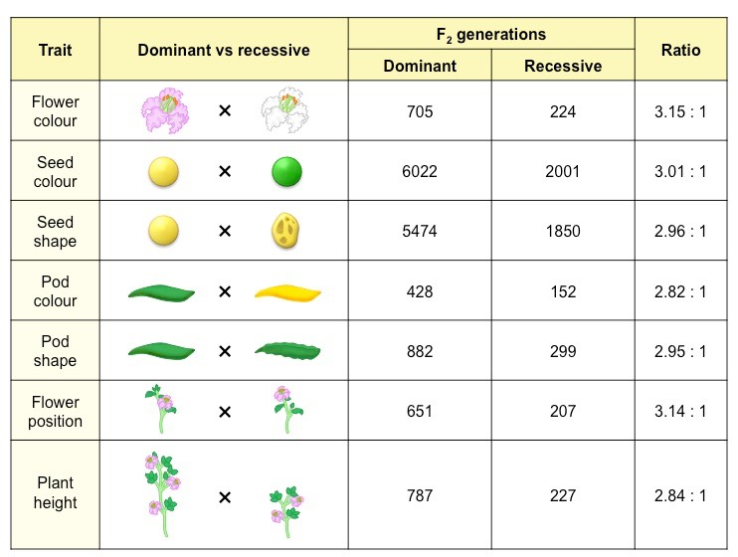

Research on heredity
In 1856, Mendel began a decade-long research project to investigate patterns of inheritance. Mendel studied the inheritance of seven different features in peas, including height, flower color, seed color, and seed shape. To do so, he first established pea lines with two different forms of a feature, such as tall vs. short height. He grew these lines for generations until they were pure-breeding (always produced offspring identical to the parent), then bred them to each other and observed how the traits were inherited.
In addition to recording how the plants in each generation looked, Mendel counted the number of plants that showed each trait. Strikingly, he found very similar patterns of inheritance for all seven features he studied:
- One form of a feature, such as tall, always concealed the other form, such as short, in the first generation after the cross. Mendel called the visible form the dominant trait and the hidden form the recessive trait
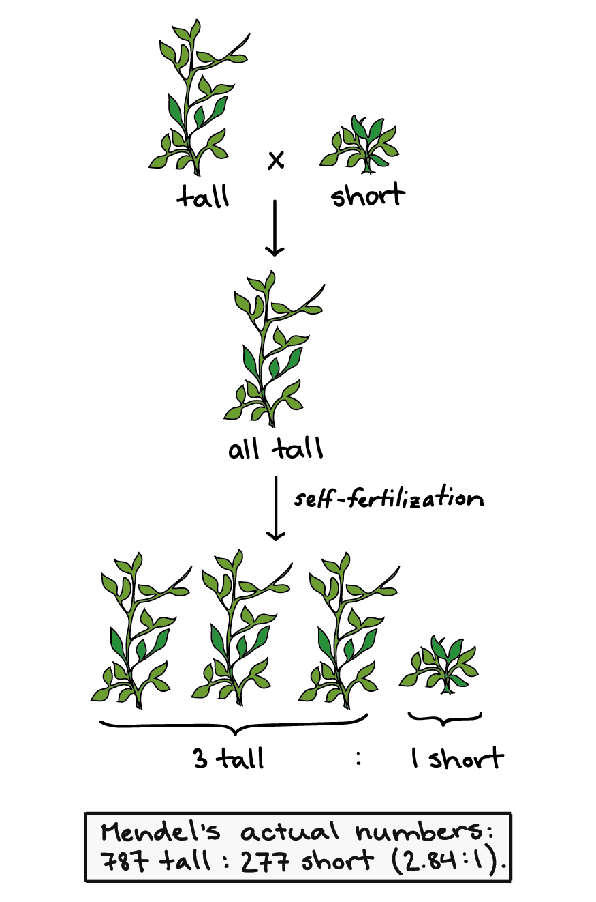
- In the second generation, after plants were allowed to self-fertilize (pollinate themselves), the hidden form of the trait reappeared in a minority of the plants. Specifically, there were always about 3 plants that showed the dominant trait (e.g., tall) for every 1 plant that showed the recessive trait (e.g., short), making a 3:1 ratio.
https://www.khanacademy.org/science/ap-biology/heredity/mendelian-genetics-ap/a/mendel-and-his-peas

- Mendel also found that the features were inherited independently: one feature, such as plant height, did not influence the inheritance of other features, such as flower color or seed shape.

