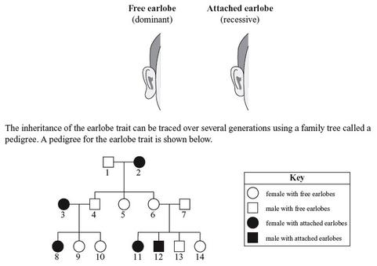
The earlobe also shows a variety of characteristics in different populations. The attached earlobe was found in more than 50–56% of the subjects in the present study; however, Singh and Purkait (2009) observed 19–24% in the Central Indian population, and Farkas (1978) reported 2–3% in Americans. On the other hand, American Whites and Dunker isolates (Gable 1958) have 40.53% and 25.30% attached earlobes respectively, a figure much closer to the subjects of the present study.

https://ejfs.springeropen.com/articles/10.1186/s41935-019-0111-0#:~:text=The%20earlobe%20also%20shows%20a,2%E2%80%933%25%20in%20Americans.

