Colorblind People Population Statistics
How many people do you think are colorblind on the planet? What country has the most colorblind population? Here Is the Population of Colorblind People in 22 Countries.

What Percentage of the Population Is Colorblind?
There is general agreement that 1 in 12 men (8%) and 1 in 200 women are colorblind (approximately 4.5% of the world population); as a result, there are more than 350 million colorblind people worldwide.
This number increases every year according to the world’s population growth (1.05%). You can compare this number to the U.S. population (332 Million).

The terminology of the “colorblind” word can be misleading. Most colorblind people can see many colors but not as broad as others. It is extremely rare to see in black and white.
According to Colblindor, 99% of all colorblind people suffer from red-green color blindness. The numbers of people with Monochromacy color blindness (Total color blindness) are small, perhaps 1 in 33,000.

What Country Has More Colorblind People?
Countries with larger populations and isolated communities with a restricted gene pool have more people with color deficiency. India has the highest population of colorblind people in the world, with 70 million people being colorblind. China is the second country with a population of 53 million colorblind people.

What Percent of the U.S. Population Is Color Blind?
According to the Howard Hughes Medical Institute, about 3.7% or 12 million Americans are colorblind (7% males and 0.4% females).

What Nations Are Most Affected by Color Blindness?
Countries with a restricted gene pool sometimes produce high proportions of color blindness, including the less usual types. Arabs have the highest percentage of color blindness among other nations. Arabs, Indians, Russians, Norwegians, French, Dutch, Swiss, Scots, and Germans are the most affected nations by color blindness.

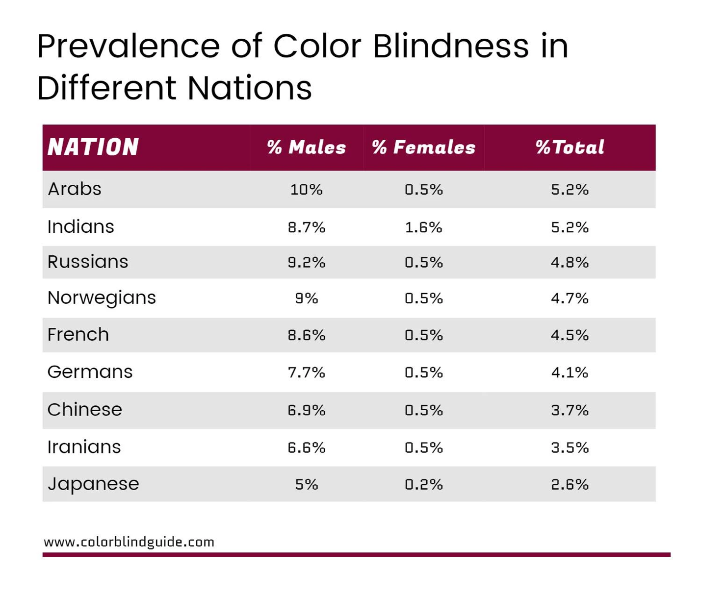

https://www.colorblindguide.com/post/colorblind-people-population-live-counter

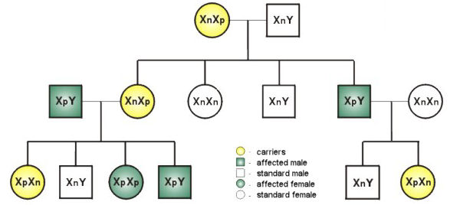
Pedigree for color deficiency
The pedigree is typical for an X-linked recessive trait. The parents in the first generation both have standard vision; the mother (circle) is heterozygous with two alleles: n and p. Four combinations of gender and color deficiency are possible in their children and are expected with equal frequency: carrier (heterozygous) daughters with standard vision, standard daughters, standard sons, and affected sons.
Suppose the first-born daughter is a carrier and marries a color-deficient husband. In that case, they can expect four types of offspring at equal frequencies: carrier daughters, standard sons, affected daughters, and affected sons. In the family on the far right, the last-born color-deficient son marries a woman with standard vision, and only two types of children can result: standard sons and carrier daughters. Note that, in this family, unlike the previous one, color deficiency will “skip” a generation and may appear in the next generation in the sons of the carrier daughters.
Note that the birth of an affected woman requires an unusual combination of circumstances. Only about 10% of men are affected, and only about 18% of women are carriers; thus, only 1.8% of marriages are at risk, and only half of their daughters will be a homozygous recessive: 0.10 x 0.18 x 0.5 = 0.9% of daughters will be so affected.
https://www.mun.ca/biology/scarr/Pedigree_color_deficiency.html
