Oculocutaneous Albinism

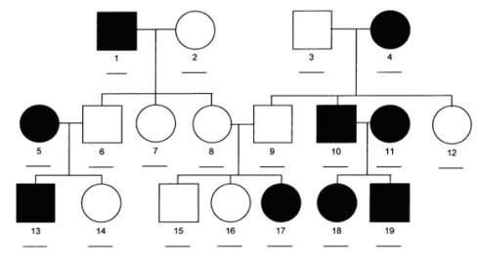

Overall, an estimated 1 in 20,000 people worldwide are born with oculocutaneous albinism. The condition affects people in many ethnic groups and geographical regions. Types 1 and 2 are the most common forms of this condition; types 3 and 4 are less common. Type 2 occurs more frequently in African Americans, some Native American groups, and people from sub-Saharan Africa. Type 3, specifically rufous oculocutaneous albinism, has been described primarily in people from southern Africa. Studies suggest that type 4 occurs more frequently in the Japanese and Korean populations than in people from other parts of the world.

https://medlineplus.gov/genetics/condition/oculocutaneous-albinism/#frequency
