ABO Blood Type
ABO blood types are determined by the presence or absence of antigens on the surface of red blood cells. There are two main antigens, A and B, and three possible alleles: I^{A}, I^{B}, and i. The I^{A} and I^{B} alleles are codominant, while i is recessive. The combination of these alleles determines an individual's blood type. The inheritance rules are as follows:
- If a person inherits an I^{A} allele from one parent and another I^{A} or an i allele from the other parent, they will have blood type A.
- If a person inherits an I^{B} allele from one parent and another I^{B} or an i allele from the other parent, they will have blood type B.
- If a person inherits an I^{A} allele from one parent and an I^{B} allele from one parent, they will have blood type AB.
- If both parents contribute an i allele, the person will have blood type O.

(See table below)

Understanding this inheritance pattern is crucial for predicting blood types in families and ensuring the compatibility of blood transfusions.

*Note: In addition to ABO inheritance, each blood type can be either Rh-positive or Rh-negative, which is determined by another gene. This gene will not be addressed in this example.
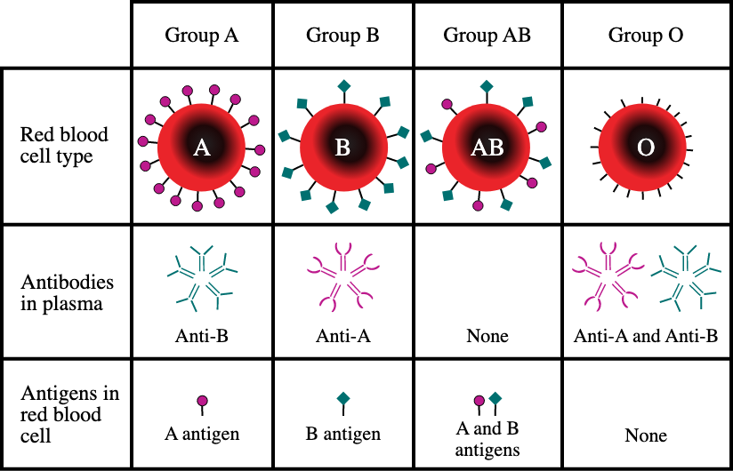

The pedigree below shows a family with fourteen children and the known blood types of individuals in the family.
