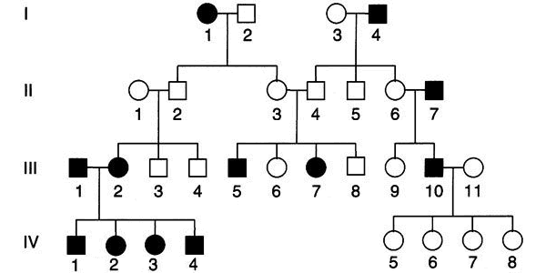
Pedigree of PTC taste sensitivity
The chemical phenylthiocarbamide (PTC) (OMIM 17120) tastes bitter to most people ("tasters") but is tasteless for others ("non-tasters"). Inability to taste PTC is sometimes described as an autosomal recessive trait: persons with the TT or Tt genotypes have the "taster" phenotype; persons with the tt genotype have the "non-taster" phenotype. The "non-taster" phenotype is therefore described as a "recessive" trait.
The pattern of inheritance of PTC sensitivity is shown in the above pedigree of two related families. Squares are males, circles are females; "tasters" are indicated by open symbols, and "non-tasters" by filled symbols. The "non-taster" phenotype shows the classic pattern of a recessive trait: it is present in generation I, "skips" generation II, and reappears in generation III in two grandchildren of two unrelated grandparents who happen to share the trait.

https://www.mun.ca/biology/scarr/PTC_tasting.html

