Name________________________________________
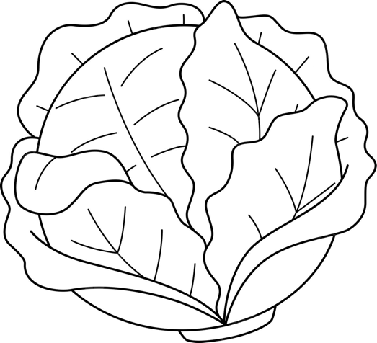
The Cruciferous Question Worksheet

- After tasting the cruciferous vegetable, write on the worksheet and sticky notes 5 adjectives that describe its taste.

- After tasting the PTC paper, describe how it tasted.

- What similarities or patterns did you notice between the taste of the paper and the vegetable?

- After gathering peers’ responses, compile the class data with the peer data and record who tasted bitter and who tasted nothing.

 | Taster (Bitter) | Non-Taster (Nothing)
Class

n = ________
Other Classes

n = ________

  - Make a Pie Chart or Bar Graph showing the class data.

  - Make a Pie Chart or Bar Graph showing the data from other classes tested.

  - What percentage of all individuals could taste the bitterness from the paper?
(This class + other classes tested)

d. What patterns do you notice between our class data and the other classes’ data?

Jigsaw Activity

- Summarize your group’s reading assignment in 2-3 sentences.

- After the Jigsaw Group discussion, describe in 1-2 paragraphs what the article was about.

- What makes cruciferous vegetables taste bitter?

- Define ‘Dominant’ and ‘Recessive.’
Dominant:

Recessive:

- Do you think the ability to taste PTC is a dominant or recessive trait? Why?

- What are the possible genotypes from your parents based on the ability to taste bitterness or not?

- Make (a) Punnett Square(s) to show what PTC genes you likely inherited from your parents.

- Describe 3 other patterns of inheritance you explored today. Compare how they are passed on and how they are expressed.

