Carbon - What’s the big deal? Name ______________________________ Per _______
Phenomenon: Carbon on the rise and the Keeling Curve
What do you notice?

What do you wonder?

Station 1: Land - Construct an explanation
Migrating Forests video and Forest Study infographic
- How are changes in atmospheric carbon levels related to migrating forests?

- What evidence do we have to show forest migration is happening?

- Look at the Claim, Evidence, Reasoning table on pages 3 and 4. The land station boxes are completed for you and provide an example of what you will fill out as you go to the other stations.

Station 2: Air - Obtaining, Evaluating and Communicating Information
Follow the directions on the Air Station card. Then answer the questions below (use the “background” to help you).
- Initially, what color was your solution?

- After increasing the CO₂ levels in the jar, what happened to the color of your solution?

- The initial pH of your solution was about 7, meaning it is neutral. After CO₂ levels increased in the jar, the pH of the solution lowered to about 5, meaning it was more acidic.
Can atmospheric CO₂ change the pH of the ocean? Explain your answer

- Fill in the Claim, Evidence, Reasoning chart for AIR at the end of the lesson.
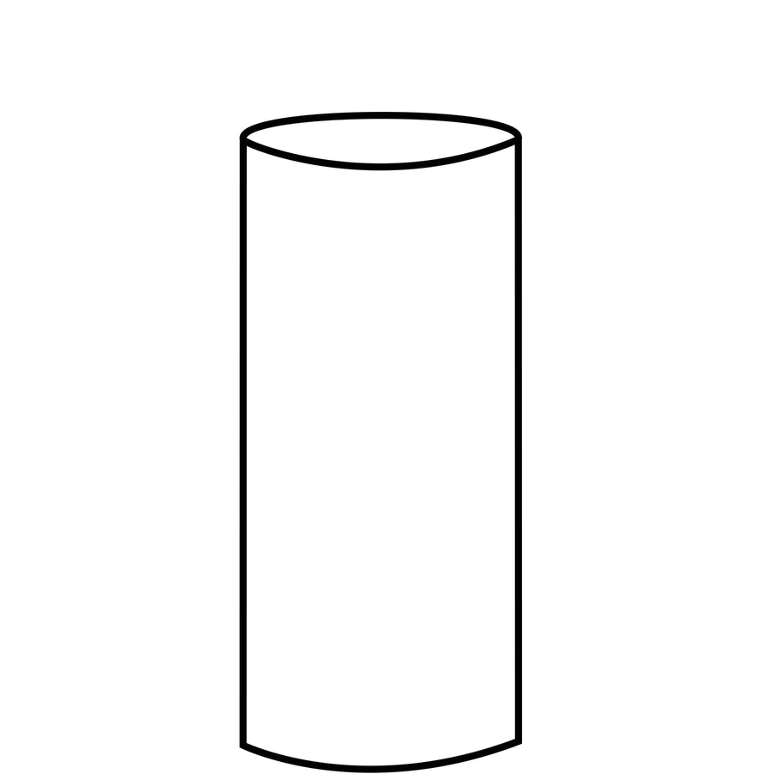
Station 3: Ice - Analyzing and interpreting data
- Examine your ice core. Measure the full length of your ice and mark it to scale (in the margin) on the picture.
- Measure and describe each layer on the picture.
- Draw and color what you see (details matter) in each layer and label it.
- READ the infographic to answer the questions.

- What information do ice cores give us?

- What are scientists able to do with ice cores that you’re unable to do today with yours?

- What do ice cores tell us about historic CO₂ levels?

- If weather patterns, temperature, and CO2 levels were stable over time, what would you expect to see in an ice core?

- Fill in the Claim, Evidence, Reasoning chart for ICE at the end of the lesson.

Station 4: Sea - Engaging in Argument From Evidence
Start this station by reading the article and looking for evidence you can use to form an argument for or against the claims in the article. Next, scan the QR code and watch the YouTube video “Sir David Attenborough On The Devastating Truth About Coral Reefs.”

- How is coral bleaching leading to change in the ocean?

- What role does carbon play in coral bleaching?

- What evidence does the article and graphs use to support their argument?

- Does your opinion differ from that in the video? Why or Why not?

- Fill in the Claim, Evidence, Reasoning chart for SEA at the end of the lesson.

For Air, Ice, and Sea, you are given one part of the C.E.R. Complete the other 2 portions.
 | Claim | Evidence | Reasoning
Land | Climate change results in migrating forests. | Western hemlock forest (W-A) migrated with the highest velocity at 327.8 km/decade. | As global temperatures increase, areas that were once too cold for specific species warmed, becoming habitable. Over time, the geographic range changes as temperatures change.
 | Claim | Evidence | Reasoning
Air | As atmospheric CO₂ increases, ocean pH drops, making the ocean more acidic.
Ice |  | Ice core records from the past 800,000 years show pre-industrial levels of CO₂ did not reach higher than 300 parts per million. Records of CO₂ concentration correlate with ice core temperature records.
Sea |  |  | Coral reef loss occurs as ocean acidification and temperature increase because coral is highly susceptible to slight changes in pH and temperature.

Carbon on the Rise and the Keeling Curve:
- As carbon dioxide concentration increases, what changes would you expect to see in worldwide coral populations?

- As carbon dioxide concentration increases, what changes would you expect to see in ice cores?

- As carbon dioxide concentration increases, what changes would you expect in ocean pH levels?

- As carbon dioxide concentration increases, what changes would you expect to see on land?

- Make an argument from evidence why changes in CO₂ affect the stability of all earth systems.

