Name: ____________________________________________________ Period: _____________

“Spitty Pudding”

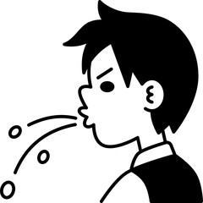
- Record any observations and wonderings you have from the images.

- What macromolecules are in pudding?

- What are the main components (matter) of macromolecules?

- Make a prediction about what will happen to the pudding with the saliva added.

- Compare the 2 cups of pudding before and after the saliva has been added.

Cup | Appearance at beginning | Mass at beginning | Appearance after waiting 10 minutes | Mass after waiting 10 minutes
1. Pudding
2. Pudding with Saliva
- Using the cup with saliva, was the mass at the beginning of the 10 min more, less, or the same as the mass at the end of the 10 min? What can we learn from this?

- Construct a model (diagram, explanation, or both) to show how your body breaks down macromolecules found in the foods you eat.

- How does your body process food to get energy?

- Why does your body process food like carbohydrates for energy?

- How can you modify (change) the activity that we just performed to further investigate carbohydrates and how/why they break down?

Post-Lab questions:
- What matter are we gaining from the food that we eat?

- What happens to the matter in macromolecules after enzymes have broken them down?

- What evidence is there that matter is conserved when enzymes break down macromolecules?

- What substance are the carbon atoms in pudding part of before and after the enzymatic process?

- Plants, like all organisms, require protein for life’s functions. However, plants can’t eat protein, so how do they obtain the proteins they need?

