Assessment of Structure and Function of Plant and Animal Cells

PLANT CELL TYPES
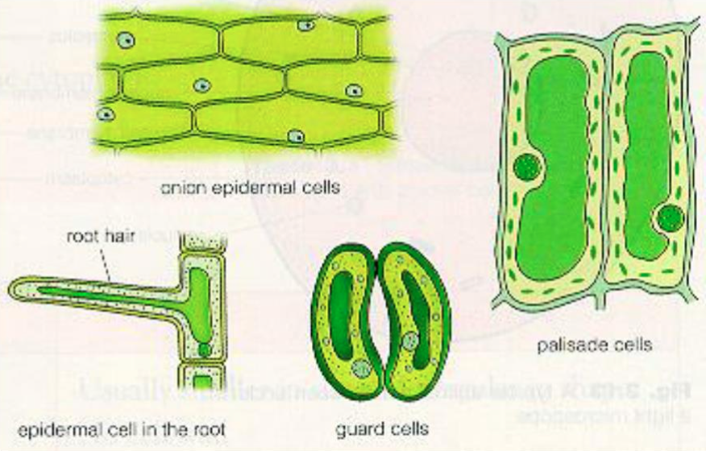

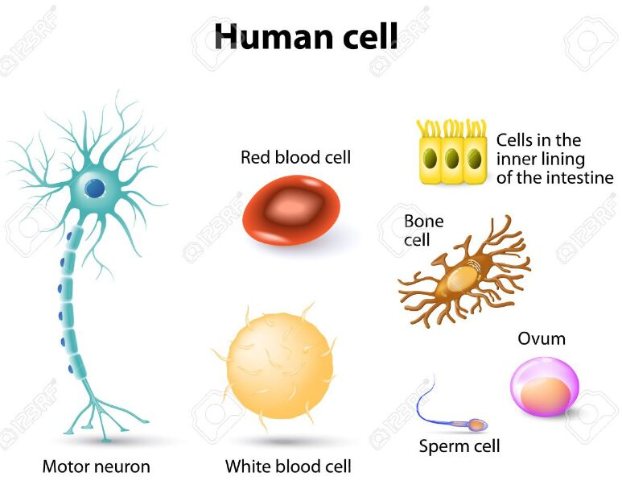

Describe the shape of your cell. Why is it shaped this way?
Describe the function of your cell. What is the purpose of the cell? What does it do?
What structure does the cell have that other cells may not have?
Compare your cell type to another cell type. What differences do you see? Why do you think they are different?
What organ does your cell type function in? What is the purpose of this organ? What does it do?

