Carbon Cycle DATA Record Sheet

NAME ________________________________

Part 1- Phenomenon

Image of a Coral Reef
What I SEE | What I THINK | What I wonder

Image of the Great Barrier Reef
What I SEE | What I THINK | What I wonder

Identify the problem or question: ____________________________________________________________________________________________________________________________________________________________________________________________________

Hypothesis: What is your prediction for the above question?
Note: Be sure to use the “if...then...because...” format unless directed otherwise
________________________________________________________________________________________________________________________________________________________________________________________________________________________________________________________________________________________________________________________

Part 2- Carbon cycle game
The key to understanding the cycles of matter on Earth begins with identifying the reservoirs (where the matter is stored), the residence times (how long matter stays in any one reservoir), and the fluxes (how the matter moves from one reservoir to another).

Instructions: Today, you are going to play a game to learn about the carbon cycle, its reservoirs, residence times, and fluxes. By the end of this activity, you should be able to describe and explain how the carbon cycle has changed in the last 250 years.
Around the room, there are signs for each reservoir. Under the reservoir sign, there is a die and a set of instructions. You are a carbon atom!! You will be assigned to start at different reservoirs. Once you reach the reservoir, record your location on the chart below. Roll the die. Depending on the number you roll, you will go to different stations around the room. If you stay at a reservoir, RECORD THAT! Be sure to record your flux mechanism (how you got to the new reservoir). When you have visited every reservoir, return to your seat and map your journey on the back of this page.

Round 1
Starting Reservoir | Flux Mechanism | Ending Reservoir

Round 2
The carbon cycle you drew in round 1 represents how carbon could have cycled through the Earth’s Systems 250 years ago, before the Industrial Revolution. Things have changed. Now, we will do the same exercise in the modern carbon cycle. Go to your original starting reservoir and wait for instructions.

Starting Reservoir | Flux Mechanism | Ending Reservoir

When you have filled in the table, go back to your seat and answer these quick questions:


Part 3: Data and Graph Analysis
Erlenmeyer Flask Demo

 | What I SEE | What I THINK | What I wonder
before
after

What I see...

What it means...

Caption IT…

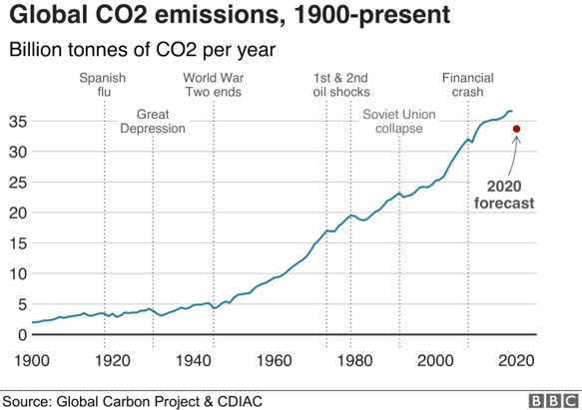

Caption IT:
____________________________________________________________________________________________________________________________________________________________
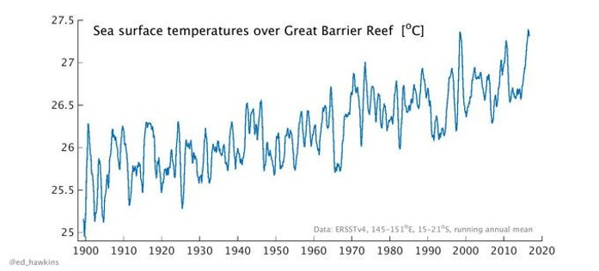
Caption IT:
____________________________________________________________________________________________________________________________________________________________

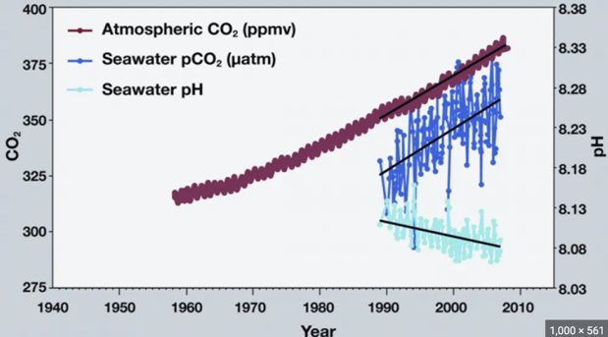
Caption IT:
____________________________________________________________________________________________________________________________________________________________

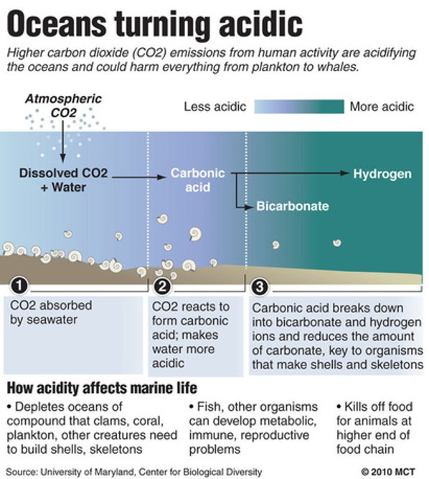
Caption IT:
____________________________________________________________________________________________________________________________________________________________

Part 4 Complete the chart below using all of your experiences from above.
Identify the question: ___________________________________________________________
Claim - Provide a possible answer to our identified question | Evidence - Which observations support your claim? | Reasoning - How and why does this evidence support your claim?
Extension Assignment:
Examine the diagram below. Carbon reservoirs are labeled with the approximate amount of carbon found in each. The arrows represent carbon fluxes.

Given what you know about the age of rocks, ocean and atmospheric circulation, life on Earth and the role of humans in the environment, estimate the amount of time you think that carbon stays in each reservoir. Record your answers in the boxes on the diagram.
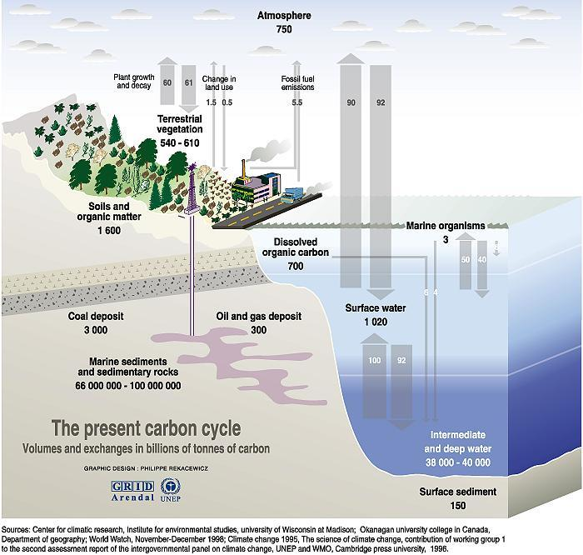

How does this diagram relate to Round 2 of the Carbon Cycle Game?

