Name:_______________________________
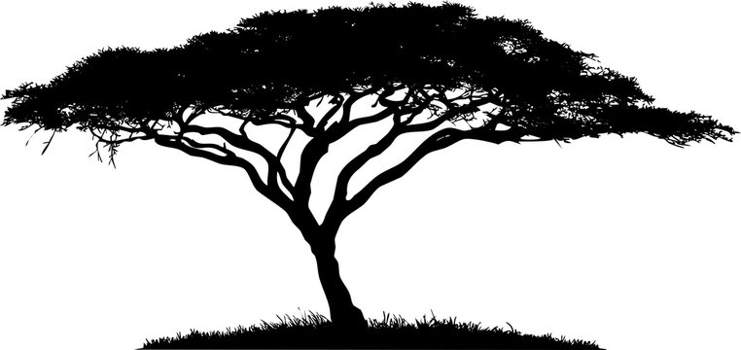
The Serengeti
- Write down at least 2 observations when looking at the time-lapse pictures. (What do you notice? What is changing?)

- What ideas do you have about why this is happening? What could have caused this?

Analyze the information on your Gray Wolf cards to understand the organism interactions in that ecosystem better. Use the data to answer the following questions:

Ecosystem Model 1: Gray Wolf
- What producers and consumers are present?
  - Producers

  - Consumers

- What biotic and abiotic factors affect the stability of this ecosystem?
  - Biotic:

  - Abiotic:

- Describe or diagram the interactions among the organisms in the ecosystem.

- What species determines the stability of the ecosystem?

  - What evidence supports your previous answer?

Community Model Building guidelines:
● Each of the five blocks must touch at least one other block.
● The structure you build must be free-standing (stand without anyone holding it up.)
● You may tape down two blocks to the table to provide support.
● If you remove any block, the entire structure will fall.
- Draw a simple representation of your community
model here.

- Did the species shown on the blocks help you decide how to arrange them? Explain.

- What is a keystone species?

- Draw a keystone model using the organisms from Yellowstone and your Gray Wolf wildlife cards.

Analyze the information in the other 2 ecosystem cards to understand the organism interactions in that ecosystem better. Choose only one of the 2 cards and use the information from that card to answer the following questions:

Ecosystem Model 2:_________________________
- What producers and consumers are present?
  - Producers

  - Consumers

- What biotic and abiotic factors affect the stability of this ecosystem?
  - Biotic

  - Abiotic

- Describe or diagram the interactions among the organisms in the ecosystem.

- What species determines the stability of the ecosystem?

  - What evidence supports your previous answer?

- Draw a keystone model using another organism from your cards.

Look up the rinderpest virus online and use the information you discover to answer the following questions.
- What type of animal does rinderpest affect?

- How does rinderpest affect the animal?

- How did the rinderpest virus affect the stability of the Serengeti ecosystem?

Wildfires in the Serengeti
- Looking at the fire triangle, what variable is most likely to change in the Serengeti?

Follow-up questions:
- Based on all the information you have learned, what animal is the keystone species in the Serengeti?

  - Explain why it is the keystone species. How does it determine the stability of the Serengeti? (include biotic and abiotic factors)

- You saw what the Serengeti ecosystem looks like now. How might this ecosystem be affected if the rinderpest virus were to hit it again?

- What abiotic factors in an ecosystem could cause a keystone species to shift or change? What biotic factors could cause a keystone to shift or change?

