Name______________________________________
- Click on the link: Synthetic Materials Link
- You will come to a website that has this information on it:
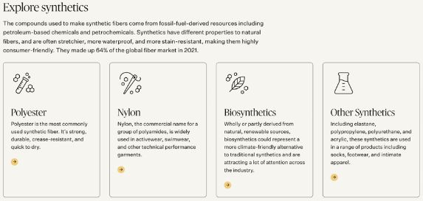
Use this information to answer the questions below:

- Click on each of the 4 boxes to EXPLORE information on Synthetic Materials. As you explore, look for answers to the following questions:
  - According to the website, what qualities make Polyester so usable and important?

  - What is the most widely used fiber worldwide?

  - According to the website, what does "virgin polyester" mean?

  - Of all the global fiber produced, what percent is Polyester? ____________

What percent is Nylon? _______________

  - What is the definition of Biosynthetics?

  - What is elastane? What is its main use?

  - According to the information on the main link you clicked above, in 2021, what percentage of global fibers were made from synthetic fibers?

  - Name 4 synthetic fibers you read about and write 2 interesting facts you found out about each one:
1.

2.

3.

4.

