Name______________________________________
Instructions:

- Click on the link below: Synthetic Materials Link
- You will come to a website that has this information on it:
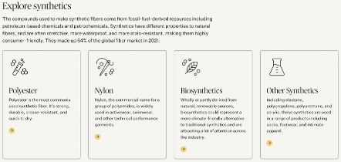
Use this information to answer the questions below:

- Click on each of the 4 boxes to EXPLORE information on Synthetic Materials. As you explore, look for answers to the following questions:
  - According to the website, what qualities make Polyester so usable and important?
It’s strong, quick to dry, durable, crease-resistant and can be used for clothing, footwear, accessories, and home furnishings.

  - What is the most widely used fiber worldwide? Polyester

  - According to the website, what does "virgin polyester" mean? They are fossil-based fibers.

  - Of all the global fiber produced, what percent is Polyester? ___80_____
What percent is Nylon? _____5%_______

  - What is the definition of Biosynthetics? Made from part or wholly derived natural, renewable resources.

  - What is elastane? What is its main use? It’s Spandex. Used when elasticity is needed and is resilient and stretchy.

  - According to the information on the main link you clicked above, in 2021, what percentage of global fibers were actually made from synthetic fibers? __64%__

  - Name 4 synthetic fibers you read about and write 2 interesting facts you found out about each one:
Answers will vary.....polyester, spandex, Nylons, Biosynthetics, etc.

