
Type of Celestial Object: | GALAXY | 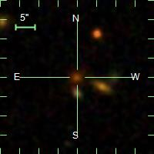
Field: | 17
Redshift Value (Z): | 0.5913969
SDDSS Object ID: | 1237667541750448382
Velocity Dispersion: | 253.66 km/s
u: | 23.372
g: | 22.930
r: | 20.516 | Galactic Coordinates (l, b)
i: | 19.363 | l | 211.83558783
z: | 18.834 | b | 43.180192561

Type of Celestial Object: | Galaxy | 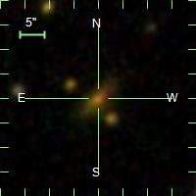
Field: | 122
Redshift Value (Z): | 0.2555275
SDDSS Object ID: | 1237674649928204593
Velocity Dispersion: | 202.9392 km/s
u: | 1.170
g: | 0.041
r: | 0.017 | Galactic Coordinates (l, b)
i: | 0.013 | l | 274.592716558
z: | 0.032 | b | 59.547239103

Type of Celestial Object: | GALAXY | 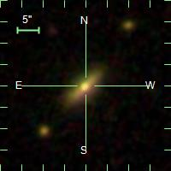
Field: | 20
Redshift Value (Z): | 0.07874168
SDDSS Object ID: | 1237667541213773994
Velocity Dispersion: | 181.2879 km/s
u: | 19.439
g: | 17.566
r: | 16.636 | Galactic Coordinates (l, b)
i: | 16.211 | l | 212.666949421
z: | 15.881 | b | 43.596257537

Type of Celestial Object: | GALAXY | 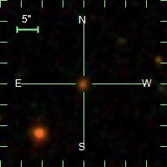
Field: | 201
Redshift Value (Z): | 0.4966374
SDDSS Object ID: | 1237667536930669265
Velocity Dispersion: | 194.7845 km/s
u: | 26.034
g: | 22.055
r: | 20.272 | Galactic Coordinates (l, b)
i: | 19.379 | l | 212.891651739
z: | 18.999 | b | 43.8109136

Type of Celestial Object: | GALAXY | 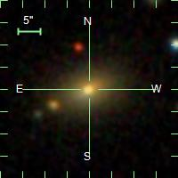
Field: | 207
Redshift Value (Z): | 0.04745351
SDDSS Object ID: | 1237667536394190955
Velocity Dispersion: | 160.9209 km/s
u: | 18.691
g: | 16.806
r: | 15.951 | Galactic Coordinates (l, b)
i: | 15.542 | l | 213.627644927
z: | 15.223 | b | 44.595275168

Type of Celestial Object: | GALAXY | 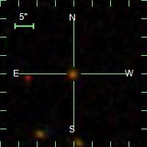
Field: | 210
Redshift Value (Z): | 0.5318861
SDDSS Object ID: | 1237667783355007527
Velocity Dispersion: | 290.6498 km/s
u: | 23.888
g: | 22.236
r: | 20.461 | Galactic Coordinates (l, b)
i: | 19.598 | l | 214.089266229
z: | 19.249 | b | 44.8528141

Type of Celestial Object: | Star | 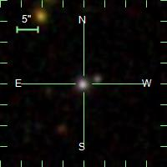
Field: | 427
Redshift Value (Z): | 0.1774526
SDDSS Object ID: | 1237648720693756185
Velocity Dispersion: | 102.4926 km/s
u: | 19.736
g: | 19.100
r: | 18.789 | Galactic Coordinates (l, b)
i: | 18.485 | l | 276.279539363
z: | 18.514 | b | 59.690720496

Type of Celestial Object: | Galaxy | 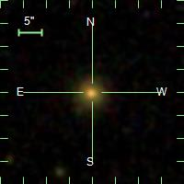
Field: | 426
Redshift Value (Z): | 0.1066886
SDDSS Object ID: | 1237648721230561564
Velocity Dispersion: | 130.3056 km/s
u: | 20.562
g: | 18.626
r: | 17.594 | Galactic Coordinates (l, b)
i: | 17.138 | l | 275.744627414
z: | 16.762 | b | 59.966896471

Type of Celestial Object: | Galaxy | 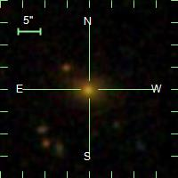
Field: | 427
Redshift Value (Z): | 0.2493847
SDDSS Object ID: | 1237648721230627123
Velocity Dispersion: | 200.261 km/s
u: | 21.180
g: | 19.455
r: | 18.023 | Galactic Coordinates (l, b)
i: | 17.469 | l | 275.952719445
z: | 17.113 | b | 60.079430105

Type of Celestial Object: | GALAXY | 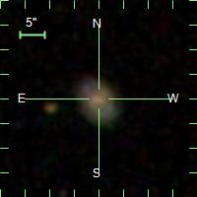
Field: | 418
Redshift Value (Z): | 0.1264552
SDDSS Object ID: | 1237648720693166240
Velocity Dispersion: | 70.73922 km/s
u: | 19.252
g: | 18.124
r: | 17.561 | Galactic Coordinates (l, b)
i: | 17.209 | l | 273.992560366
z: | 17.033 | b | 58.957800204

Type of Celestial Object: | Galaxy | 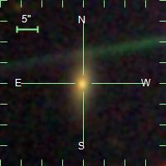
Field: | 84
Redshift Value (Z): | 0.0389346
SDDSS Object ID: | 1237667486457135152
Velocity Dispersion: | 95.76093
u: | 19.104
g: | 17.225
r: | 16.338 | Galactic Coordinates (l, b)
i: | 15.984 | l | 140.47139
z: | 15.616 | b | 18.74074

Type of Celestial Object: | Galaxy | 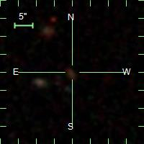
Field: | 186
Redshift Value (Z): | 0.7412894
SDDSS Object ID: | 12376675380003428153
Velocity Dispersion: | 40.28861
u: | 24.708
g: | 22.453
r: | 21.779 | Galactic Coordinates (l, b)
i: | 20.798 | l | 140.83414
z: | 20.885 | b | 18.58596

Type of Celestial Object: | Galaxy | 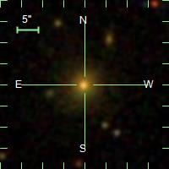
Field: | 14
Redshift Value (Z): | 0.1931261
SDDSS Object ID: | 1237667541750251727
Velocity Dispersion: | 219.5279
u: | 20.504
g: | 18.464
r: | 17.174 | Galactic Coordinates (l, b)
i: | 16.688 | l | 141.95760
z: | 16.307 | b | 18.70569

Type of Celestial Object: | Galaxy | 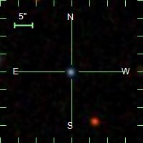
Field: | 135
Redshift Value (Z): | 0.1312126
SDDSS Object ID: | 1237660669810507925
Velocity Dispersion: | 160.6553
u: | 20.285
g: | 18.527
r: | 17.400 | Galactic Coordinates (l, b)
i: | 16.945 | l | 137.98735
z: | 16.533 | b | 8.22936

Type of Celestial Object: | Galaxy | 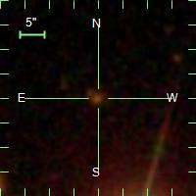
Field: | 155
Redshift Value (Z): | 0.6007018
SDDSS Object ID: | 1237661070317519642
Velocity Dispersion: | 186.6964
u: | 22.744
g: | 22.185
r: | 20.365 | Galactic Coordinates (l, b)
i: | 19.342 | l | 139.49335
z: | 18.939 | b | 11.21588

Type of Celestial Object: | Galaxy | 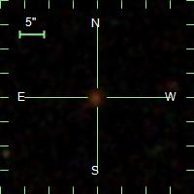
Field: | 155
Redshift Value (Z): | 0.6392783
SDDSS Object ID: | 1237661070317519593
Velocity Dispersion: | 167.5775
u: | 24.208
g: | 22.359
r: | 21.055 | Galactic Coordinates (l, b)
i: | 20.022 | l | 139.49320
z: | 19.549 | b | 11.13512

Type of Celestial Object: | Star | 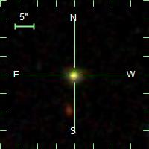
Field: | 155
Redshift Value (Z): | 0.0002753348
SDDSS Object ID: | 1237661070317519079
Velocity Dispersion: | 10.1092
u: | 20.869
g: | 18.159
r: | 17.009 | Galactic Coordinates (l, b)
i: | 16.599 | l | 139.45497
z: | 16.377 | b | 11.09794

Type of Celestial Object: | Galaxy | 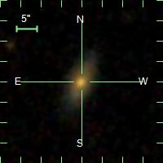
Field: | 151
Redshift Value (Z): | 0.1563233
SDDSS Object ID: | 1237661924478877981
Velocity Dispersion: | 195.3343
u: | 19.657
g: | 18.210
r: | 17.281 | Galactic Coordinates (l, b)
i: | 16.821 | l | 139.61709
z: | 16.493 | b | 11.00147

