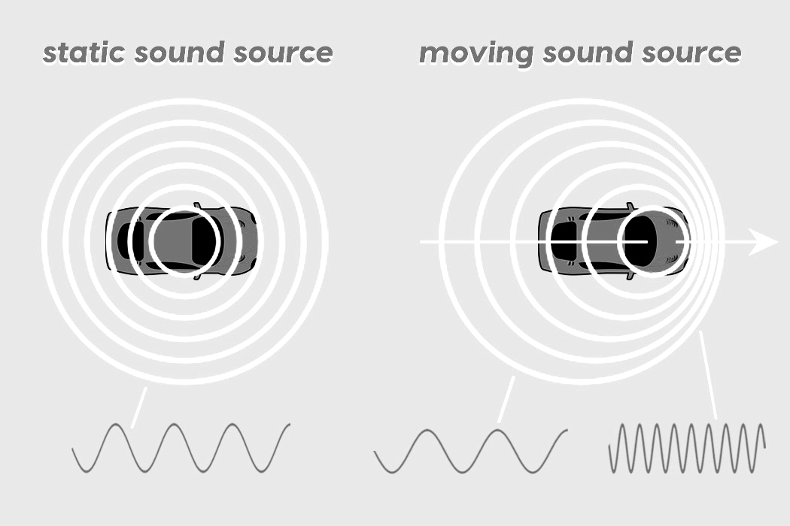
Shift Happens Name: ___________________________ Per____
Section A: Sound Waves and Doppler Effect
- As you watch these two videos, describe any patterns you notice about sound in regard to movement.

- What happens to the wavelength of a sound wave as the source of the sound moves further away?

- How is wavelength(frequency) related to pitch?

Section B: Light Waves and Doppler Effect
Light waves also exhibit the Doppler effect as the source of the light wave moves toward or away from the observer. Below, you will explain and draw redshift and blueshift. Your picture must include the Earth and a star. Show the direction of movement and change in wavelength.
- What is Redshift?
Explanation | Picture

- What is Blueshift?
Explanation | Picture

Section C: Wavelengths and Expansion Demonstration
As you watch the demonstration, answer the following questions:
- What does the slinky represent between the “Earth” and the “Star”?

- What is being modeled here? (redshift or blueshift)?

- How do you know?

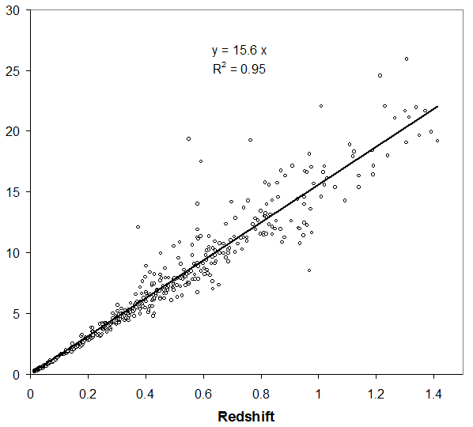


Section D: Redshift and Distance:
9. Looking at the graph, explain the relationship between redshift and distance:

10. If you have a redshift value of 0.8, what is the distance in billion lightyears from Earth?

Take the printed cards from your supplies. There are five spectral data cards. One card shows the original spectral lines emitted by a star. The others represent the spectral lines that would occur from that same star at varying distances.

Arrange the cards according to distance from Earth, closest to farthest. Record the order below.
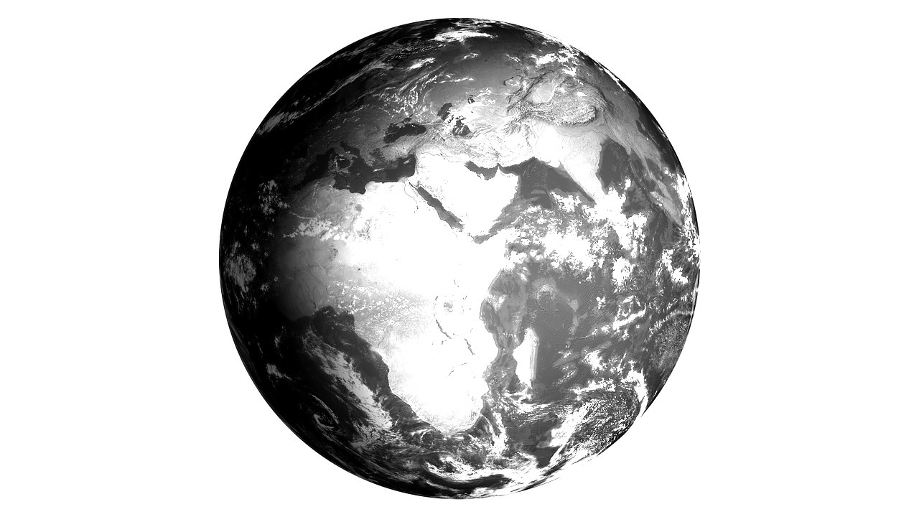

11. What pattern do you notice to the degree of redshift that occurs as you get farther from the Earth?

Section E: Redshift and Velocity:
Fill in the table below using the data collected from the Skyserver website. When you have the data, plot redshift and velocity dispersion on the graph.
Optical Spectra Data
 | Color of celestial object | Type of celestial object  (Galaxy, Star, QSO) | Redshift (Z) value | Velocity Dispersion (km/s)
1
2
3
4
5
6
7
8
9
10
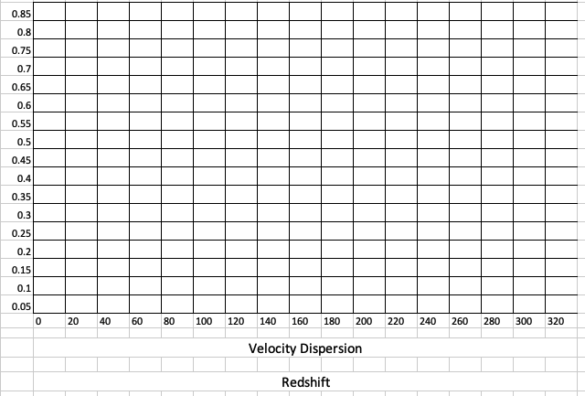

12. What overall pattern in the data do you see in relationship to Redshift (z values) and velocity?

13. Does the color you see coming from a star indicate Redshift or blueshift? Explain.

14. How are the majority of celestial objects in space moving in relation to Earth?

15. We can observe the pattern of celestial objects continuously moving away from each other. What does that pattern tell us about the universe as a whole?

16. Using Claim, Evidence, Reasoning, explain what redshift tells us about the universe.
Claim | Evidence | Reasoning

