Name ____________________________________________________________

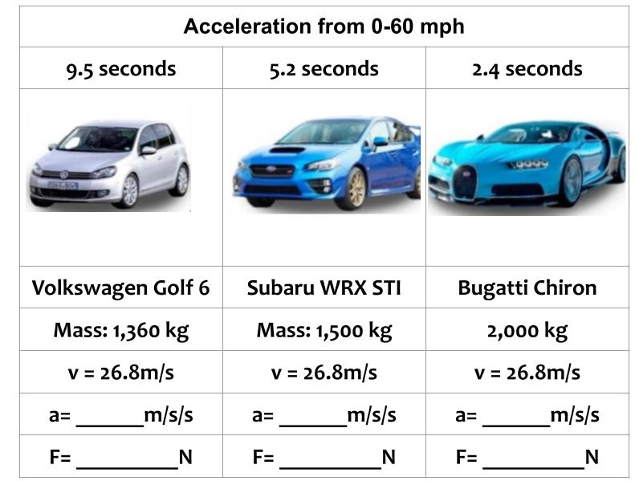
Based on the information above, identify the variable that is causing the difference in the acceleration of each vehicle. Circle the answer(s).

Mass Force Tension Weight Velocity Acceleration

Explain your claim above using evidence from the data provided and your understanding of Newton's Second Law. Your answer must be at least three sentences in length.
___________________________________________________________________________________________________________________________________________________________________________________________________________________________________________________________________________________________________________________________________________________________________________________________________________________________________________________________________________________________________________________________________________________________________________________________________________________________________________________________________________________________________

Name _____________________________________________________
Complete the data table below using calculations from Newton’s 2nd Law.
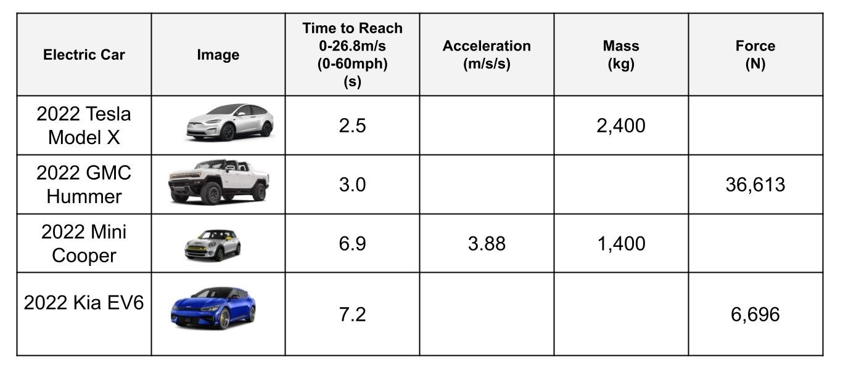
Which electric vehicle is able to exert the greatest amount of force? ____________________
Which electric vehicle accelerated the fastest? ____________________________________
Why isn’t the fastest vehicle the one with the most force in this case? ___________________ ______________________________________________________________________________________________________________________________________________________

Name _____________________________________________________
Complete the data table below using calculations from Newton’s 2nd Law.
Which electric vehicle is able to exert the greatest amount of force? ____________________
Which electric vehicle accelerated the fastest? ____________________________________
Why isn’t the fastest vehicle the one with the most force in this case? ___________________ ______________________________________________________________________________________________________________________________________________________

Answers:
