Name ___________________________________________ Period _________

Will you get to school on time?
Section A:
Predictions
In order to get to school on time, which lane would you rather be in? Explain your reason why.
Section B:
Materials
Pasco Cart and track  Masses  Motion Sensor | Scale  Rubber bands (optional)  Rulers or Yard Sticks
Safety Measure
Remember to respect the science equipment. While the carts have wheels, they are not toys. Also, the plungers on the carts are fragile and spring out quickly, so make sure you are aware of where they would spring out at all times.
Parameters
- Derive a formula that relates mass, force, and acceleration.
- How you perform your tests is up to you; just be sure to use good science and engineering practices.
- Run several tests to collect data to enter into the tables on the next page.

Given the prior parameters, develop a set of procedures for gathering data on the cause-and-effect relationship between mass and acceleration.

Teacher Initials _______
Given the prior parameters, develop a set of procedures for gathering data on the cause-and-effect relationship between force and acceleration.

Teacher Initials _______

Collecting Data:
Table 1: | Mass  (____) | Acceleration (m/s/s) | Table 2: | Force | Acceleration (m/s/s)

Section C:
Analyze and Interpret Data:

Mass (______)
Force
Acceleration (m/s/s)
Graph 1:
Graph 2:
Acceleration (m/s/s)
Question 1. For Table 1, which variable was left constant?  Question 2. List your variables below  Independent Variable _______________  Dependent Variable _______________  Question 3. What effect does mass have on acceleration?  __________________________________ |  | Question 4. For Table 2, which variable was left constant?  Question 5. List your variables below  Independent Variable _______________  Dependent Variable _______________  Question 6. What effect does force have on acceleration?  _____________________________________
Question 7. Check with 2 other people outside of your original group to verify the effect that mass and force has on acceleration.
Initial person 1 _____________ Initial person 2 _____________

Question 8:
* Which variable(s) caused the change in acceleration?

* Which variable(s) affect the change in acceleration?

Question 9: Using the data you collected, propose one formula that relates the three variables from the experiment.
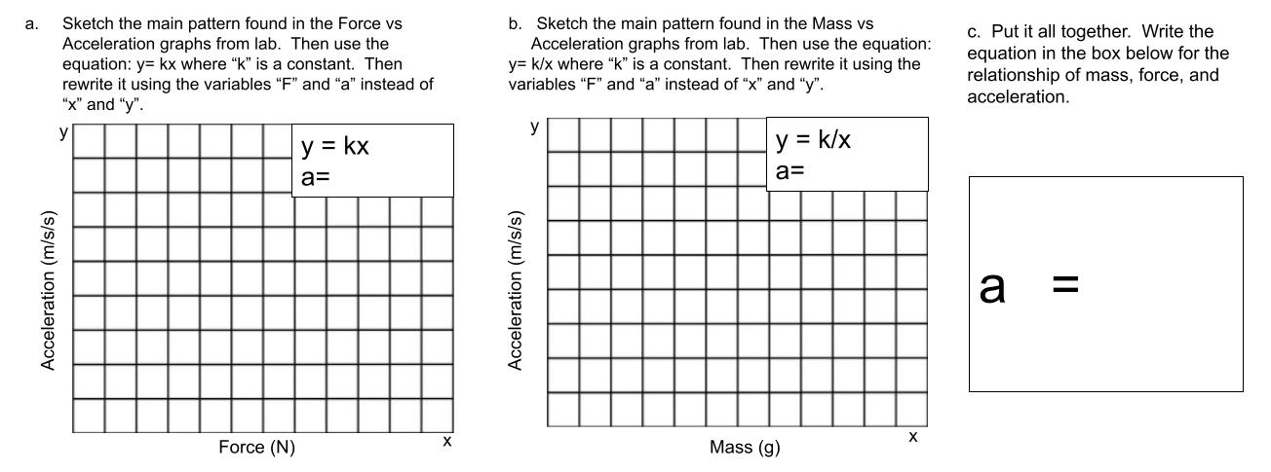
Section D:
Elaborate-Newton’s 2nd Law
With your partner, use the data below to calculate the acceleration for each vehicle.
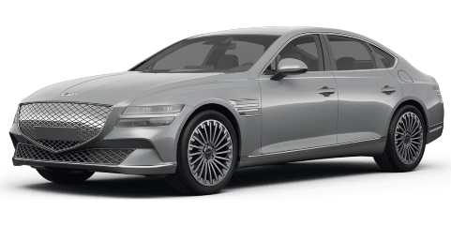 | Average Sedan Mass: 1760 kg  Average Horsepower: 220 hp  This gives a force of 8,800 N  Acceleration: __________
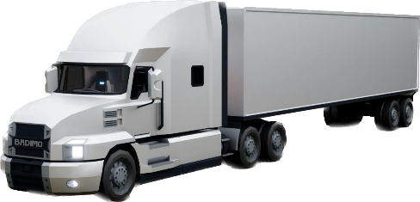 | Average 18-Wheeler Mass: 36,310 kg  Average Horsepower: 600 hp  This gives a force of 32,000 N  Acceleration: __________

Claim: Write a complete sentence stating which lane you would pick.

Evidence: Cite the specific data that you analyzed that supports your claim.

Reasoning: Use Newton’s 2nd Law to explain the cause-and-effect relationship that informed your decision on which lane you picked.

On your own, calculate the acceleration and force for each vehicle below.
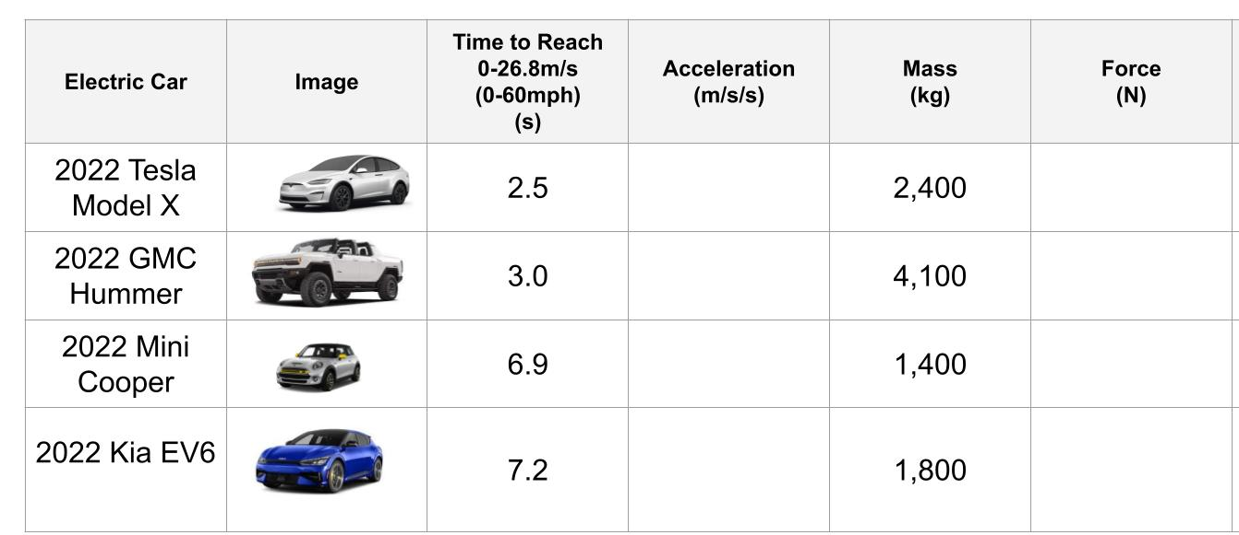

Use the data to explain which variable (mass or force) is causing the acceleration differences between the electric vehicles. Use at least 2 sentences with evidence from the data.

Use the data above to explain which variable (mass or force) is affecting the acceleration differences between the vehicles. Use at least 2 sentences with evidence from the data.

