Name: _____________________________________ Hour: ______________________ Date: ______________________
4.5 Student Handout: Bananas
A. Phenomenon—Define the Problem. As you watch the video (“Will Bananas go extinct?”), answer the following:
- Why could Cavendish bananas be killed in a short period of time (what is the problem)?

- Why was the Gros Michel banana killed previously?

- How have bananas been treated for fungal diseases?

- After the video, what are two additional questions you have or two things you wonder about?

After Video Questions (cause and effect):
- How can the TR4 fungus (Tropical race 4) disease attack the new Cavendish banana in a way that the banana cannot adapt?

- Without researching, what are some solutions you can think of that would help to fight off the fungus affecting the survival of the Cavendish banana species?

- What are some unintended consequences of your ideas to help the bananas survive?

B. Potential Solutions “What would the best solution to this problem look like?”

Criteria (what we want to happen) | Constraints (what barriers are in the way?)

C. Do Background Research
1. Below, you will find links to several articles which describe methods biologists have tried to help bananas survive. Some criteria/constraints topics have been chosen and placed as the title of each column. After reading the articles, fill out each box of the table with how well a particular method meets the criteria or constraints, and then share it with your group.
 | Who should pay for this solution? Why? | Is this a long-term solution? Why? | Does this solution cause ethical problems (hurts the environment, humans, etc.)? Why? | What other problems could occur? Is this solution doable? Why?
Transgenics
Article 1

Article 2:

Fungicides
Article 3

Bio-Control
Article 4

Article 5

Artificial Selection
(Breed a new type of banana)
Article 6

Article 7

_____________________________________________________________________________________
D. After Research Questions
- Using what you have learned, what do you think is the best solution for the banana plant to resist the TR4 fungus? Note: Different students may come to different conclusions on this question.

- Why do you feel that the solution you chose is the best option? (Is it the best solution using the criteria in section B above?)

- Would this solution work for all types of species that are facing similar threats? Why or why not?

- What are the possible unintended consequences of your chosen solution (does our solution cause any unintended effects)?

Extension
Description of the Graph Below:
The graph shows the percentage of infected plants in two normal types of Cavendish bananas (“Williams” and “Grand Nain”) over three years. It also shows the percent of diseased bananas in different genetically modified banana varieties (RGA2-2*, RGA2-3*, RGA2-4*, RGA2-5*, RGA2-7) as well as two other types.
“GCTCV 218” is a banana created in Taiwan using plant breeding. It has a natural resistance to the disease. “DPM25” is a normal banana that has mutations caused by radiation. It is disease-resistant to a fungus similar to the fungus attaching Cavendish bananas.

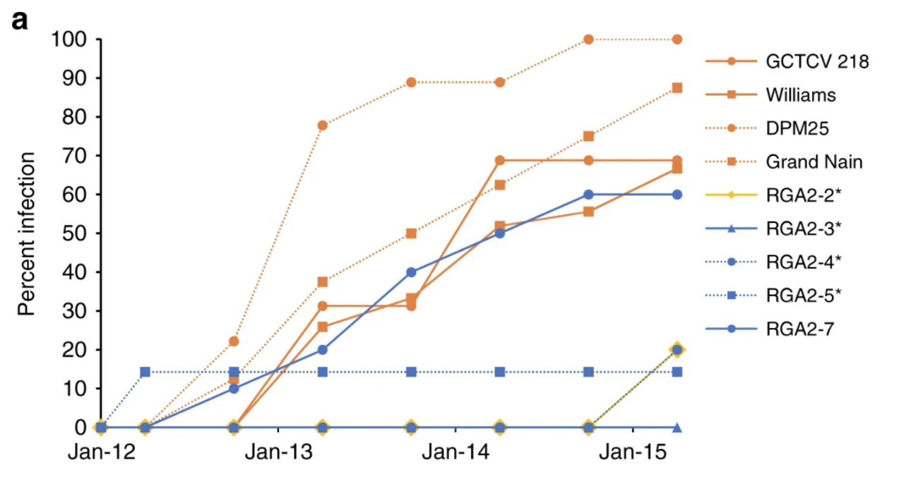
1. Look at the graph above. What does this graph tell you about which solutions scientists have tried? How effective have these solutions been? (Look at the different types of solutions and follow and compare them through the graph.)

2. Pick one of the following fruit diseases: Citrus greening of oranges, vanilla beans and black rot, apples and fire blight, tomato mosaic virus, cacao plant (chocolate) pod rot disease.
These fruits are undergoing similar threats to their existence as the banana. Explain the threat and potential solutions scientists are trying for that disease.

