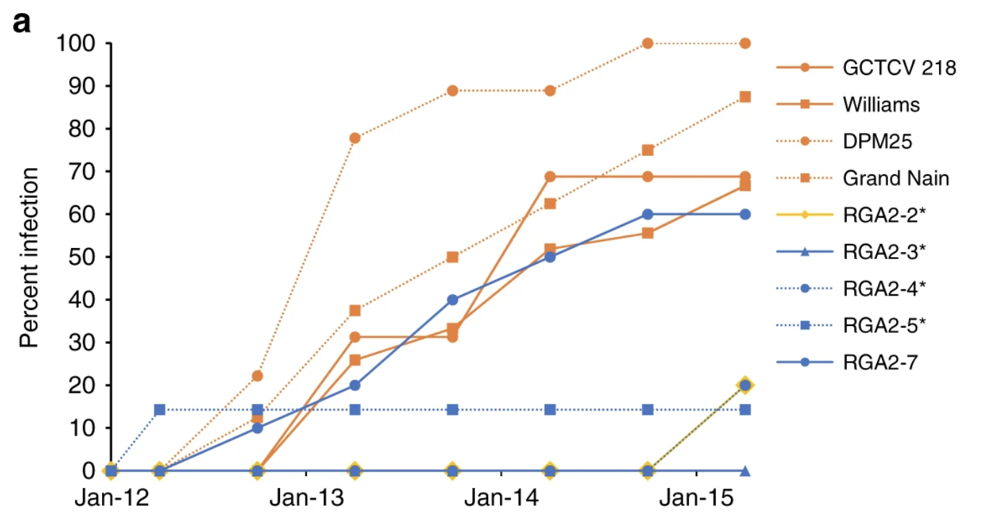

Figure Above: Percent of infected plants in two normal types of Cavendish bananas (“Williams,” and “Grand Nain”) over three years. Also, the percent of diseased bananas in different genetically modified varieties of banana (RGA2-2*, RGA2-3*, RGA2-4*, RGA2-5*, RGA2-7) as well as two other types.

“GCTCV 218” is a banana created in Taiwan using plant breeding. It has natural resistance to the disease. “DPM25” is a normal banana that has mutations caused by radiation. It is disease-resistant to a fungus very similar to the fungus which causes our disease in question.

