Name: _____________________________________ Hour: ______________________ Date: ______________________
4.5 Student Handout
A. Phenomenon- Define the Problem Video------ As you watch the video (“Will Bananas go extinct?”) answer the following questions.
- Why could Cavendish bananas be killed in a short period of time (what is the problem)?
1 Point | 0 Points
Answer contains each of the following components:
- The Cavendish bananas are clones (i.e., does not have genetic differences between the population)
- The Panama Fungus can adapt and may adapt to kill the Cavendish.

- Why was the Gros Michel killed previously?
1 Point | 0 Points
Answer contains each of the following components:
- Answer should recognize that the process that killed the Gros Michel is the same process that may kill the Cavendish.

- How have bananas been treated for fungal diseases?
1 Point | 0 Points
Answer contains each of the following components:
- Answers may very but should include responses, such as fungicides, genetic modification, etc.

- After the video, what are two additional questions you have or two things you wonder?

2 Points | 1 Point | 0 Points
Answer contains each of the following components:
- 2 original questions created as an individual or group.

After Video Questions (cause and effect):
- How can the TR4 fungus (Tropical race 4) disease attack the new Cavendish banana in a way that the banana cannot adapt?
2 Points | 1 Point | 0 Points
Answer contains each of the following components:
- The student recognizes that the Cavendish are clones that do not change.
- The student recognizes that the fungus undergoes sexual reproduction and does genetically change through its generation according to natural selection.

- Without researching, what are some solutions you can think of that would help to fight off the fungus affecting the survival of the Cavendish banana species?
1 Point | 0 Points
Answer contains each of the following components:
- Student has made a list of 2-3 possible solutions to help the Cavendish banana species. They do not have to be absolutely logical yet ( i.e., just having them reproduce.)

- What are some unintended consequences of your ideas to help the bananas survive?
1 Point | 0 Points
Answer contains each of the following components:
- Student comes up with at least 1 unintended consequence of their proposed solution(s) in question 2.

B. Potential Solutions “What would the best solution to this problem look like?”
Criteria (what we want to happen) | Constraints (what barriers are in the way?)

C. Do Background Research
1. Below, you will find links to several articles which describe methods biologists have tried to help bananas survive. Some criteria/constraints topics have been chosen and placed as the title of each column. After reading the articles, fill out each box of the table with how well a particular method meets the criteria or constraints, and then share it with your group.
 | Who should pay for this solution? Why? | Is this a long-term solution? Why? | Does this solution cause any ethical problems (hurts the environment, humans, etc.)? Why? | What other problems could occur? Is this solution doable? Why?
Transgenics
Article 1

Article 2:

Fungicides
Article 3
Bio-Control
Article 4

Article 5

Artificial Selection
(Breed a new type of banana)
Article 6

Article 7

5 Points | 2.5 Points | 0 Points
Constraint Table and Research Table contains each of the following components:
- Tables are filled out according to directions.

_____________________________________________________________________________________
D. After Research Questions
- Using what you have learned, what do you think is the best solution for the banana plant to resist the TR4 fungus? Note: Different students may come to different conclusions on this question.
1 Point | 0 Points
Answer contains each of the following components:
- The student uses evidence gained from the table and talking with their group to propose what they believe is the best solution. (There is not right or wrong answer here as long as they give evidence.)

- Why do you feel that the solution you chose is the best solution? (Is it the best solution using the criteria in section B above?)
1 Point | 0 Points
Answer contains each of the following components:
- The student uses evidence gained from the table and talking with their group to propose what they believe is the best solution. (There is not right or wrong answer here as long as they give evidence.)

- Would this solution work for all types of species that are facing similar threats? Why or why not?

1 Point | 0 Points
Answer contains each of the following components:
- The student recognizes that each case is unique and may require a different solution based upon the type of plant and fungus present.

- What are the possible unintended consequences of your chosen solution (does our solution cause any unintended effects)?
1 Point | 0 Points
Answer contains each of the following components:
- The student uses logical and creative thinking to answer the question.

Expert | Proficient | Emerging Proficient | Below Proficient
This student has shown proficiency with the entirety of the lesson and high rigor extensions below this lesson is recommended. | This student has shown proficiency in this standard and extensions below this lesson is recommended with aid. | This student needs more practice to show proficiency in this standard. | This student needs a large amount of practice to become proficient in this standard intervention is recommended.
18-16 Points | 15-12 Points | 12-9 Points | 9-0 Points

Extension
Description for the Graph Below:
The graph shows the percentage of infected plants in two normal types of Cavendish bananas (“Williams” and “Grand Nain”) over three years. It also shows the percent of diseased bananas in different genetically modified banana varieties (RGA2-2*, RGA2-3*, RGA2-4*, RGA2-5*, RGA2-7) as well as two other types.
“GCTCV 218” is a banana created in Taiwan using plant breeding. It has a natural resistance to the disease. “DPM25” is a normal banana that has mutations caused by radiation. It is disease-resistant to a fungus similar to the fungus attaching Cavendish bananas.

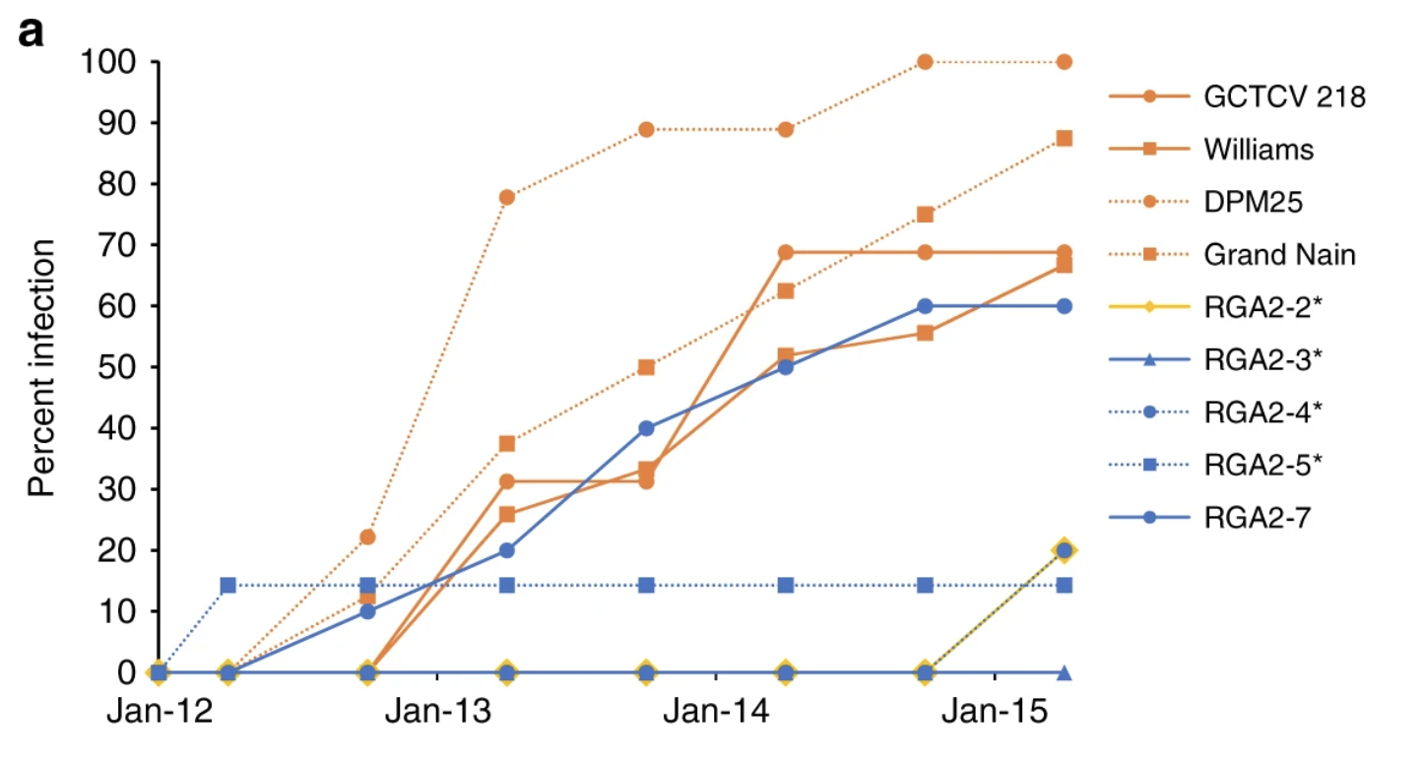
1. Look at the graph above. What does this graph tell you about which solutions scientists have tried? How effective have these solutions been? (Look at the different types of solutions and follow and compare them through the graph)

2. Pick one of the following fruit diseases. They are undergoing similar threats to their existence much like the banana. Explain what is the threat and what is a potential solution scientists are trying for that disease.
Citrus greening of oranges, vanilla beans and black rot, apples and fire blight, tomato mosaic virus, cacao plant (chocolate) pod rot disease

