Variation and Natural Selection in Guppies

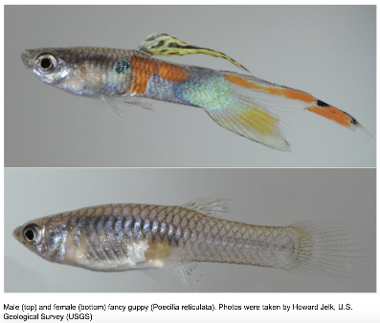
Male guppies are a colorful and vibrant species of fish that are widely distributed in the freshwaters of South and Central America. Usually, guppies will live in clear tropical water of the Caribbean islands. They are also found in South America in countries like Guyana, Brazil and Venezuela. People have also introduced them to every continent except Antarctica. Guppies have been purposely introduced into local waterways for mosquito abatement, they eat mosquito larvae to reduce mosquito populations. However, in some areas people have simply dumped their aquarium fish into local fresh water.
Guppies are popular among aquarium enthusiasts due to their bright colors and unique traits, such as their ability to change colors and their playful behavior. Because they are tropical fish, guppies live in warm waters. In most cases, you’ll find them in habitats that contain water at about 72 to 79 degrees Fahrenheit. The pH level of the water they live in tends to be between 5 and 9. However, to be sure they live a healthy life in your tank, keep these numbers between 6.5 and 8.
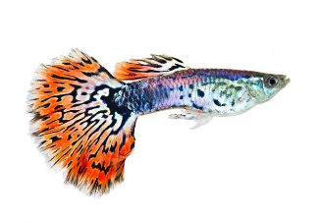
Guppies have several adaptations to survive in the wild. Female guppies have the ability to store sperm in a special cavity in their ovaries. They keep the sperm alive with small amounts of sugar until the eggs are fertilized. This allows females to give birth to more than one brood with a single semination.
When evolutionary biologist John Endler began studying Trinidad's wild guppies in the 1970s, he was struck by the wide variation among guppies from different streams, even among guppies living in different parts of the same stream. Males from one pool sported vivid blue and orange splotches along their sides, while those further downstream carried only modest dots of color near their tails. Endler also observed differences in the distribution of guppy predators, and in the color and size of gravel in different stream locations.

Endler photographed hundreds of guppies and carefully measured their size, color, and the size and placement of their spots. He began to see a strong correlation between where guppies lived in a particular stream and whether the fish were bright or drab. The more brightly colored a male guppy is, the more likely he will be seen, and eaten, by a predator. In a simulation or in the wild, where predators are plentiful, male guppies become increasingly drab over generations, pushed by predation pressure toward greater camouflage. So, if camouflage provides an obvious survival benefit to species like guppies when it comes to predator avoidance, what possible advantage could there be to sporting colors and patterns that make an individual more conspicuous?

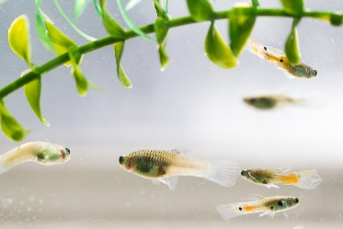
The answer lies in the fact that guppies have to do more than just survive. They also have to reproduce, and to do that, they have to attract mates. The "flashier" a male guppy is, the more likely a female guppy will choose him as a mate, giving him the opportunity to pass his genes along to the next generation. This is sexual selection at work, and it is the force that pushes guppy coloration toward conspicuousness just as hard as predation pushes coloration toward drabness. There may be several evolutionary reasons why female guppies prefer flashy males. On the most basic level, the male with the biggest, brightest tail spot announces most loudly, "Hey, I'm over here" to any female within eyeshot. Flashy colors are simply easier to locate.

Bright colors may also indicate good genes, in the way the strong physique of a human athlete is a direct indicator of that individual's health and vitality. And more indirectly, bright coloration may signal to a potential mate that he's got something else going for him. After all, he's been able to survive the very handicap, conspicuousness to predators, that his flashiness creates. Whatever the reasons, it is clear from the research of Endler and other evolutionary biologists that male guppies live in the crossfire between their enemies and their would-be mates, with the opposing forces of predation and sexual selection forever pushing the guppy coloration in opposite directions.

Adapted from: https://www.pbs.org/wgbh/evolution/sex/guppy/low_bandwidth.html

