Name: ____________________________________________________ Hour: _____________ Date: _______________
DNA Student Handout
Write down two things you notice about today’s phenomenon.
1.

2.
Write down two things you wonder about today’s phenomenon.
1.

2.
HUMAN DNA AND MOUSE DNA COMPARISON: Here is a visual comparison of chromosomes to show how much DNA humans share with mice.
Directions:
Look at the mouse chromosomes below. Circle any segments of DNA found in the mouse genome which are not shared with humans. (Note: The numbers to the right of each chromosome shows which human chromosome contain similar DNA). Remember, only 30 percent of DNA differs between a mouse and a human (https://www.nature.com/scitable/knowledge/library/comparative-genomics-13239404/).

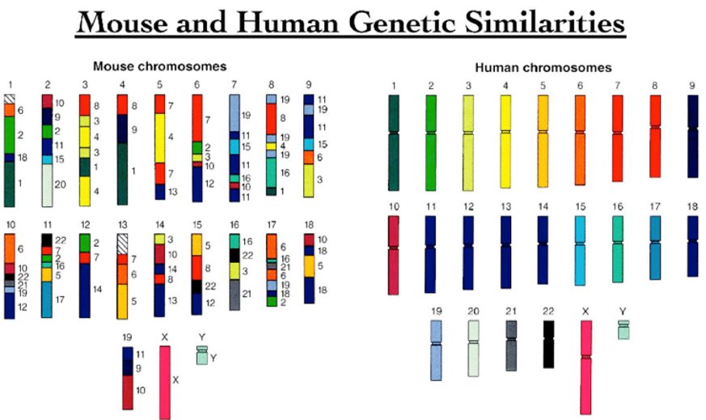

Stated Clearly Video questions. (Read questions before the video begins):
- What are amino acids?

- Below, fill in the blanks from the chain of life as described in the video.
DNA à Amino Acids à à Living Cells à Tissue à à Living Creatures

- In 2-4 sentences, describe what was learned in the video. Use pictures if needed.

Go to the CK12 webpage and read. Pay attention to how the structure of DNA leads directly to specific functions (i.e., specific proteins).
Answer the following questions related to the structure and function of DNA found on the CK12 website.
- What are nucleic acids? What do they do for our bodies?

- What 3 things are nucleic acids comprised of:

- What are the 4 bases found in DNA?

- What bases pair together?

- What are hydrogen bonds, and how do they play a role in base pairing?

Create a model of DNA using the bead models. First, link the red and white beads together to make the sugar-phosphate backbone. Next, make a key to identify the other colors for the 4 types of bases. The 5th color will be used to make mRNA with uracil. Finally, use the clear connectors to make hydrogen bonds between the bases. The model should be able to help you construct evidence for why the function of DNA leads to its function.

 | Excellent | Good | Poor
DNA is double-stranded, showing both sides of the DNA molecule | Model shows both sides of the DNA molecule. | Model does not clearly show that DNA is double stranded. | Model does not show either side of the DNA.
DNA is 5-10 base pairs long. | Model has 5-10 DNA bases in length to show structure. | Model has more than 10 or less than 5 bases in length. | Model only shows 1 base pair.
The correct bases are labeled and paired correctly. | Bases are paired correctly. | Bases are paired, but there are errors in pairing. | Model does not show base pairs.
Every part of the DNA structure is identified with its function. | All parts of DNA are identified with their name and function. | Parts of DNA are labeled or identified | Labels are missing, or all labels are incorrect.

After Model Questions
- DNA stores information much like a computer and communicates information. In computers, information is stored as 0s or 1s. What does DNA use? Explain why it makes sense that the information to build a human can be built using just the information in DNA.

- Think about the phenomenon of this lesson. We share 50% of our DNA with a banana and even more with other living organisms. Circle or highlight all the things that a banana’s DNA and our DNA code for in common.
  - Building cell organelles out of protein
  - Making proteins for hair
  - Bright yellow in color
  - Fighting off diseases
  - Making mitochondria
  - Two arms and two legs
  - Regular cell functions
  - Producing a cell wall

- What percentage of things did you circle in question 3? How does that relate to us sharing 50% of our DNA with a banana?

- In question 3, would you expect more of the items to be circled if we were comparing a mouse and a human? Explain why.

- Pretend money is not an issue. How could you revise your physical DNA model to represent DNA more accurately?

- Create a CER paragraph. Focusing on your structural model of DNA, provide an explanation for why living organisms have similar traits. Use pictures if it helps you describe your explanation.
  - Claim: DNA provides instructions for the proteins that create similarities in living organisms.
  - Evidence:
    - The first evidence is…

    - The second evidence is…

    - The third evidence is…

  - The reason DNA is similar between organisms is because…

