DNA Student Handout Rubric
Write down two things you notice about today’s phenomenon.
1.
2.
1 Point | 0 Points
Student accomplished both items below:
- Student wrote down 2 things that they noticed about the phenomenon.
- Student showed evidence of engagement through what they wrote.
Write down two things you wonder about today’s phenomenon.
1.
2.
1 Point | 0 Points
Student accomplished both items below:
- Student wrote down 2 things that they wondered about the phenomenon.
- Student showed evidence of engagement through what they wrote.
HUMAN DNA AND MOUSE DNA COMPARISON: Here is a visual comparison of chromosomes to show how much DNA humans share with mice.
Directions:
Look at the mouse chromosomes below. Circle any segments of DNA found in the mouse genome which is not shared with humans. (Note: The numbers to the right of each chromosome show which human chromosome contains similar DNA). Remember, only 30 percent of DNA differs between a mouse and a human (https://www.nature.com/scitable/knowledge/library/comparative-genomics-13239404/).

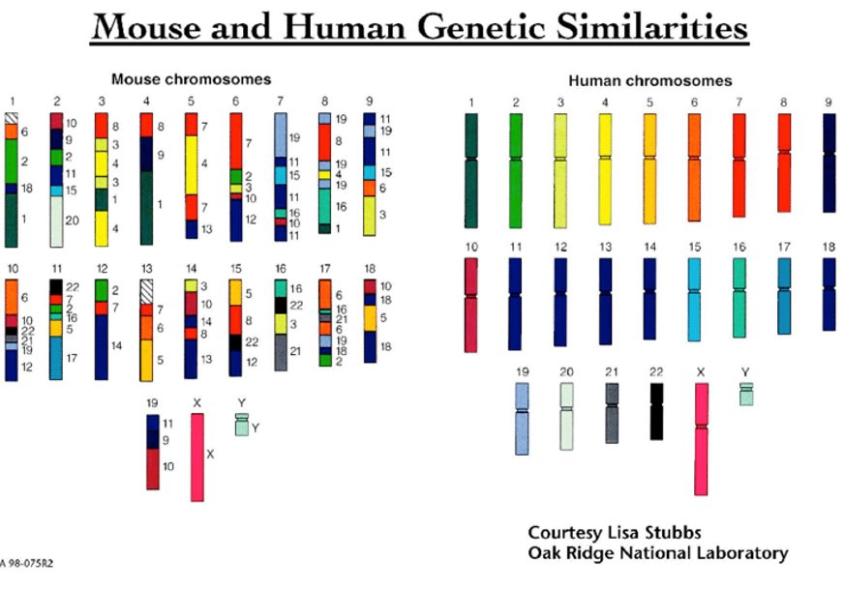
2 Points | 1 Point | 0 Points
Student accomplished the item below:
- Student circled mouse chromosomes 1 and 13.
Stated Clearly Video questions. (Read questions before the video begins):
- What are amino acids?
1 Point | 0 Points
Student accomplished either item below:
- Student wrote that amino acids are building blocks of proteins.
- Student recognized that there are 20 amino acids, which act like Legos that build into proteins.

- Below, fill in the blanks from the chain of life as described in the video.
DNA Amino Acids Living Cells Tissue Living Creatures
1 Point | 0 Points
Student accomplished both items below:
- The first blank is filled in with proteins.
- The second blank is filled in with organ systems.

- In 2-4 sentences, describe what was learned in the video. Use pictures if needed.
2 Points | 1 Point | 0 Points
Student accomplished the item below:
- Student summarized the video in two or more sentences describing amino acids, DNA, and proteins.
Go to the CK12 webpage and read. Pay attention to how the structure of DNA leads directly to specific functions (i.e., specific proteins).
Answer the following questions related to the structure and function of DNA found on the CK12 website.
- What are nucleic acids? What do they do for our bodies?
1 Point | 0 Points
Student accomplished the item below:
- Student wrote an explanation they found from the CK12 webpage describing nucleic acids. “The double helix shape of DNA, together with Chargaff’s rules, led to a better understanding of DNA. DNA, as a nucleic acid, is made from nucleotide monomers, and the DNA double helix consists of two polynucleotide chains. Each nucleotide consists of a sugar (deoxyribose), a phosphate group, and a nitrogen-containing base (A, C, G, or T).”

- What 3 things are nucleic acids comprised of:

1 Point | 0 Points
Student accomplished the item below:
- Student answered phosphate group, nitrogenous base, and sugar.

- What are the 4 bases found in DNA?
1 Point | 0 Points
Student accomplished the item below:
- The student answered A, G, C, T (U for RNA) or
- They answered Adenine, Guanine, Cytosine, and Thymine (Uracil for RNA)

- What bases pair together?
1 Point | 0 Points
Student accomplished the item below:
- The student answered that Adenine pairs with Thymine (or Uracil in RNA) and Guanine pairs with Cytosine.

- What are hydrogen bonds, and how do they play a role in base pairing?
1 Point | 0 Points
Student accomplished the item below:
- The student wrote an explanation that states how a hydrogen bond holds the two strands of DNA together.

Create a model of DNA using the bead models. First, link the red and white beads together to make the sugar-phosphate backbone. Next, make a key to identify the other colors for the 4 types of bases. The 5th color will be used to make mRNA with uracil. Finally, use the clear connectors to make hydrogen bonds between the bases. The model should be able to help you construct evidence for why the function of DNA leads to its function.
 | Excellent 2 Point | Good 1 Point | Poor 0 Points
DNA is double-stranded, showing both sides of the DNA molecule | Model shows both sides of the DNA molecule. | Model does not clearly show that DNA is double stranded. | Model does not show either side of the DNA.
DNA is 5-10 base pairs long. | Model has 5-10 DNA bases in length to show structure. | Model has more than 10 or less than 5 bases in length. | Model only shows 1 base pair.
The correct bases are labeled and paired correctly. | Bases are paired correctly. | Bases are paired, but there are errors in pairing. | Model does not show base pairs.
Every part of the DNA structure is identified with its function. | All parts of DNA are identified with their name and function. | Parts of DNA are labeled or identified | Labels are missing, or all labels are incorrect.
After Model Questions
- DNA stores information much like a computer and communicates information. In computers, information is stored as 0s or 1s. What does DNA use? Explain why it makes sense that the information to build a human can be built using just the information in DNA.
2 Points | 1 Point | 0 Points
Student accomplished both items below:
- The student recognizes that information stored in a computer is stored in 0 or 1s and is seemingly endless.
- The student recognizes the similarities between the two systems of storing information.

- Think about the phenomenon of this lesson. We share 50% of our DNA with a banana and even more with other living organisms. Circle or highlight all the things that a banana’s DNA and our DNA code for in common.
  - Building cell organelles out of protein
  - Making proteins for hair
  - Bright yellow in color
  - Fighting off diseases
  - Making mitochondria
  - Two arms and two legs
  - Regular cell functions
  - Producing a cell wall
1 Point | 0 Points
Student accomplished the item below:
- Student circled letters a, d, e, g

- What percentage of things did you circle in question 3? How does that relate to us sharing 50% of our DNA with a banana?
1 Point | 0 Points
Student accomplished both items below:
- The student writes that 50% were circled.
- Related how many they circled to how much DNA we share with a banana.

- In question 3, would you expect more of the items to be circled if we were comparing a mouse and a human? Explain why.
1 Point | 0 Points
Student accomplished both items below:
- Student answers that about 70% would be circled due to us sharing that much DNA with a mouse.
- The student writes a short explanation of why they would expect more to be circled.

- Pretend money is not an issue. How could you revise your physical DNA model to represent DNA more accurately?
1 Point | 0 Points
Student accomplished the item below:
- Student shares ideas on how the model could be revised to reflect actual DNA better.

- Create a CER paragraph. Focusing on your structural model of DNA, provide an explanation for why living organisms have similar traits. Use pictures if it helps you describe your explanation.
  - Claim: DNA provides instructions for the proteins that create similarities in living organisms.
  - Evidence:
    - The first evidence is…
    - The second evidence is…
    - The third evidence is…

  - The reason DNA is similar between organisms is because…

3 Points | 2 Points | 1 Point | 0 Points
Student accomplished the item below:
- The student provides reasonable evidence for the claim provided.

Expert | Proficient | Emerging Proficient | Below Proficient
This student has shown proficiency with the lesson, and high-rigor extensions to this lesson are recommended. | This student has shown proficiency in this standard, and extensions to this lesson are recommended. | This student needs more practice to show proficiency in this standard. | This student needs a large amount of practice to become proficient in this standard intervention is recommended.
24-21 Points | 20-17 Points | 17-14 Points | 14-0 Points

