How does drought impact deer?
Before reading the article below, answer the following questions about the impact of drought on deer.
- How is drought related to the amount of vegetation deer rely on?

- What information about bucks (male deer) would you use to determine how drought has affected them?

- What information about does (female deer) would you use to determine how drought has affected them?

- What prediction would you make on how fawns (baby deer) are affected by drought?

Read the Following article and respond to the prompts at the bottom.
SOURCE: https://wildlife.utah.gov/news/wildlife-blog/1291-drought-and-our-deer-herds.html

Quality and quantity of vegetation
Plants need water to grow, and deer need plants as a food source. When drought puts stress on plants, there's a negative ripple effect on deer and other wildlife that depend on high-quality vegetation in large quantities.
If there is insufficient moisture, plant growth is stunted and lacks the nutrition that deer need for survival and reproduction. Without proper nutrition, deer will not gain the necessary fat reserves to make it through the winter. Malnourished deer are less likely to survive and successfully reproduce.
Drought has different impacts on plants and deer, depending on the time of year.

SPRING/SUMMER DROUGHT IMPACTS
In the spring, plants begin to turn green and grow tender new shoots. This new growth is very palatable to deer and contains rich nutrients such as protein and calcium. The spring "green-up" of healthy plants is what deer need most after being in a nutritional deficit during the winter months.

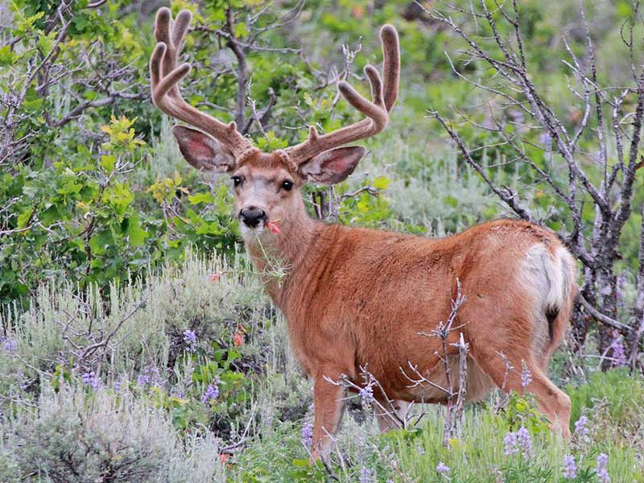
Mule deer eat a lot of leafy, flowering plants (called forbs) in the spring and summer. These plants have exceptionally high nutritional value, but many of them — especially in southern Utah — have adapted to drought conditions. When there is insufficient moisture, these plants will not produce flowers and may go dormant.
Drought's resulting reduction in vegetation quality and quantity during the spring and summer months decreases the ability of mule deer to put on much-needed fat before winter arrives.

FALL/WINTER DROUGHT IMPACTS
Shrubs like sagebrush and bitterbrush are a valuable part of mule deer diets year-round, but particularly in the fall and winter. Drought conditions can limit new growth on shrubs in the spring, which in turn limits food availability during the winter. Mule deer prefer to browse on the new growth because it is the most tender, nutritious part of the plant and is rich in protein.
Unfortunately, drought conditions also make the new growth on shrubs harden faster than usual, limiting a deer's ability to eat and digest it effectively. If shrub growth is insufficient or too tough to eat, that can be a problem for deer, who ideally need to build up their fat reserves during summer and fall. Having adequate body fat is one of the key factors determining whether mule deer survive the winter or not.

Age and sex of deer
A deer's age can make it more susceptible to the effects of drought. Fawns raised in drought conditions may not be able to put on sufficient fat reserves before their first winter arrives.

During drought conditions, fawns are born smaller and grow more slowly than during wetter periods. If fawns do not reach a sufficient size and weight prior to winter, they will not have enough energy reserves to make it through, especially if the winter is severe.
Drought also affects deer differently, depending on whether they are female or male.

HOW DROUGHT IMPACTS DOES
For adult female deer (does), drought can lead to poor body condition and result in the following possible outcomes:
- Decreased adult survival
- Stillborn births
- Low birth weights and poor newborn fawn survival
- Inadequate milk supply to nourish a fawn
Sometimes, a doe will carry a fawn full-term and raise it, but the newborn fawn is much smaller than a fawn born in a non-drought year. Smaller, weaker fawns are less likely to survive their first winter, especially if conditions are harsh.
Milk production (lactation) is also very demanding on a doe's body. If drought affects a doe's milk supply, that can lead to decreased survival of newborn fawns during both the summer and winter months.
Drought can reduce deer population growth by impacting both survival and reproduction:
- Survival impacts: Adult doe survival averages around 85% in Utah, but even a small drought-induced decline in survival — even if it's only 5% — can have widespread impacts on overall population growth.
- Reproduction impacts: In non-drought years, twins are a normal occurrence for mule deer. If the does stop having twins, or even single fawns, it reduces the whole population.
Having fewer deer overall means there will be fewer bucks available to hunters, possibly for years to come.

HOW DROUGHT IMPACTS BUCKS
Drought can affect antler growth for bucks. And although antlers are not necessarily needed for survival, they can improve the likelihood of winning mating battles and achieving reproductive success.
During drought years, bucks will not have surplus nutrition to grow antlers as large as they might in a non-drought year. They will still produce them — and they may be big — but perhaps not as big as they would grow during a year with good precipitation.
If a pregnant mule deer doe is in poor body condition, it will affect any fetuses she is carrying. They will not receive optimal nutrition and will likely be smaller at birth and throughout their lives. This is why bucks born to drought-affected does may have smaller antlers. With all of this in mind, don't be surprised if you see fewer bucks — and smaller bucks — during the fall hunt.

- Now that you have read the article, what is your conclusion on how drought impacts the vegetation deer rely on?

- Why is antler growth a key indicator of how healthy a deer population will be?

- If does from a drought year were compared to does during a non-drought year, what differences in the deer population would you expect to see?

- What facts would you select to support the statement that drought has a harmful effect on fawns?

- What are some management methods that could be used by the DWR to manage deer populations based on a “good” vs. “bad” water year?

- Develop a conclusion that explains the differences between a healthy/stable deer population, and one that is impacted by drought/change.

