Do the 2022 drought conditions represent a moderate or extreme environmental change?
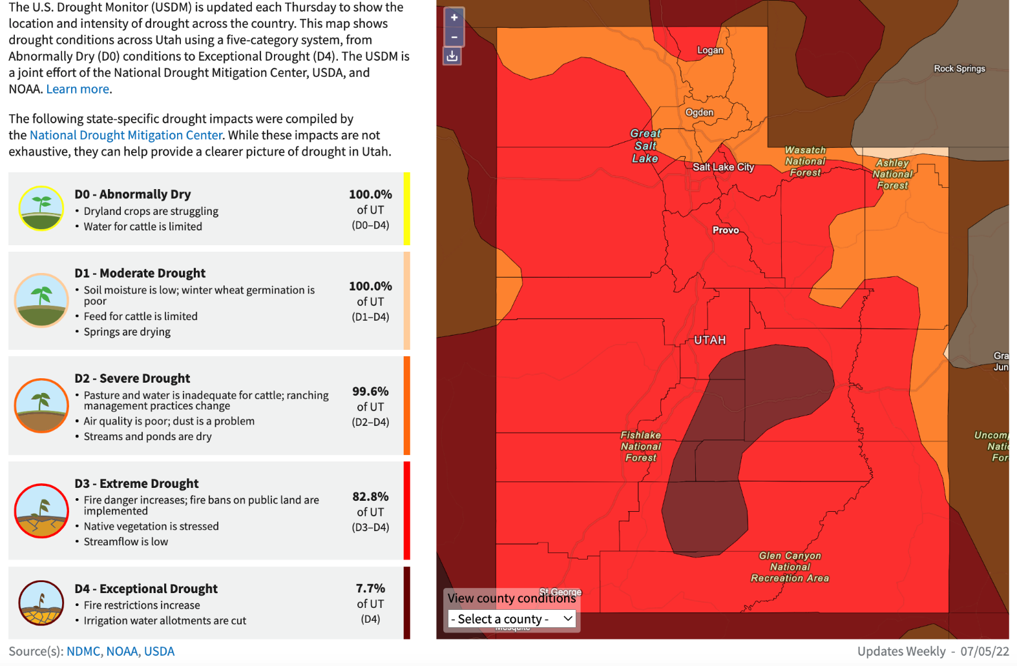
Prompt:
- What conclusions do you draw from the 2022 Utah Drought Monitor Map?
  - What does it mean to be in D0 vs D1 drought?

  - What does it mean to be in D2 vs D3 drought?

  - What are some bigger issues/problems that can be caused by D4 droughts?
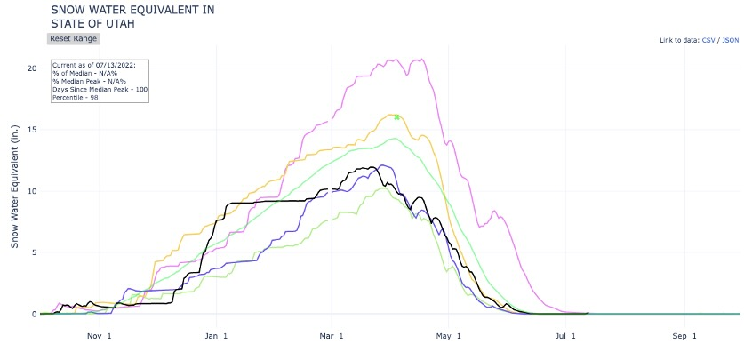
This Snowpack Graph focuses on the years 2018-2022
Lighter Green - 2018
Purple - 2019
Yellow - 2020
Blue - 2021
Black - 2022
Darker Green – mean (average)

Prompt:
- What conclusions do you draw from the Utah Snowpack Graph:
  - What year do you notice that has the best snowpack?

  - What changes do you notice?

  - What is occurring on a year-to-year basis that is contributing to drought in Utah?

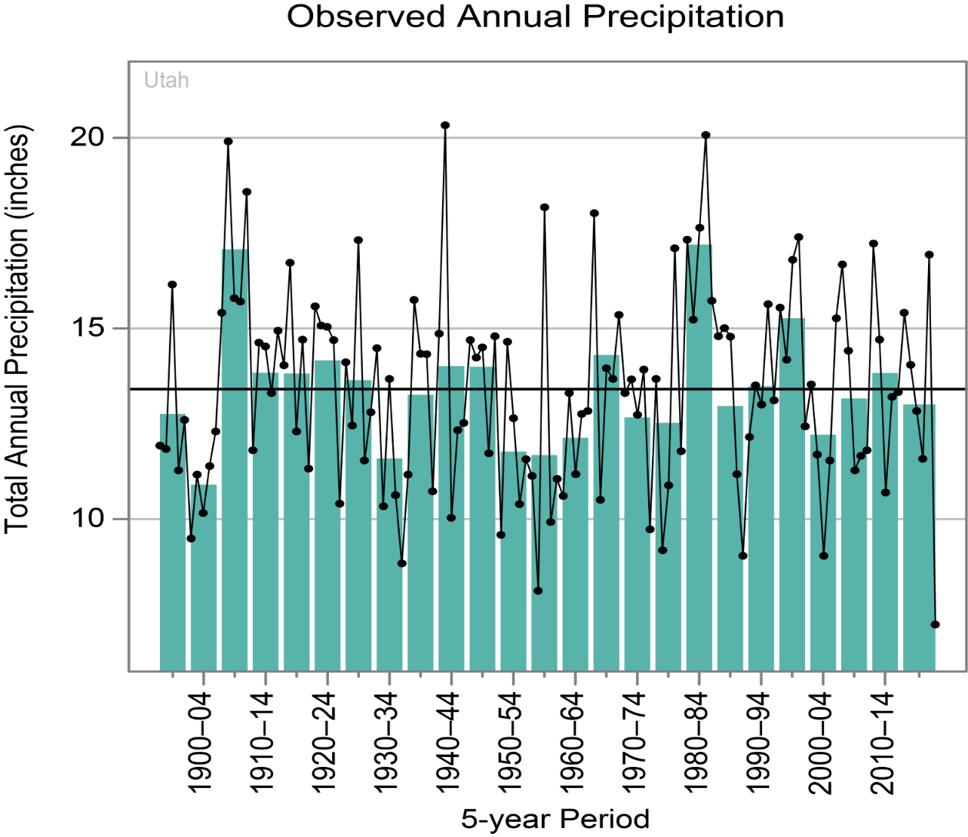
Each dot on this graph represents specific year. Each green bar represents the average precipitation for a 5-year period.
Prompt:
- What conclusions do you draw from the Observed Annual Precipitation graph?
  - When was total precipitation most stable over time?

  - What was the total average precipitation (green bar) for the years for 1980-1984?

  - According to the graph, what individual year (black dot) had the lowest precipitation levels on record?

  - Since 1950, how many 5-year periods have been above average? How many have been below average?
Prompt for all three graphs:
- What new conclusions do you draw after analyzing all three:
  - What patterns or trends do you see in the graphs above?

  - How did you use these three graphs to identify the patterns in the data?

  - Based on your analysis of the data, do the current drought conditions represent a moderate (somewhat below average) or an extreme (significantly below average) environmental change?

