What is happening to the deer population in Utah?
Read the following article and respond to the prompt.
Why experts say the West's deer population is at 'inflection point' after another drop in 2021
By Carter Williams, KSL.com | Posted - Feb. 13, 2022
Estimated read time: 9-10 minutes
SALT LAKE CITY — Utah wildlife biologists fear there was another 10% drop in the statewide mule deer population in 2021 as mostly dry conditions reigned through the first half of the year.
The projection is based on below-normal adult and fawn survival rates, as well as fawn production in the second half of the year, Utah Division of Wildlife Resources officials told KSL.com.
While they are still tabulating their numbers for a final population estimate ahead of the 2022 hunting season, their preliminary estimates suggest a 10% decrease from the 314,850 deer estimated at the end of 2020. That would put the 2021 count on track to be somewhere in the range of 285,000 — much fewer than the 376,450 deer recorded in 2018.
Drought is a large contributor to this decline in recent years, but there are many factors behind the drop in mule deer populations. In fact, the trends in Utah aren't entirely unique — they mirror some of the mule deer trends across the West, according to the Western Association of Fish & Wildlife Agencies.
However, with the return of monsoons, a wet October and December, along with collaborative efforts between biologists, conservationists and even hunters, experts are hopeful trends are about to change. They say these trends are happening in other parts of the West, too.
"I believe we're at an inflection point for deer and deer management. ... We've largely stopped the decline," said Joel Pedersen, the president and CEO of the Utah-based Mule Deer Foundation.
That optimism highlighted the foundation's inaugural Mule Deer Summit on Friday. The summit, Pedersen said, was planned for previous years but then was put on hold due to COVID-19.
It brought experts from across the region together in Salt Lake City, to share information about the problems plaguing mule deer and highlight the solutions being used now that are helping mule deer populations grow in other parts of their native habitats.
It's also where U.S. Department of Interior Deputy Secretary Tommy Beaudreau explained how a record $1.5 billion will go to states to help fund hunting and fishing education and conservation projects, helping out species like the mule deer.

- Based on the article, what is happening to the deer population in Utah, and what are the reasons causing it to happen?

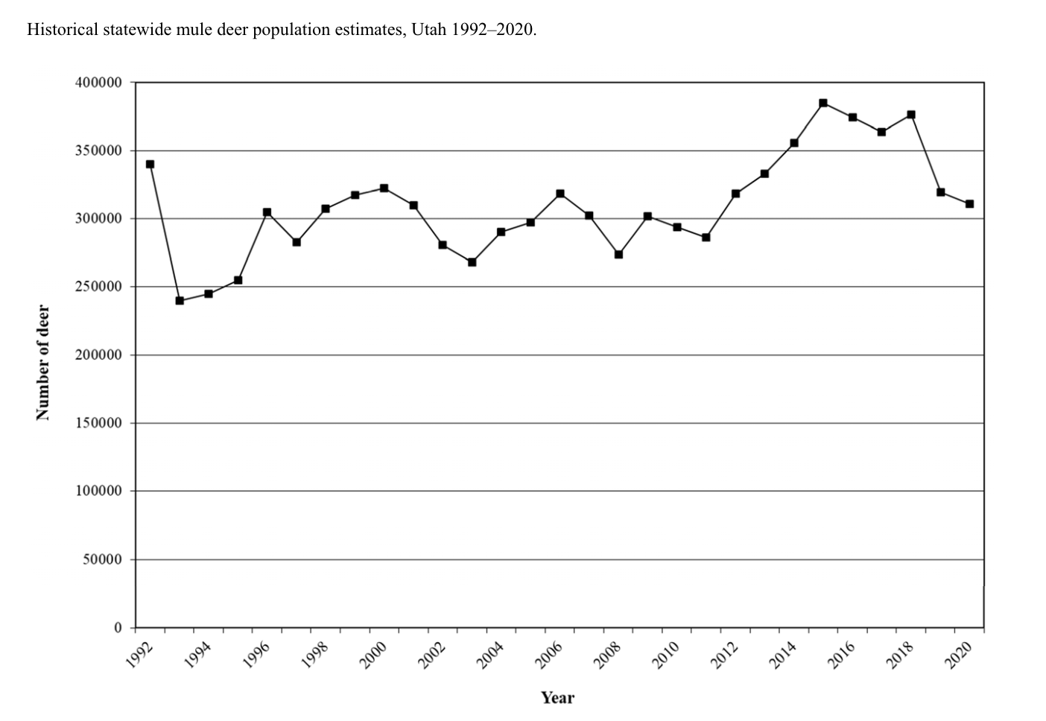
- Based on the graph, what is the overall trend of the deer population from 2000-2020?

The state estimated 285,000 deer in March 2022 with continued drought depleting the population. Down from the 2021 estimate of 314,850 which was the lowest pre-hunt population in 10 years due largely to drought.
- Using the passage above for 2021 and 2022, what has happened to the deer population since 2015?

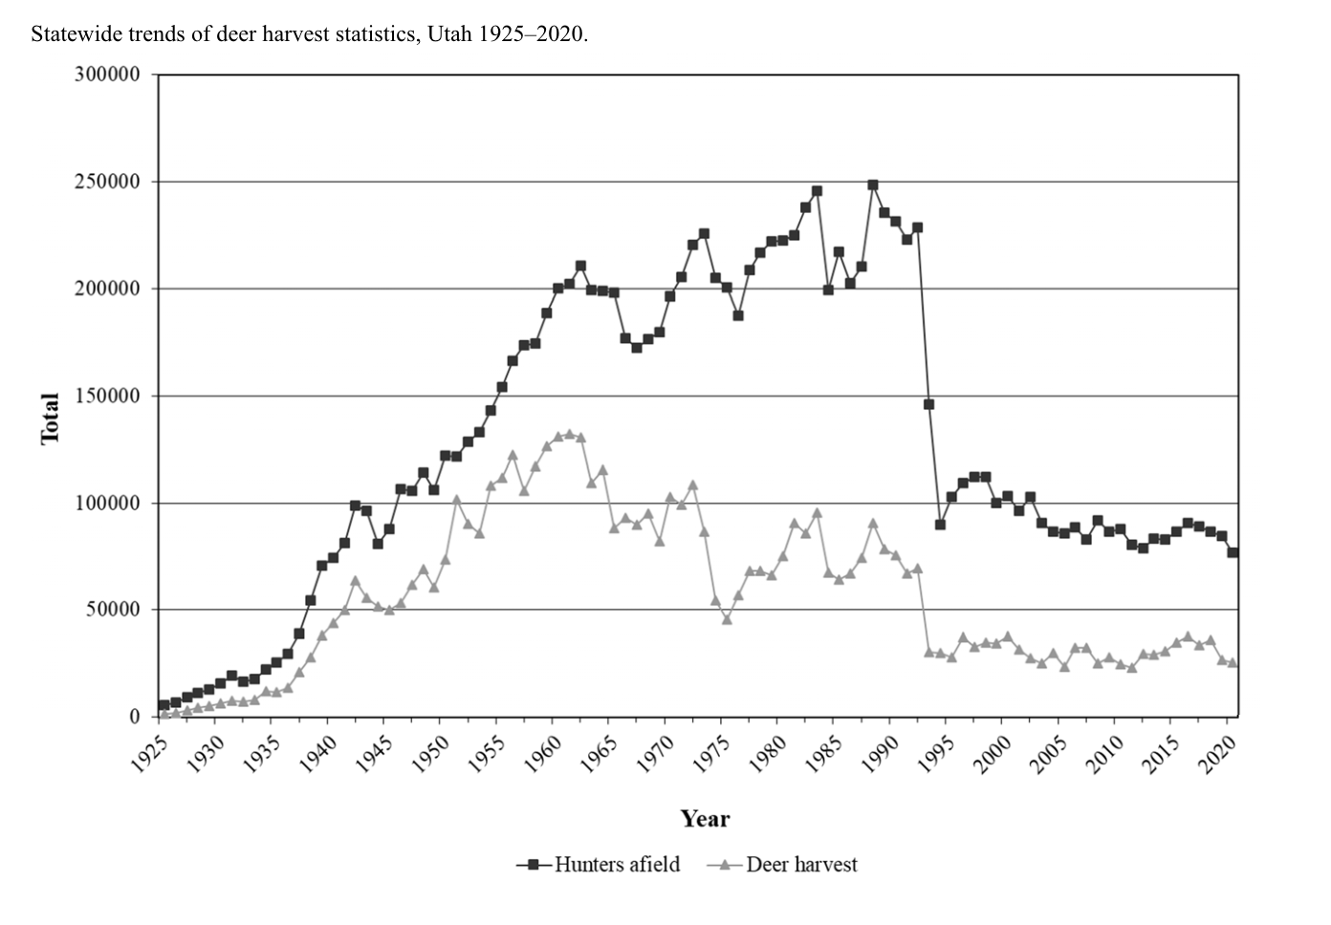*** “Hunters afield” means how many people have a permit and who actively hunted; “Deer harvested” is the number of deer that were killed by hunters.
- How do the trends of the Hunters Afield and the Deer Harvested compare? What insight could the graph provide that would help us better understand the deer population?

- Reviewing all data together, were there any periods of stability and growth in population numbers? What evidence shows that?

- How has the deer population changed over time? What evidence leads you to your conclusion?

