Stability and Change Within an Ecosystem
The graph below represents the Annual Precipitation for the State of Utah over the past 10 years.
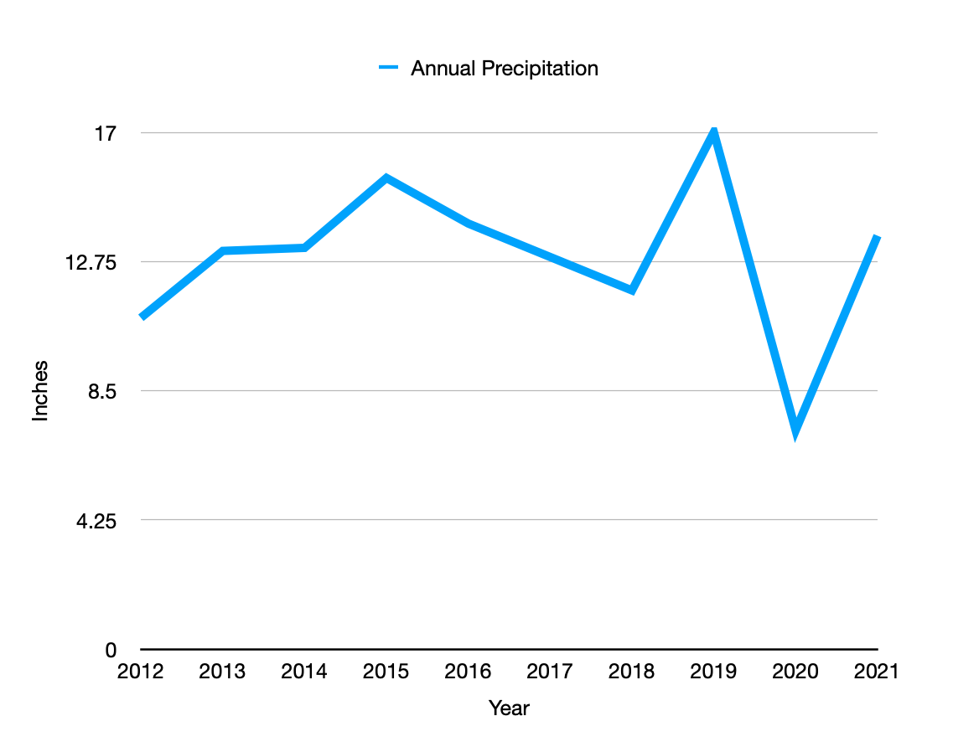
- Draw lines on the graph to represent what you think the trend of the following will be:
  - Deer population
  - Quantity of vegetation
- For each of the trend lines you drew, explain why you drew the trend line you did.
  - Deer population -

  - Quantity of vegetation -

- Draw an ecosystem web that illustrates the impact of water on an ecosystem. Use a marker to highlight all areas that could be impacted by drought. List any extreme changes that might cause irreversible change to your ecosystem drawing.

